Development of a biomass pre-treatment technology for fuel production and combustion
Mooktzeng Lim PhD, TNB Research Sdn. Bhd., Malaysia
Bumshin Kim PhD, Myungsoo Park, Korea Electric Power Corporation Research Institute, South Korea.

Abstract

A process that reduces slagging and fouling from the combustion of certain types of biomass is developed. The utilization of biomass for combustion causes several operational issues, such as slagging and fouling, particulate matter emissions, and corrosion. These issues are caused by a higher alkali metal content, especially potassium (K), which increases slagging propensity by lowering its formation temperature; and higher chlorine (Cl) content in the biomass, which causes corrosion. The above issues are especially prevalent in the combustion of empty fruit bunches (EFB), a type of biomass from the palm oil industry. Thus, this research develops a pre-treatment process for EFB to reduce the K and Cl contents. The process reduces K & Cl by 80% at an optimal biomass-to-water ratio and pre-treatment time. Combustion trials in a 100 kW boiler show that fouling thickness was reduced by 80% with lower K content. A further combustion trial in a 10 MW power plant with 75 tons of treated EFB is performed, and showed that the fuel consumption was reduced by 12% and increased net plant efficiency by 0.67%. The K content in fly ash reduced by 19% and bottom ash by 40%. FactSage, a commercially available software, is used simulate the amount of ash, based on thermodynamic equilibrium models. The simulation results showed that the amount of ash is within to 3 to 30% of experimental values. In addition, based on the elemental composition of the ash from the treated EFB, the K₂O-Al₂O₃-SiO₂ ternary diagram shows that the fusion/slagging temperature is higher than 1530 K, above those from the untreated EFB.
Image
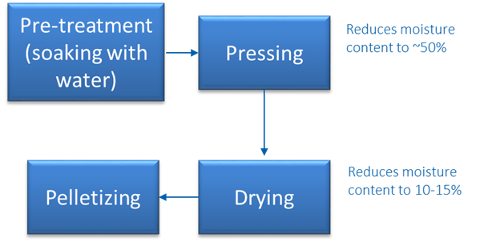
Recent Publications
- Lim MT, Lea-Langton A (2020) Investigation of Non-thermal Plasma Assisted Combustion of Solid Biomass Fuels: Effects on Flue Gas Composition and Efficiency. Plasma Chemistry and Plasma Processing 40:1465-1483.
- He X, Lou C, Qiao Y, Lim MT (2020) In-situ measurement of temperature and alkali metal concentration in municipal solid waste incinerators using flame emission spectroscopy 102:486-491.
- Lim MT, Matsuoka L (2019) Quantitative analysis and speciation of alkali metal emissions from biomass combustion in a 150 kW th furnace by optical emission spectroscopy. Chem. Eng. Comm. 10.1080/00986445.2019.1647182
- He Z, Chun L, Fu J, Lim MT (2019) Experimental investigation on temporal release of potassium from biomass pellet combustion by flame emission spectroscopy. Fuel 253:1378-1384.
5. Chong CT, Chiong MC, Ng JH, Lim MT, Tran M, Valera-Medina A, Chong W, (2019) Oxygenated Sunflower Biodiesel: Spectroscopic and Emissions Quantification under Reacting Swirl Spray Conditions. Energy 178:804-813.

 Biography
Mooktzeng has more than 10 years of experience in biomass & plasma technologies for energy sustainability, with a PhD from the University of Canterbury (New Zealand). His research areas are in biomass conversion and plasma technologies. Research outcomes include plasma synthesis of biogas, plasma assisted solid fuel combustion and pre-treatment of biomass. He has designed & commissioned a 150 kW & a 600 kW fluidized bed gasifiers, and is a professional Engineer with the Institute of Mechanical Engineers (UK) and Board of Engineers Malaysia. Mooktzeng’s international experience includes postdoctoral experiences in New Zealand, the United Kingdom.
Email: mooktzeng.lim@live.com

Notes/Comments

