Integrated algal biorefinery approach using microalgae grown in domestic wastewater for biofuels and biochar synthesis for iron oxide reduction

Ashokkumar Veeramuthu ^{a,}, Chong Cheng Tung^{b}, Chawalit Ngamcharussrivichai ^{a,}

ª Center of Excellence in Catalysis for Bioenergy and Renewable Chemicals (CBRC),
Faculty of Science, Chulalongkorn University, Pathumwan, Bangkok 10330, Thailand.

^{b} China-UK Low Carbon College, Shanghai Jiao Tong University. Lingang,201306 Shanghai China

Abstract
In this present scenario, the reduction of CO₂ emissions is a foremost issue for environmental sustainability due to the deteriorative atmospheric greenhouse effects and global warming. Thus, scientists are looking forward to finding a solution to the interrelated problems of population growth, energy scarcity, and global warming is one of the most important challenges of the 21st century. In this context, the photosynthetic microalgae are considered as a potential organism to fix the atmospheric CO₂ at a faster growth rate compared to other land plants. This study demonstrates an integrated biorefinery approach on domestic wastewater treatment coupled with biofuel production. Besides, another important part of this study is to explore the biofuels extracted residues for biochar production and metallic iron conversion from iron oxides. The alga was cultivated in domestic sewage at a large scale, the results revealed that the maximum biomass yield of 24.6 g/m² was recorded on the 18th day at semi-continuous mode. The biofuel production was investigated and achieved a significant quantity of yield. Furthermore, the lipid extracted residual biomass was pyrolyzed and obtained biochar. The iron oxide reduction was successfully carried our using biochar through the thermogravimetric analyzer. The results showed harvest 990℃ supported iron oxide reduction.
.

Graphical Abstract

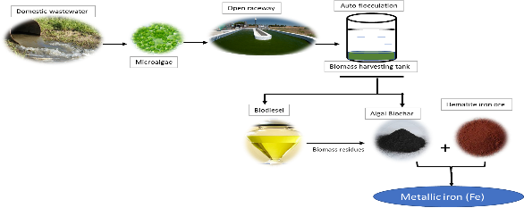

Recent Publications
- Ashokkumar V, Chen WH, Ngamcharussrivichai C, Agila E, Ani FN. Potential of sustainable bioenergy production from Synechocystis sp. cultivated in wastewater at large scale – A low cost biorefinery approach. Energy Convers. Management. 186 (2019) 188–199.
- Ashokkumar V, Chen WH, Muhtaseb AA, Kumar G, Sathishkumar P, Pandian S, Ani FN, Ngamcharussrivichai C. Bioenergy production and metallic iron (Fe) conversion from Botryococcus sp. cultivated in domestic wastewater: Algal biorefinery concept. Energy Conversion and Management, 196 (2019) 1326–1334
- Ashokkumar. V., Salim, M.R., Salam, Z., Sivakumar, P., Chong, C.T., Elumalai, S., Suresh, V., Ani, F.N. 2017. Production of liquid biofuels (biodiesel and bioethanol) from brown marine macroalgae Padina tetrastromatica. Energy Conversion and Management. 135 (2017) 351–361
- Ashokkumar. V, Agila. V, Sivakumar. P, Salam Z, Rengasamy R, Ani FN. Optimization and characterization of biodiesel production from microalgae Botryococcus grown at semi-continuous system. E. Convers. Management. 88 (2014) 936–946.
- Ashokkumar.V. Rengasamy. R Deepalakshmi. S, Sivalingam. A. and Sivakumar.P. Mass cultivation of microalgae and extraction of total hydrocarbons: A kinetic and thermodynamic study. Fuel. 119 (2014) 308–312.

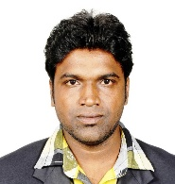

Biography
I have been working in the field of Microalgal Biorefinery for biofuels and bioproducts for the past 12 years at academic and industrial level. During my research period, I have extensively worked on marine and freshwater microalgal species at large scale cultivation through open raceway pond and closed photobioreactor (PBR). I have experience in growing microalgae at zero nutrients cost technology using various wastewater (Municipal, Industrial, and agricultural waste). Also, I am expertise in microalgae biomass production at commercial level for biofuels and high value-added bioproducts. In addition, I had excellent experienced in thermochemical techniques, torrefaction, biochar synthesis, CO₂ mitigation, metallic iron production using microalgal biochar
Email: rvashok2008@gmail.com

