QUANTITATIVE investigation of the Catalytic Activities of Analogues Nickel Complexes in Ethylene OLIGO-/Polymerization
Arfa Abrar Malik, ^{1,2} Wenhong Yang,^{1,2}* and Wen-Hua Sun^{1,2}*
Key Laboratory of Engineering Plastics and Beijing National Laboratory for Molecular Science, Institute of Chemistry, Chinese Academy of Sciences, No.2 North 1st Street, Zhongguancun, Beijing 100190, China

Abstract

Catalytic activity is the most important property among the catalytic performance of transition metal complexes. Many achievements have been obtained previously on increasing the catalytic activity of complex, by the modification of ligands, the change of substitutions on ligands as well as the design of new structure of ligand [1−2]. However, the potential principle of transition metal complex with high catalytic activity is still necessary to be clarified at the molecular level. The catalytic activity is fundamentally determined by the structure of catalyst, including the electronic and steric effects. To expose the relationship between catalyst structure and reaction activity, two carbocyclic fused pyridineimine nickel analogue systems (Ni1 and Ni2) with different fused member ring are investigated [3−4]. Multiple linear regression analysis is performed by means of five electronic and two steric descriptors, including Hammett constant (F), effective net charge (Q_{eff}), energy difference (ΔE), HOMO‒LUMO energy gap (Δε_{1,} Δε₂), open cone angle (θ), and bite angle (β) [5]. The value of correlation coefficient values (R²) is over 0.938 obtained by using the combinations of effective net charge (Q_{eff}) and open cone angle (θ) for both individual and comparison analogues systems. The contribution analysis indicates that the dominant descriptor is effective net charge (Q_{eff}) in Ni1 system and open cone angle (θ) in Ni2 systems, respectively.

Image
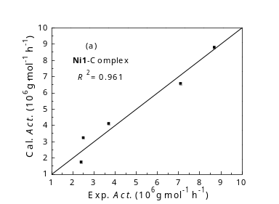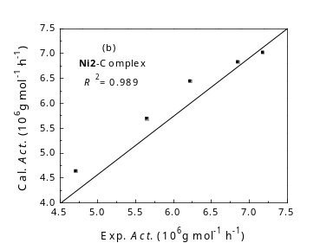

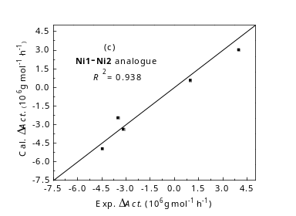
Fig 1. Comparisons between calculated and experimental activities of (a) Ni1 system, (b) Ni2 system, and (c) Ni1‒Ni2 analogue system, using the descriptors of effective net charge (Q_{eff}) and open cone angle (θ).

Acknowledgments: This work was financially supported by the National Natural Science Foundation of China (Grant Nos. 21871275 and 51861145303).
References:
- Gibson, V.C.; Redshaw, C.; Solan ,G.A. Chem. Rev. 2007, 107, 1745‒1776.
- Zheng, W.; Solan, G.A.; Zhang, W.; Sun W.-H. Coord. Chem. Rev. 2018, 363, 92–108 (2018).
- Yu, J.; Hu, X.; Zeng, Y.; Zhang, L.; Ni, C.; Hao, X.; Sun, W.-H. New J. Chem. 2011, 35, 178–183.
- Huang, F.; Sun, Z.; Du, S.; Yue, E.; Ba, J.; Hu, X.; Liang, T.; Galland, G. B.; Sun, W.-H. Dalton Trans. 2015, 44, 14281–14292.
- Ahmed, S.; Yang, W.; Ma, Z.; Sun, W.-H. J. Phys. Chem, A. 2018, 122, 9637–9644.
Recent Publications
- Malik, A.A.; Yang, W.; Ma, Z.; Sun, W.-H. The Catalytic Activities of Carbocyclic Fused Pyridineimine Nickel Complexes Analogues in Ethylene Polymerization by Modeling Study. Catalysts 2019, 9, 520.
- Meraz, M.M.; Malik, A.A.; Yang, W.; Sun, W.-H. Catalytic Performance of Cycloalkyl-Fused Aryliminopyridyl Nickel Complexes toward Ethyrfalene Polymerization by QSPR Modeling Catalysts 2021, 11(8), 920. (Equal Contribution)

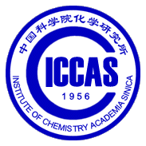


Biography
Arfa Abrar Malik is a PhD research scholar at the Institute of Chemistry, Chinese Academy of Science Beijing China. Her research work is focused on the synthesis of transition metal complexes and the effect of their activities on ethylene polymerization. Her research focus for the duration of her Ph.D. is to synthesize organometallic complexes of Iron and Cobalt and correlate her experimental results with the models/simulations, which she computed during her MS research. She also managed to successfully publish her MS research based on the simulation and models of the transition metal complexes and their enhancement as catalysts in ethylene oligo/polymerization. Currently, she is working as an exchange researcher at the Department of Chemistry, Quaid-i-Azam University Islamabad, Pakistan. Apart from her philanthropic activities, Arfa is Co-Founder at WEmpower Pakistan and also affiliated with this international non-profit organization as the Chief Information Officer and works towards bridging the gap between competent students and academia. She advises students regarding their PhD applications and scholarships.
Email:arfamalik@iccas.ac.cn
arfamalik@wempowerpakistan.org
https://wempowerpakistan.org/arfa-abrar-malik/

Notes/Comments:
Arfa Abrar Malik is going to defend her Ph.D in this summer 2022.
Her collaborative papers on computational and experimental are going to be published soon which are under process.

Presenting author details
Full name: Arfa Abrar Malik
Contact number:+8615501190388
Twitter account:ArfaAbrar
Linked In account: Arfa Abrar Malik
Session name/ number: Polymer Chemistry
Category: Oral presentation

