Novel Selectivity Algorithm for Metaloxide Chemical Sensor on Volatile and Hazardous Gases in the Air
V.Chistyakov¹, A.Sokolov² and S. Soloviev¹
¹Ioffe Institute, Saint-Petersbourg, Russia
E-mail: v.chistyakov@mail.ioffe.ru
²OSTEK Enterprise Ltd, Moscow, Russia

Abstract
New algorithm is presented for selective identification such gases and vapors in the air as hydrogen, methane, propane, ethanol, acetone etc by use of ZnO and SnO₂ based sensors doped with PdO and La₂O₃. The conductivity responses Δσ(μS) vs z=1000/T (K⁻¹) from temperature modulation process are interpolated by following parameterized l discriminating functions
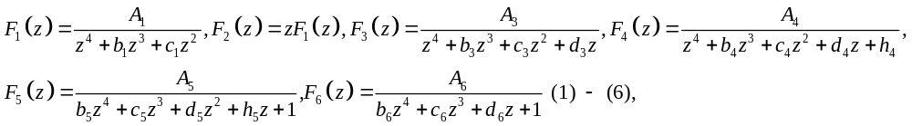
which parameters are estimated via nonlinear regression method. The dependences of the principal ones A_{i}(C_{Y}) on analyte Y concentration C_{Y} compose multivariate calibration portrait fitting to which an unknown analyte X is identified as the Y (e.g. ethanol in dry air— Fig). And the common abscissa of all intersection points of the level lines A_{iX} and calibration curves A_{i}(C_{Y}) defines the analyte concentration in the units used (mg/m³, Fig).
In case the abscissas are different or some of them are missing the analyte X is not Y. The method allows selective detection of broad list of analytes in synthesized dry and real wet air and even distinguishes the substances of the same homological group: methane/ propane/hexane and ethanol/methanol/isopropyl alcohol. Actually, the method is breakthrough in solving the very important problem among 3S-problems: selectivity, stability, sensitivity.
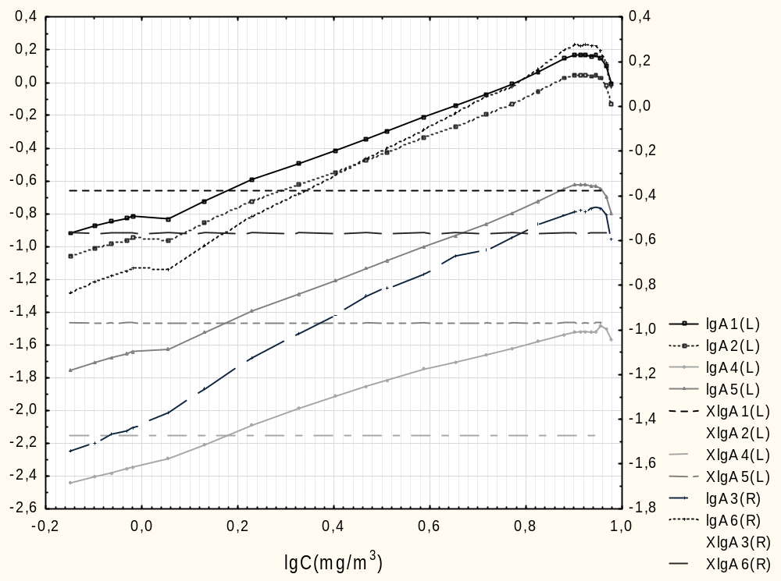
Figure. 1.5 mg/m³ absolutized ethanol is identified as ethanol due to Multivariate Gauge C₂H₅OH on SnO₂. All abscissas of intersection points are visually equal.

Keywords
chemical sensor, semiconductor, metaloxide, rare earth, selectivity, nonlinear estimation, multivariate calibration
Recent Publications:
- 1. V.Chistyakov, S.Kazakov, M.Grevtsev, S.Soloviev, Nonlinear-regression based algorithm of chemical sensor’s signal processing for selective detecting of various species in artificial air//Technical Physics Letters 2021(6):15, DOI: 10.1134/S1063785021030184
- 2. V.Chistyakov, S.Kazakov, M.Grevtsev, S.Soloviev,Thin nanocrystalline semiconductor films as selective chemical sensors for ammonia, acetone and other donors// Journal of Physics Conference Series 2103(1):012125, DOI: 10.1088/1742-6596/2103/1/012125
- 3. V.Chistyakov., Quantum Analogue of Unstable Limit Cycles of a Periodically Perturbed Inverted Oscillator// Theoretical and Mathematical Physics 198(1):17-28, DOI: 10.1134/S0040577919010021
Biography
Born 1957, town of Buy, Kostroma region. Graduated from the faculty of general and applied physics of Moscow Physical-Technical Institute in 1981. Defended the dissertation “On chemisorption influence on electro-physical properties of polycrystalline semiconductor adsorbents” in 1992. Worked as a scientist and professor in higher education institutes of Yaroslavl and Saint-Petersbourg such as Yaroslavl Pedagigical University named after K.Ushinsky, ITMO University< Mikhailov Artillery Academy. Now senior scientists of the Lab of RareEarth Semiconductors of the Ioffe Institute in SPb.
Presenting Author Details and Photo
Full Name: Viktor Vladimirovich Chistyakov
Email ID: v.chistyakov@mail.ioffe.ru
Phone No: +7981-815-7495
Recent Photograph:


