Press Release

Governor Signs “Emerging Therapies Act of 2017”
Pilot Study will allow Regenerative Injection Therapies to be covered on
State Employee and Teacher health plans

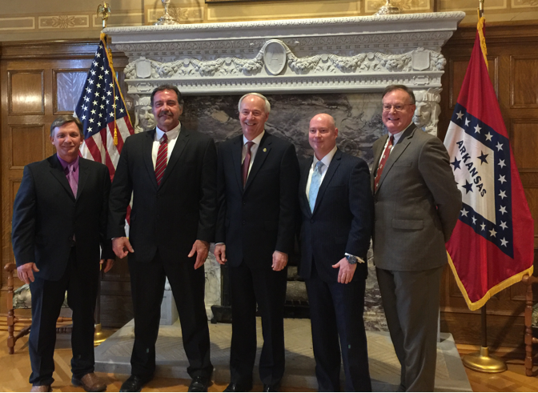
Immediately after signing of the bill into law in the Governor’s office at the Arkansas State Capitol, left to right, State Representative Scott Baltz, State Representative Joe Ferrer, Arkansas Governor Asa Hutchinson, Morgan Pile, and Dr. David Harshfield M.D. (Medical Director Arkansas Institute of Regenerative Medicine, Chairman International Cellular Medicine Society IRB and member AAOM Board of Directors).
Little Rock, ARK, April 10, 2017: The Emerging Therapies Act of 2017 was signed into law by Governor Asa Hutchinson today, granting pilot access to State Employees and Teachers on their health care plans to Regenerative Injection Therapies (RIT) as a treatment of orthopedic conditions. Arkansas now leads the country as the first state to adopt a policy to include these emerging therapies in state employee health insurance.
“This could potentially save the state $100 Million using regenerative medicine as an alternative to surgery or pharmaceuticals for orthopedic conditions.” states Morgan Pile, who worked with HB2014 sponsors Senator David Sanders, Rep Joe Farrer and Rep Scott Baltz to bring the opportunity to the state. “Regenerative Injection Therapies like Platelet Rich Plasma (PRP), Bone Marrow Aspirate Concentrate (BMAC) and Amniotic tissue have been shown to be effective treatments with up to an 80% savings of surgical costs with virtually absent complications.”
Representative Scott Baltz has personal experience with these therapies, as his wife was advised that a surgical intervention might not provide more than 2 years’ relief of her symptoms, and could ultimately leave her with worse symptoms than she had been experiencing. The Baltz family elected to use Regenerative Injection Therapy (RIT) instead of a surgical procedure, and 4 years later she is still experiencing relief that allows her to raise her grandchildren and resume normal activities of daily life. Representative Baltz realized that RIT was “something that could help other Arkansans if insurance would cover it.” His wife testified to the Employee Benefits Division (EBD) about the merits of this emerging therapy in 2014. In the amended bill, the Employee Benefits Division will conduct a pilot study for state employees and teachers’ health plans. The EBD will set up the parameters of the study including assuring that only certified providers, settings and applications will be available for reimbursement under the health plan. At the end of 2018, the full study results will be reviewed with a goal of providing all insured Arkansans access to these therapies.
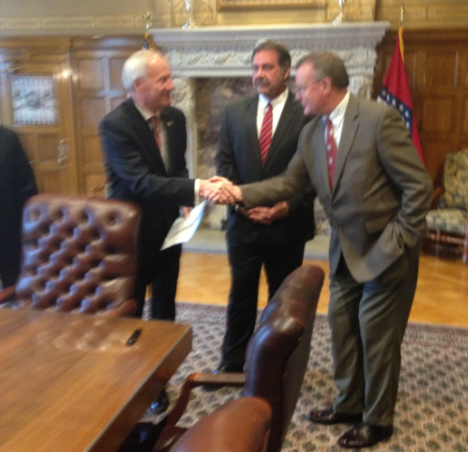
Dr. David L. Harshfield, Jr. is a pioneer in regenerative cellular therapy. He believes that Regenerative Medicine allows us to move away from the existing Allopathic medicine (M.D.) model, where a physician must match a diagnosis to only a binary, pharmaceutical or surgical solution. Instead, Regenerative Medicine is leading the “correction of medicine” by focusing on safe, effective and less costly patient and family centered regenerative medical solutions. With the transition to a value-based healthcare model, and an industry ripe with ineffective ‘group think’ solutions, Regenerative Medicine will continue to grow in importance.
Consider the possibilities- if we can fix our health care system, we will not only have an enormous positive impact on the health of Americans, we will also take pressure off our country’s struggling economy. In the U.S., nearly 20% of our budget is spent on health care (first in the world) and yet our patient outcomes rank nearly last in the industrialized world. The reason is that the Medical-Industrial complex is controlling the debate, and the ‘group think’ is simply to improve the efficiency and speed of performing the same old surgical procedures and pharmaceutical regimens. Add to that, the current U.S. system is based on ‘acute care’ mind set (emergencies, heart attacks, broken bones, etc.) which does not translate well into dealing with chronic diseases (diabetes, obesity, Alzheimer disease, cancer, etc.) or problems associated with normal aging. Regenerative medicine can treat both acute and chronic problems and is more safe and effective at only a fraction of the cost of the existing “standard of care”.

We must be cognizant of the words we use in the discussion about our health care system. As Mark Twain said, ‘the difference in the right word and the not so right word is the difference in the lightening bug and the lightening’. The fact is that we do not have a ‘health’ care system in this country, we have a ‘sick’ care system. And until now, there have been no financial incentives for wellness care. In fact, the U.S. is facing a devastating drug addiction problem that was caused by the misconception that drugs are somehow the universal answer to our health issues. The current iteration of Regenerative Medicine is based on decades old, safe and effective procedures, in most cases eliminating dangerous pharmaceuticals as well as unnecessary and ineffective surgical procedures. As patients become increasingly connected via the internet and social media they grow more dissatisfied with the status quo ‘health’ care system in favor of our functional regenerative medicine solutions that are patient centered, family friendly, safe and effective.
To that end, the State of Arkansas will now give patients a choice beyond drugs or surgery. To get this into perspective, let’s all step back and remember that we are not ‘man-made’, and thus no ‘man’ can heal us. Physicians must admit to patients that we are only ‘men’ and as such, we can only help patients heal themselves. With Regenerative Medicine, physicians are given the tools to help patients restore their health by utilizing the natural healing responses found within the body. And to achieve true “patient centered” health care, the physician needs to step out of the center of the circle and place the patient in their rightful position. And although we should have made this correction of Medicine long ago, as T. Boone Pickens said. ‘the second-best time to do something is right now”.
Dr. Harshfield, an Interventional Radiologist with specialization in musculoskeletal radiology and cellular medicine, has been exploring autologous (patient’s own) adult stem cells since graduating from the University of Arkansas Medical School with Honors in 1981 and has become a leader in cellular restoration. Dr. Harshfield, Medical Director for the Arkansas Institute of Regenerative Medicine, brings his expertise in cellular therapy to treat a variety of conditions without expensive, often dangerous surgery and pharmaceuticals to improve outcomes while reducing recovery and rehabilitation time.
And last but certainly not least, unlike pharmaceutical and surgical options, few serious adverse events (SAE) have been associated with regenerative therapies when administered by credentialed physicians utilizing certified protocols (conditions mandated by The Emerging Therapies Act of 2017).
The passage of this bill is not only good for Arkansans; ultimately the concept of Regenerative Medicine will spread across all 50 states and will be an enormous benefit for all Americans.
AAOM STATEMENT / PRESS RELEASE --- 4/10/2017
Thomas K. Bond, M.D., M.S.- President Elect of AAOM issued in a statement.
As the world’s oldest educational organization dedicated to teaching Interventional Regenerative Orthopedic Medicine (IROM), whose mission has been the advancement and increased availability of these regenerative techniques to patients universally, the American Association of Orthopaedic Medicine (AAOM) is honored and proud to be a facilitator for this landmark legislation. The “Emerging Therapy Act of 2017” in Arkansas, is revolutionary in

both vision and scope. Its implementation will forge a new path in healthcare delivery, and the AAOM is inspired by as well as committed to its success going forward. The AAOM has the resources to administer training and educational programs for physicians who desire to become credentialed providers of Interventional Regenerative Orthopedic Medicine (IROM) in the state of Arkansas and around the world.
ICMS STATEMENT / PRESS RELEASE --- 4/10/2017
David L. Harshfield M.D., M.S.- Chairman ICSM Institutional Review Board
Founded in 2003, it is the mission of the International Cellular Medicine Society (ICMS) to advance the field of adult cell based medicine through a steadfast dedication to developing international best practice standards that ensure patient safety, facilitate physician education, and necessitate peer oversight.
The International Cellular Medicine Society (ICMS) is a 501c3 non-profit that represents doctors, researchers and patients from over 35 countries and 6 continents who are dedicated to advancement of adult stem cell medicine.
Our society strives to be the primary provider of unbiased, objective information regarding the medical use of autologous adult stem cells. Through the publication of best practice standards, the operation of a comprehensive stem cell patient treatment registry, and the provision of an international Institutional Review Board, the ICMS is working to evidence the safety of these innovative therapies. The ICMS can help certify the clinics and approve the protocols for physicians who wish to provide Regenerative medical therapies in the state of Arkansas and around the world.
Agility Center Orthopedics in Bentonville, Arkansas/ PRESS RELEASE
Dr. Christopher Dougherty, Orthopedic Surgeon
“Arkansas has always been a leader in medical innovation. This is a major step forward for healthcare in our state.” Dr. Christopher Dougherty, orthopedic surgeon at Agility Center Orthopedics in Bentonville said. “The opportunity to offer non-surgical solutions for an injury that formerly may have required surgery is both a time and money saver for the patient and society as a whole.”

