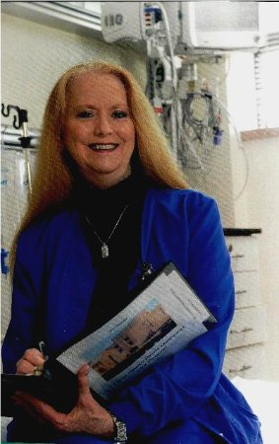

ICU Diary: Providing the Critically-ILL Patient a Retrospective Path to Psychological Recovery
Name: Judy J Martin-Morgan MSN BSN RN CPC
University of Phoenix, Arizona, USA
Forty to fifty percent of patients who are critically ill and on the ventilator 3 days or longer, will experience post-traumatic stress disorder (Zarbano, 2016). A pilot study was conducted with the purpose of introducing the use of the ICU diary within the Intensive Care Unit (ICU) located in the USA. While the ICU diary has been widely used throughout Europe since the 1980’s, the United States health care system has been hesitant to use this tool. The participants in this evidenced-based practice (EBP) study were ICU patients who were on the ventilator for 24 hours. The psychological problems experienced by the critically ill patient has been attributed to delusional memories and gaps in the patients’ memories as to what happened to them while they were in the ICU. The diary fills in the blanks and provides the patient a first-hand written report of what really happened to them. Pictures were taken of the patient on the ventilator, providing a base-line measurement of how sick they had been, while providing a retrospective documented path of their physical and psychological recovery.
The participants in this study were critically ill and sedated, and unable to give consent. The primary support person was approached by Martin-Morgan PI (principle investigator) to obtain consent to implement an ICU diary designed to help the patient understand what happened to them while they were critically ill. The photographs provided the patient a visual recording of how sick they had been and the progress they had made.
Biography
Martin-Morgan has been a registered nurse for 20 years, working within the intensive care setting for the last 18 years. She is a certified profession coach, Master NLP Practitioner, and certified emotional intelligence coach. She attended University of Phoenix working toward her Doctorate of Management in Organizational Leadership all but dissertation. She serves on the board of directors for GSI – Guardianship Services and is a volunteer on the Denton Medical Services local disaster relief organization.
Presenting Author Details
Full Name: Judy J Martin-Morgan
Contact number: 210 393-7852
Email address: jjmartinrn@yahoo.com

