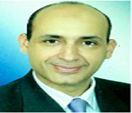
Ayman Sameh Nabawi
Alexandria University
Egypt
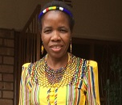
Azwihangwisi Helen
University of South Africa
South Africa
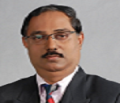
Sathappan Subramanian
Cyberjaya University
Malaysia
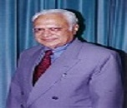
Shyam Parashar
King Faisal University
Saudi Arabia
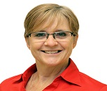
Lorraine Mclnnis
Cleveland Clinic
UAE
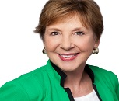
Candace Campbell
University of San Francisco
USA

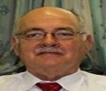
Guy A Richards
University Of Witwatersrand
South Africa

Matina Kampra
National & Kapodistrian University of Athens
Greece

