

Rohini Mehta
American college of Nursing USA


Martin Egerth
Lufthansa Aviation Training Germany
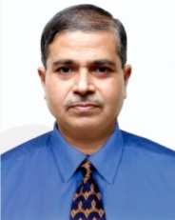

Dr.S M Motahar Hossain
Directorate General of Medical Service Dhaka Cantonment Bangladesh
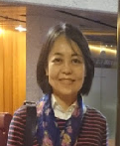

Mirva Kolonen
University in Tampere Finland


Sari Himanen
University in Tampere Finland


Dr Damien Byas
President North American Scientific Committee on Cardiovascular Health USA


Dr Matthias Muenzberg
Univerity of Heidelberg Germany

