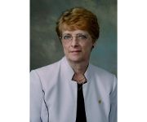

Marlene M Rosenkoetter
Georgia Regents University, USA


Steve Smith
Robert Gordon University Aberdeen., UK


Sek Ying Chair
Director and Professor The Nethersole School of Nursing, Hong Kong


Jelena Roganovic
Hematology and Oncology School of Medicine , Croatia


Xiao-hua Wang
Director of Medical Nursing Soochow University , China


Kathleen R. Stevens
Professor and Director Improvement Science Research Network, USA
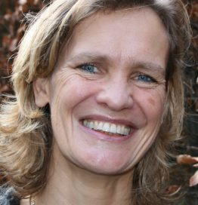

Petra Boersma
Inholland University of Applied Sciences, Department of nursing, Netherlands
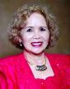

Rose E. Constantino
University of Pittsburgh, USA


Federico Calixtro
Roseman University of Health Science, USA
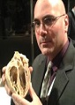

Dave Fornell
Editor Diagnostic and Interventional Cardiology , USA


Heather J. Sobko
University of Utah College of Nursing Salt Lake City,Utah, USA


Ratanaporn Yontrakul
Director at Mahasarakham Hospital, Thailand


Jill M. Berg
President & Dean Columbia College of Nursing, USA


Gordon Fung
Professor UCSF School of Medicine , USA
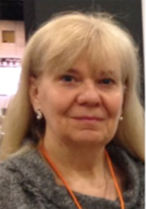

U. Margaretha Wallon
Lankenau Institute for Medical Research, USA


Wicharn Poolnjern
Prapokklao Hospital, Thailand


Sharon Decker
Chair Texas Tech University Health Sciences Center USA, USA


John C Lewin
President and CEO Cardiovascular Research Foundation , USA
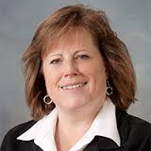

Ronda Hughes
Associate professor Marquette University, USA


Michele Nanna
Associate Clinical Professor Albert Einstein College of Medicine , USA
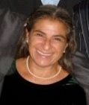

Pam Bellefeuille
Clinical professor University of California , USA


Luigi Gianturco
Assistant Director Istituto Ortopedico Galeazzi, Italy
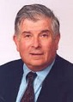

Stephen F. Vatner
Director Cardiovascular Research Institute , USA


Sidney Chocron
Cardiac Surgeon University Hospital of Besancon , France


Dominique Letourneau
President, Director, Associate Professor Créteil University, France
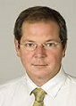

Louis P. Perrault
Doctor,Surgery Department Montreal Heart Institute , USA


Debra A. Simons
Associate Dean, Associate Professor The College of New Rochelle , USA


Andi Mabhala
Senior research fellow Programme Leader Senior Lecturer Newman University, UK


Dennis C. Stevens
Professor and Interim Chairman Sanford School of Medicine, USA


Debra M. Wolf
Associate Professor, Assistant Director Chatham University , USA
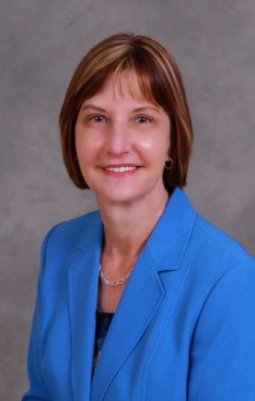

Janet H. Davis
Purdue University Northwest College of Nursing, USA


Angela Opsahl
Indiana University School of Nursing, USA, USA

Angela Opsahl
Indiana University School of Nursing, USA


Danuta M. Wojnar
Seattle University, College of Nursing , USA


Dr. Mouhanad Hammami
County Health Officer & Chief of Health Operations Health and Human Services Wayne County, USA


Wala Maaitah
Friedrich Schiller University Jena, Germany


Katie Hooven
The College of New Jerseyx, USA
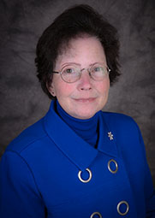

M. Kathleen Murphy
University of Texas Medical Branch , USA


Josée Bonneau
Ingram Schhol of Nursing, McGill University, Canada


Sally Doshier
Northern Arizona University , USA


Marie F Gerdtz
University of Melbourne, Australia


Shari Dingle Costantini
CEO of Avant, USA


Nebahat Bora Güneş
Hacettepe University , Turkey
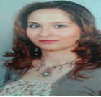

Aylin Güneş
KIRIKKALE UNIVERSITY, Turkey
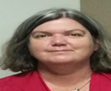

Amanda Charles
Risk Manager at Austin Health, Heidelberg, Australia


Susan Gledhill
Australian Catholic University , Australia


Annie Lau
Robert Gordon University School of Nursing and Midwifery, UK
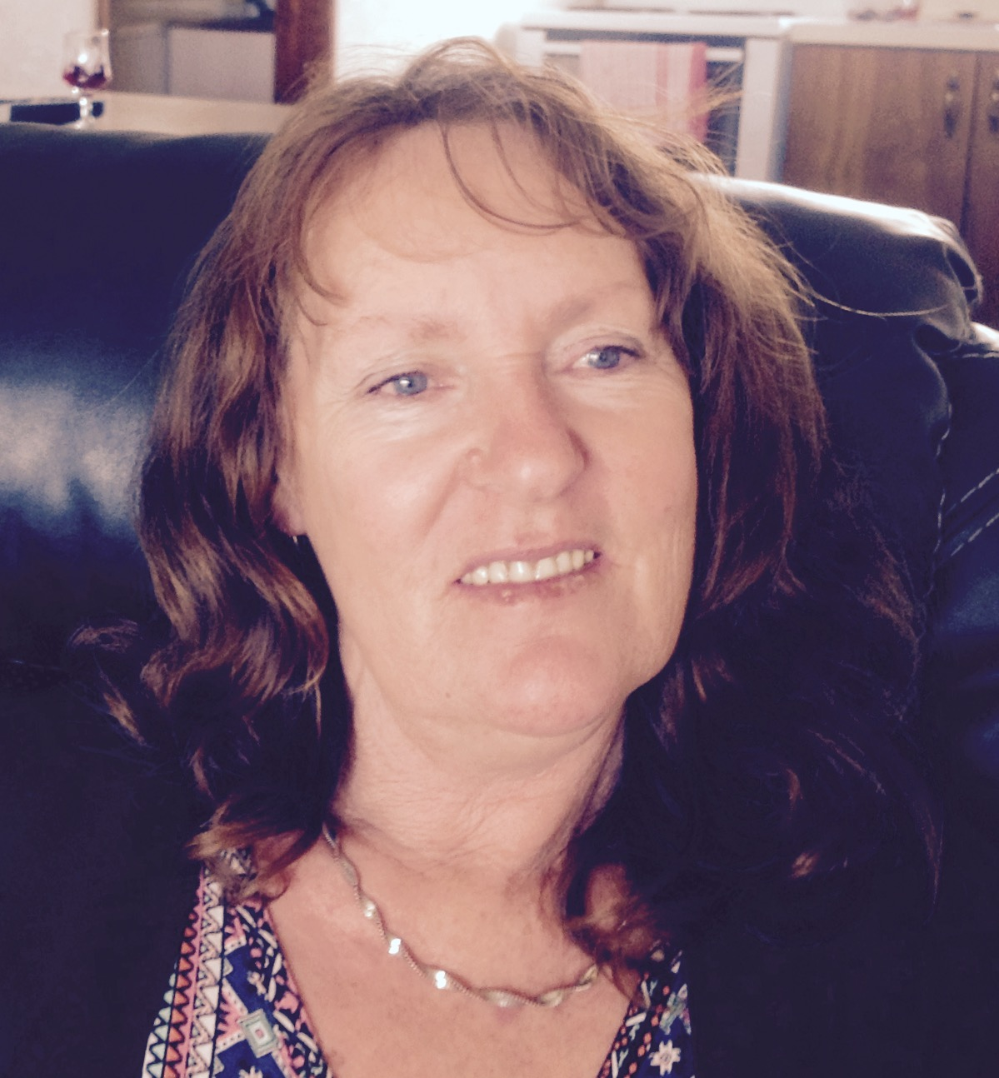

Nancy McNarma
Central Queensland University, New Zealand


Ian Dove
University of Hertfordshire, UK
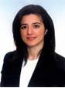

Emine ŞENYUVA
Istanbul University Florence Nightingale, Turkey


Max Bishop
Director of Clinical Simulation, USA


Gregory M Christman
University of Florida, USA


Debasis Bagchi
Cepham Research Center, USA
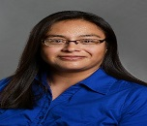

Ninive Sanchez
University of Missouri-Columbia, USA


Willy Aasebo
Akershus University Hospital, Norway


Yuko Harding
Japanese Red Cross Toyota College Of Nursing, Japan


Hiba Abdel Aziz
Northeast Ohio Medical University, USA


Claudia M.Elsig
Calda Clinic, Switzerland


Dimitrios Karakitsos
Keck medical school USC(University of Southern California), USA


Lynne Moore
Laval University in Quebec City, , Canada


Cuong Tran Chi
University of Medicine and Pharmacy at HCM city, Vietnam


Tim Collins
Teleflex Medical, UK


Awaneesh Katiyar
Institute of Medical Sciences , India

Heather J. Sobko
Utah College of Nursing, USA


Lobel A Lurie
Cone Health, USA


Alessandra Falco
University of Padova, Italy
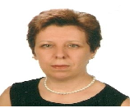

Hülya KAYA
Istanbul University Florence Nightingale Nursing Faculty, Turkey


Chris Gaul
Nelson Marlbourough Institute of Technology, New Zealand
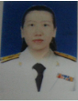

Benyapa Thitimapong
Prince of Songkla University, Thailand


Alessandro De-Carlo
LUMSA University, Iceland


Pataraporn Kheawwan
King Chulalongkorn Memorial Hospital , Thailand
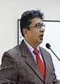

Mohammed Yunus
NEIGRIHMS, India
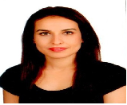

Nil Kucuk Yuceyurt
Istanbul University Florence Nightingale Nursing Faculty, Turkey


Chanya Thanomlikhit
King Chulalongkorn Memorial Hospital, Thailand


Andreas Fette
University of Pecs, Hungary


Samonnan Thasaneesuwan
Prince of Songkla University, Thailand


Melanie Berube
McGill University, Canada


Karen McCutcheon
Queen’s University Belfast , Ireland
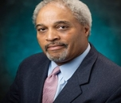

John M. Flack
Southern Illinois University School of Medicine , USA


Jean-Bernard Durand
University of Texas USA, USA


Peter Norrie
Chief Psychiatrist, USA


Clare Henn-Haase
National University of New York Medical Center, USA / National University of Singapore , Singapore


Ping-I (Daniel) Lin
Cincinnati Children’s Hospital Medical Center, USA


Tran Quynh Nhu
University of Tokyo, Japan


Julie M. Pullen
Montana State University, USA, USA


Shridevi Pandya Shah
Rutgers University, USA


Claudia Benkwitz
Vanderbilt University, USA


Christy Cotner
California Baptist University, USA, USA


Jinu Varghese
University of Brimingham, UK


Arne Rehnsfeldt
Western Norway University of Applied Sciences , Norway


Cathy Dickson
Western Sydney University, Australia


Maria Bohus
University Of Toronto, Canada
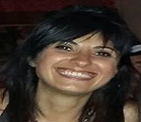

Anna Bocchino
Salus Infirmorum University school of Nursing, Spain


Madara Blumberga
Children University Hospital , Latvia
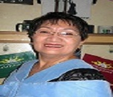

Florminda B Tejano
Holy Child Colleges of Butuan Hospital , Philippines


Laura Odom
University of Tennessee College of Nursing, USA


Alejandro Berenstein
Icahn School of Medicine at Mount Sinai, USA


Angelica Marie B. Pineda
University of the East Ramon Magsaysay Memorial Medical Center, Philippines


Jichuan Wang
Children’s National Medical Center, USA


Amin El Gohary
Burjeel Hospital, UAE
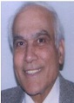

Samir K Ballas
Thomas Jefferson University, USA


Angela Clark
University of Cincinnati, USA


Nuurhidayat Jafar
Hasanuddin University School of Nursing, Indonesia
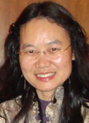

Guang Zeng
Associate Professor Texas A&M University–Corpus Christi , USA


Elizabeth G. NeSmith
Georgia Regents University , USA


Dr. James C. Pace
Associate Dean New York University , USA


Krystal Shelmire
Alternative Natural Health Solutions, LLC, USA


Melissa J. Geist
Tennessee Tech University , USA

