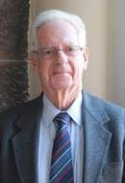
Dennis Bloomfield
Emeritus Professor of Medicine Richmond University Medical Centre, USA
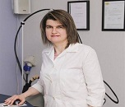
Maria Voyatzi
Aristotle Uninersity of Thessaloniki, Greece

Mark Rosenbloom
LIFEFORCE Medical Institute, USA
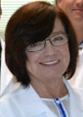
Anna Radominska-Pandya
University of Arkansas for Medical Sciences, USA
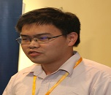
Shuai Zhong
University of Chinese Academy of Sciences, China
China
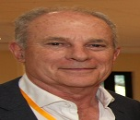
Agustin Coluses
Linde Center for Global Environmental Science, USA
USA
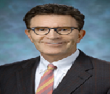
Edward Bernacki
Johns Hopkins University School of Medicine
USA

Nimisha Kalia
Johns Hopkins University School of Medicine
USA
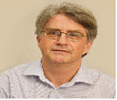
Hermann Fromme
Bavarian Health and Food Safety Authority
Germany

