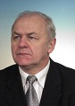

Jerzy Leszek
Wroclaw Medical University, Poland
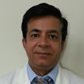

Suresh Kumar
Cognitive Research Institute, USA
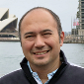

Andres Barboza
Universidad del Aconcagua Argentina
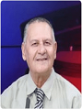

Abdullatif Azab
Eastern Plants Company, Israel
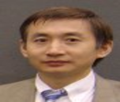

Theodore A Petti
Johns Hopkins University of Medicine, USA
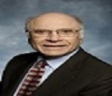

Theodore A Petti
Johnson Medical School, USA
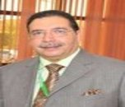

Ahmed Ammar
Dammam University, Saudi Arabia
