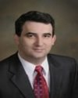
Konstantin Slavin
University of Illinois
USA
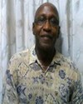
Durodami Lisk
Ministry of Health
USA
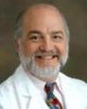
Peter Kaplan
Johns Hopkins University
USA
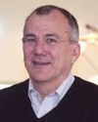
Michael Sofroniew
Department of Neurobiology UCLA School of Medicine
USA
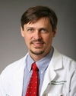
Brent Harris
Georgetown University Medical Center
USA

Milivoj Perat
Academy of Developmental Medicine
Slovenia
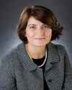
Cigdem Akman
Columbia University
USA

Diana Kljenak
Ontario Psychiatric Association
Canada

Noormamode Youssouf
Edycs Epilepsy Group
Mauritania

Kevin Thomas
University of Capetown
USA

Deepa Vinoo
New York City Health+Hospitals
USA

Kostas N Fountoulakis
World Psychiatric Association University of Thessaloniki
Greece
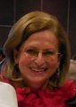
Ljudmila Stojanovich
Belgrade University
Serbia

Martin Correa
University Rovira i Virigili
Spain
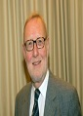
Norbert Muller
Psychiatry and Psychotherapy Ludwig-Maximilians-University
Germany

Peter Vlerick
Ghent University
Belgium

Crisanto Diez-Quevedo
University Autonoma de Barcelona
Spain

