 Alvin SmuckerMichigan State University, USA
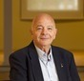Ilan ChetHebrew University of Jerusalem, Israel
Nasir S. A. MalikResearch Plant Physiologist USDA-ARS , USA
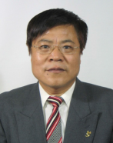
Jiang Gaoming, The Chines Academy of Science, China



Byoung Ryong Jeong, Gyeongsang National University, South Korea
 Bernard Omodei Measured Irrigation, Australia
 Timo Wulfmeyer, R-Biopharm AG, Germany.
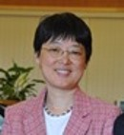Grace Chen, U.S. Department of Agriculture, USA
 Arpad Ambrus, National Food Chain Safety Office, Hungary
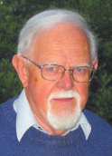 Peter J Leggo, University of Cambridge, UK
Kelly T Morgan, University of Florida, USA
Andy RenzBenson Hill Biosystems Inc. , USA
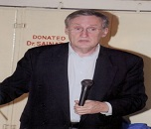Henk-Maarten LaaneMD, ReXil Agro BV, Netherlands
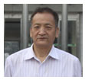Shanghai Institutes for Biological Sciences, China
George Chilingar, University of Southern California, USA
Ahn Ji Whan, Korea insititute of Geoscience and Mineral Resources, Spain
David Crookall , University de Nice Sophia Antipolis, France
Priyasankar Chaudhuri , Tripura University, India

Jose Ramon Barros Cantalice Rural Federal University of Pernambuco, Brazil
Nilwala Kottegoda, University of Sri Jayewardenepura, Sri Lanka
Kalanithi Nesaretnam, Minister, Embassy of Malaysia , Belgium
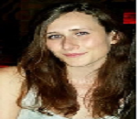Catherine Bowe, Northumbria University, UK
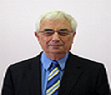Malcolm Elliott, Editor in Chief, Agriculture and Food Security, UK
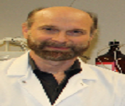 Stan Kubow, McGill University , Canada.
 Jan Kuhlmann, SGS Germany GmbH, Germany
 Nigel G Halford, Rothamsted Research, UK
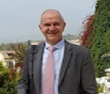 Giancarlo Cravotto, University of Turin , Italy

Jose S. Torrecilla, Complutense University of Madrid , Spain

Sylvia Pfaff, Food Information Service , Germany.

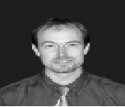 Michael Granvogl , Technical University of Munich, Germany
 Aimee Sheree A. Barrion, University of the Philippines , Philippines
Aimee Sheree A. Barrion, University of the Philippines , Philippines
 Qatar Environment and Energy Research Institute (QEERI) , Qatar
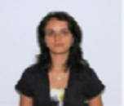 Geana Elisabeta-IrinaNational R&D Institute for Cryogenics and Isotopic Technologies, Romania
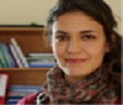 Derya Boyaci Izmir Institute of Technology, Turkey
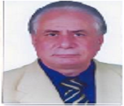 Saad M Magdy, National Research Centre , Egypt
F Ayca Ozdemir Olgun, Istanbul Technical University, Turkey
 Catherine, Northumbria University, UK
 Yong Ho Park, Seoul National University, South Korea
 Jackie Healing, Coles Supermarkets, Australia
Hsiao Ping Lee, Chinese Petroleum Corporation, Taiwan

Sibu C Padmanabhan, University College Cork , Ireland
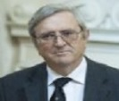 Akos Mesterhazy, Cereal Research non-profit Ltd, Hungary

 Timo Wulfmeyer, R-Biopharm AG, Germany
 Jerzy Radecki, Polish Academy of Science , Poland
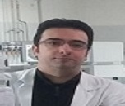
Marco Iammarino, Istituto Zooprofilattico Sperimentale della Puglia e della Basilicata , Italy
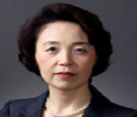Cho-il Kim, Korea Health Industry Development Institute, South Korea
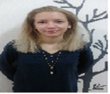
Ana Mornar, University of Zagreb, Croatia

Bárbara Teixeira, Portuguese Institute for the Sea and Atmosphere , Portugal
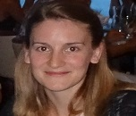 Evamaria Melcher, University of Bonn , Germany
 Maristela Martins Pereira, Federal University of Amazonas , Brazil
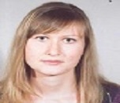
Sarah Zecchin, University of Milan ,Italy


Anisa S. Khan, University of the West Indies , Trinidad and Tobago
 Nitu Kumar, University of the West Indies , Trinidad and Tobago
 Kun Taek Park, Seoul National University, South Korea
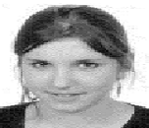 De Boeck Elien, Ghent University , Belgium

Alenka Hmelak Gorenjak, University of Maribor, Slovenia.

Deborah Wortelhock ,Cardiff Metropolitan University South Wales , UK
Ahn Ji Whan, Korea insititute of Geoscience and Mineral Resources, Spain
 Nurgul Kitir, Yeditepe University, Turkey
 Posada R Enrique, INDISA S.A, Colombia
 University of Agricultural Sciences, INDIA
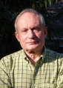 Paul A Comet, Comet Environmental Consulting, USA
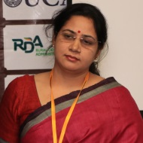 Smita Purohit, IIS University, India
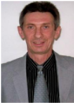 Yuri Yevdokimov, University of New Brunswick, Canada
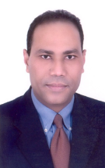
Salah Abdel-Rahman, Genetic Engineering and Biotechnology Research Institute, Egypt
 Ivan S. Belyuchenko, Kuban State Agrarian University, Russia
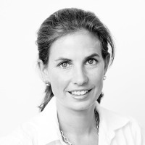 Birgit Steininger, University College for Agrarian and Environmental Pedagogy, Austria
 Ozlem Tokusoglu, Celal Bayar University, Turkey
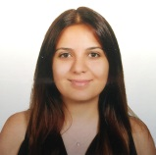 Ahsen Ezel Bildik, Istanbul University, Turkey
 Sanjay Mukherjee, Sheffield Hallam University, UK
 Messaouda Kaci, Lorraine University, France
 Roberto Romaniello, University of Foggia, Italy
 Gulhan Unlu, University of Idaho, USA
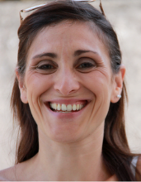
Rosa Palmeri, University of Catania, Italy
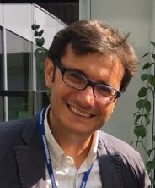 Alessandro Leone, University of Foggia, Italy
 Ursula Wölwer-Rieck, Institute of Nutrition and Food Sciences, Germany
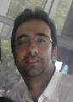 Marco Iammarino, Zooprofilattico Institute of Puglia and Basilicata of Foggia, Italy
 Rosaly V. Manaois, Philippine Rice Research Institute, Philippines


Antonia Tamborrino, University of Bari Aldo Moro, Italy

