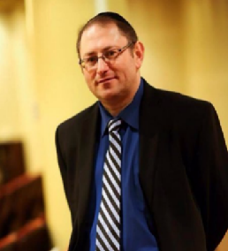
- Max Tokarsky
Founder & CEO of InvestAcure
USA

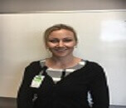
- Kathy Kirby
Kyneton District Health
Australia

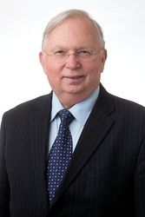

3 Claude M Wischik
TauRx Therapeutics, UK
UK

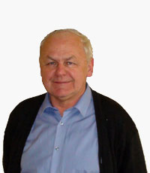

4 Jerzy Leszek
Wroclaw Medical University, Poland
Poland

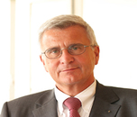
5. Walter E. Muller
University of Frankfurt
Germany

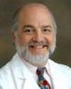

6. Peter Kaplan
Johns Hopkins University
USA

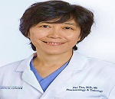
7. Fan Fan
University of Mississippi Medical Center
USA
. 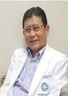
8. Cornelio G. Banaag
Head of Department The Medical City
Philippines

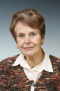

9. Sona Nevsimalova
1st Faculty of Medicine Charles University
Czech Republic


10. Esther Martinez
Universitat Autònoma de Barcelona
Spain


11. Eef Hogervorst
Maastricht University
UK

