Tunisian dietary and Type 2 Diabetes Mellitus: Importance of Macro and Micronutrients in Glucose Homeostasis

Nadia Kheriji^{1,2}, Wided Boukhalfa^{1,2}, Faten Mahjoub³, Meriem Hechmi¹, Thouraya Dakhlaoui⁴, Mehdi Mrad^{2,5}, Afef Hadj Salah Bahlous^{2,5}, Nadia Ben Amor⁶, Henda Jamoussi^{3,6}, Rym Kefi ^{1*}

¹-Laboratory of Biomedical Genomics and Oncogenetics, Institut Pasteur de Tunis, University of Tunis El Manar Tunis, Tunis 1002, Tunisia.
²⁻Faculty of Medicine of Tunis, University of Tunis El Manar, EL Manar I, Tunis 2092, Tunisia.
³⁻National Institute of Nutrition & Food Technology of Tunis, Service “A” of Nutritional Diseases, Tunis 1007, Tunisia.
⁴⁻Regional Association of Diabetics of Zaghouan-Regional Hospital of Zaghouan, Zaghouan 1100, Tunisia.
⁵⁻Laboratory of Clinical Biochemistry and Hormonology, Institut Pasteur de Tunis, Tunis 1002, Tunisia ⁶⁻ Research Unit UR18ES01 on “Obesity”, National Institute of Nutrition and Food Technology, Tunis 2092, Tunisia.
* Correspondence: rym.kefi@pasteur.utm.tn
Abstract
Statement of the problem: The prevalence of Type 2 diabetes (T2D) is increasing worldwide. More than 530 million of adults had diabetes in 2021[1]. Diabetes is usually caused by a combination of genetic and environmental factors [2] including lifestyle and diet [3]. Hence, analyses of macro- and micronutrient intake across global populations may help to explain their impact on glucose homeostasis and disease development [4][5]. The purpose of this study is to conduct a prospective cross-sectional study of daily dietary intake among Tunisian population to determine nutritional components associated with diabetes development and their impact on glucose homeostasis.
Methodology & theoretical orientation: In this study, 420 Tunisians have been enrolled. Various data were collected and blood samples were drawn for biochemical assay. A 24-hour Recall questionnaire (24-HR) was obtained from participants to evaluate dietary intake. Statistical analyses were conducted using Nutrilog and R software. Biochemical analyses stratified the studied population (n = 371) into three groups: diabetics (n = 106), prediabetics (n = 192) and controls (n = 73); 49 subjects were excluded.
Findings: Our findings indicated that Tunisian studied cohort consumed hypercaloric diets rich in carbohydrates and fat. Variation in the amounts of some vitamins and minerals, such as riboflavin and niacin were statistically different among groups. A higher risk of T2D was linked to reduced vitamin D intake. Higher vitamin A and sodium intake were associated with poor glucose homeostasis, although protein intake may improve it (Figure 1).
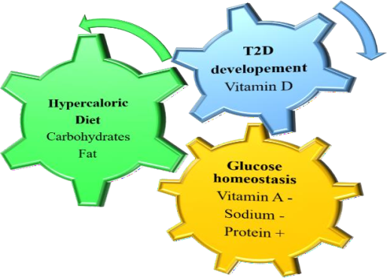
Figure 1: Characteristic of dietary intake among Tunisian studied population and effects of nutrients (macro and micro) on glucose homeostasis and diabetes development. (T2D: Type 2diabetes).

Conclusion: This study is the first of its kind investigating the role of micro and macronutrient intake on glucose homeostasis among Tunisians. Our results will help to establish a National Program for the prevention of diabetes adapted to the nutritional specificities of the Tunisian population. In perspective, it would be interesting to conduct nutrigenomic and nutrigenetic studies in Tunisia.

References
- “IDF Diabetes Atlas 10th Edition.” https://www.diabetesatlas.org/data/en/ (accessed Feb. 08, 2022).
- H. Mizukami and K. Kudoh, “Diversity of pathophysiology in type 2 diabetes shown by islet pathology,”
J. Diabetes Investig., vol. 13, no. 1, pp. 6–13, Jan. 2022, doi: 10.1111/JDI.13679.
- E. Papakonstantinou, C. Oikonomou, G. Nychas, and G. D. Dimitriadis, “Effects of Diet, Lifestyle, Chrononutrition and Alternative Dietary Interventions on Postprandial Glycemia and Insulin Resistance,” Nutr. 2022, Vol. 14, Page 823, vol. 14, no. 4, p. 823, Feb. 2022, doi: 10.3390/NU14040823.
- L. Della Guardia, C. Roggi, and H. Cena, “Diet-induced acidosis and alkali supplementation,” Int. J. Food Sci. Nutr., vol. 67, no. 7, pp. 754–761, 2016, doi: 10.1080/09637486.2016.1198889.
- L. Della Guardia, M. A. Thomas, and H. Cena, “Insulin sensitivity and glucose homeostasis can be influenced by metabolic acid load,” Nutrients, vol. 10, no. 5, pp. 1–17, 2018, doi: 10.3390/nu10050618.

Biography
Nadia KHERIJI is a Tunisian PhD student. She is very interested in scientific research. Mss. Nadia did an applied bachelor's degree in medical biology obtained with honor in 2017 from Higher School of Health Sciences and Techniques of Monastir. Her enthusiasm and scientific curiosity pushed her to do a research master's degree in biomedical sciences. She finished her master's degree in 2019 with honor from Higher School of Health Sciences and Techniques of Tunis. Currently, she is performing her doctoral degree in the Biomedical Genomics and Oncogenetics Laboratory in Institut Pasteur in Tunis under the supervision of Dr. Rym KEFI. Her research project focuses on the study of monogenic forms of diabetes among Tunisian population. She is interested in genomic investigation. She has strong background on analysis of Next generation sequencing data, Whole genome sequencing, Programing (Linux, Plink, and R) and statistical analysis. She attended many international courses and conferences to enhance her capacities in bioinformatics and soft skills. She was involved in the InSPIRES project “Ingenious Science shops to promote Participatory Innovation, Research and Equity in Science”, a societal project funded by Horizon 2020 (grant agreement No 741677). In the frame of this project, she contributed to a sub-project on the study of the epidemiological situation of diabetes in Tunisia and the impact of dietary intake on glucose homeostasis and disease development.

