Scientific Agenda

19th World Nephrology Conference
May 25, 2023 | Singapore

Theme: “Recent advancements of research and treatment in the field of nephrology”
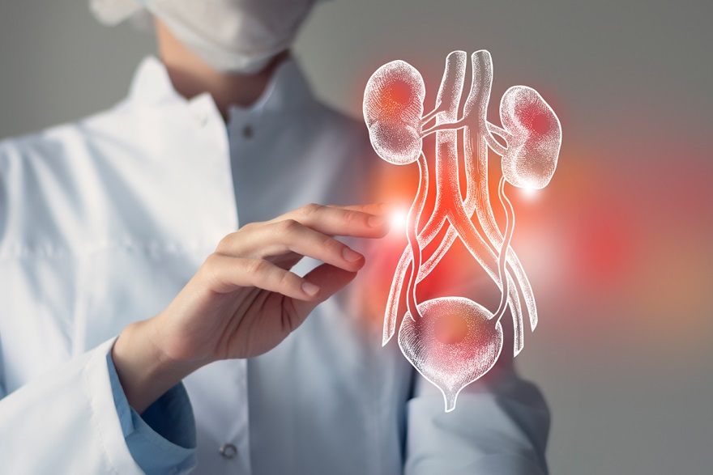

Time | Name | Title
09:00-09:30AM Introduction
Oral Presentations
09:30 AM | Chun-Jung Chien, National Taiwan University, Taiwan | Investigate the Role of Thioredoxin Domain-containing Protein 5 (TXNDC5) in Peritoneal Dialysis-induced Peritoneal Fibrosis
10:00 AM | Boris Ajdinovic, Military Medical Academy, Serbia | Different guidelines for imaging in children with febrile urinary tract infections
10:30 AM | Marie Angeline J. Mora, St. Luke’s Medical Center Quezon City | The Effect of Finerenone in Reducing Disease Progression among patients with Chronic Kidney Disease: A systematic review and Meta-analysis
11:00 AM | Dessalegn Temesgen Leye, AAST UNIVERSITY, ETHIOPIA | Correlation between the Nature of Respiratory Organs Anatomy-physiology exceptionalities and Success in fighting against the Respiratory based Pathogens
11:30 AM | Chia-I Lin, National Cheng Kung University, Taiwan | The association between gut microbiota, metabolome and kidney function decline
12:00 AM | Yu Chi Hung, National Cheng Kung University, Taiwan | Effects of exposure to organophosphate pesticides on renal function and metabolomic signatures of patients with chronic kidney disease
12:30-01:00PM Break
Poster Presentation
01:00 PM | Medhavi Gautam, King George's Medical University, India | Causes and clinical outcome of PRAKI in patients admitted to a tertiary care center of Northern India
01:20 PM | Jasim Jalal, Olive Health Care, India | Covid-19 Vaccination and Myocarditis – Who is the culprit?
01:40 PM | Lauren Shipperbottom, NHS Foundation Trust ,United Kingdom | Diet and environment play an important role in stone disease, presumably by modulating urine composition

