
*
*
D


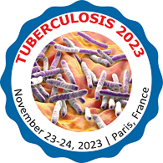
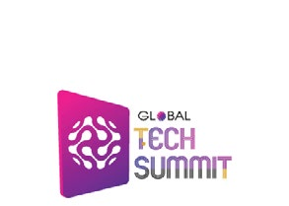
E


GLOBAL
PHARMA SUMMIT SERIES
GLOBAL
HEALTH SUMMIT SERIES

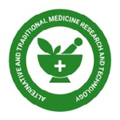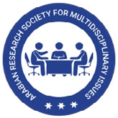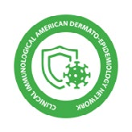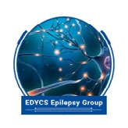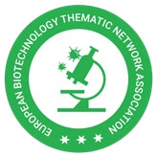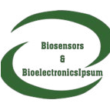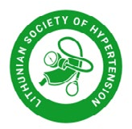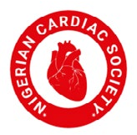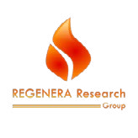
Unleash Your Brilliance: Gain Recognition and Global Exposure at Esteemed G20 Conferences and in Renowned G20 Proceedings

Unleash your potential: Gain recognition and worldwide exposure by presenting your research at prestigious G20 conferences, while enjoying the opportunity to publish in renowned G20 proceedings in multiple global languages. Embrace the flexibility of virtual or in-person presentations
Join us, scholars, scientists, industry professionals, and physicians, in shaping the future of affordable healthcare and medicine. Unleash your impact and be rewarded for your scientific, healthcare, and technological services through the prestigious G20 Event series and G20 Proceedings Publication.
Embarking on a global journey of innovation, the Abstract Submission and Presentation Guidelines set the stage for the prestigious Global Tech20 Summit, Pharma20 Summit, G20 Health20 Summit, and a selection of other remarkable conferences. These grand events transcend borders and time, captivating the world’s attention in captivating cities such as New York City, London, Tokyo, Paris, Los Angeles, Istanbul, Shanghai, Beijing, Moscow, Sao Paulo, Cairo, Mexico City, Hyderabad, Chennai, New Delhi, Vizag, Sydney, Rio de Janeiro, Buenos Aires, Johannesburg, Dubai, Rome, Seoul, Amsterdam, Toronto, Hong Kong, Singapore, Berlin, Madrid, Kuala Lumpur, Bangkok, Vancouver, San Francisco, Chicago, Abu Dhabi, Barcelona, Washington D.C., Istanbul, Osaka, Prague, Milan, Jakarta, Stockholm, Copenhagen, Vienna, Athens, Warsaw, Helsinki, Brus- sels, Lisbon, Budapest, Dublin, Auckland, and Edinburgh. Unfolding throughout the year, these vibrant gatherings not only offer in-person experi- ences but also embrace the limitless possibilities of online participation. We may change or choose a nearby venue in the respective city depending on availability and cost constraints. These details will be showcased regularly on the websites at least 30 days in advance.
The abstract submission and presentation guidelines are crucial for ensuring a fair and standardized evaluation process for award nominations. These guidelines provide a framework for applicants to effectively showcase their work and for selection committees to assess their qualifications. Here are ten comprehensive guidelines to help applicants prepare their abstracts and presentations.
- Word Limit and Biography: The abstract should not exceed 1000 words, with a minimum of 200 words, while the biography should be within 200 words (minimum 50 words). Adhering to these limits allows for concise yet comprehensive submissions.
- Images and Publications: Applicants can include a maximum of three images, including their own photography. Additionally, they should provide a list of recent and relevant publications, ranging from a minimum of five to a maximum of 10. These references demonstrate the applicant’s knowledge and expertise.
- Abstract Structure and Formatting: The abstract should be well-structured with clear headings and subheadings, facilitating easy navigation through different sections. Applicants must follow specified formatting guidelines for font size, margins, and spacing to ensure consistency and readability.
- Content Clarity and Objectives: The abstract should clearly convey the research or project’s objectives in a concise and understandable manner. The methodology employed, including any innovative approaches, should be highlighted, and the results presented with relevant data and statistical analysis.
- Significance to the Award: Applicants must emphasize how their work aligns with the objectives and criteria of the specific award. It is essential to highlight how the research or project addresses the challenges or advancements sought by the awarding organization.
- Language and Style: The abstract should be written in clear and concise language, avoiding technical jargon that may hinder understanding.Proofreadingiscrucialtoeliminategrammaticalandspellingerrors,ensuringapolishedandprofessionalpresentation.Engagingand captivating writing style helps convey the applicant’s enthusiasm and passion for their work.
- Presentation Guidelines: In addition to the abstract, applicants may be required to prepare a presentation that further elaborates on their research or project. Specific guidelines will be provided, including the format (e.g., oral or poster presentation), time limit, and content requirements. The presentation should effectively communicate key findings and implications.
- Review and Evaluation: An expert panel or jury will review and evaluate the abstracts and presentations based on factors such as scientific rigor, innovation, clarity of communication, and potential for practical applications. The guidelines ensure a consistent and fair evaluation process.

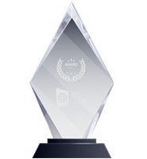
Best Research Scholar
The Best Research Scholar award is a renowned honor presented to persons who have made substantial research contributions to their profession. This award honors researchers who have made major contributions to their
discipline and have exhibited excellence pursuits of research. The award is frequently bestowed upon persons who have made major contributions to the academic community via their research, and it is seen as a mark of acknowledgment and esteem within the academic community.

9. Conference Presentations: Successful candidates will be invited to present at respective pre-conferences, Global Tech20 Summits, Pharma20 Summits, G20 Health20 Summits, and other conferences held in major global cities throughout the year. Alternatively, online presentations may be arranged. A registration fee of $399 USD will be required to cover conference costs.

10. Publication and Proceedings: Accepted presentations will be published in a reputed journal with a nominal publication cost of approximately from $999 USD to $1999 USD depending on the journal of publication. This allows for wider dissemination of the research and contributes to the applicant’s academic and professional recognition
Abstract Submission and Presentation Guidelines serve as a guiding light, illuminating the path for talented individuals to showcase their brilliance. As they navigate the captivating cities and engage in the exchange of knowledge, these guidelines ensure that excellence prevails, leaving an indelible mark on the global landscape of innovation.
Be a Part of the Distinguished G20 Community, Showcasing Your Research and Gaining Recognition in Global Conferences and Proceedings
For details on the list of venues and dates, please visit
https://www.globaltechsummit.com | https://www.20summit.com | https://www.conferenceseries.com/

Be a Part of the Distinguished G20 Community, Showcasing Your Research and Gaining Recognition in Global Conferences and Proceedings
We extend a cordial invitation to scholars, scientists, and physicians to actively participate in an endeavor that holds the potential to shape the future of affordable healthcare and medicine. Your invaluable research can make a remarkable impact in these vital areas.
We invite you to submit your research for presentation and publication in prestigious platforms such as the G20 Affordable and Accessible Health- care Summit series, Global Tech20 Summits, Pharma20 Summit series working group meetings, Pharma20 Summit series, digital health, and the esteemed G20 conference proceedings publications. By joining this distinguished community, you have the opportunity to earn recognition for your work while contributing to the esteemed G20 proceedings.
We seek research that focuses on promoting affordable and accessible healthcare, accessible medicine, and the practical application of your find- ings in the domains of science, technology, and medicine. This is an excellent opportunity to present your selected abstracts at the designated G20 conferences or through virtual presentations. Following these presentations, your work will be featured in the renowned G20 conference proceed- ings publication.
This is an excellent opportunity to present your selected abstracts at the designated G20 conferences or through virtual presentations. Following these presentations, your work will be featured in the renowned G20 conference proceedings publication.
We eagerly anticipate your participation and the valuable insights you will bring to this exceptional platform. Together, we can make significant strides in advancing affordable healthcare and medicine, ensuring their accessibility to all.
Regardless of Physical Presence, Showcase Your Work and Get Published in the G20 Event Series Proceedings, Available in Global 20 Languages
In the event that unforeseen circumstances prevent your physical presence at these events, we are pleased to offer a virtual presentation opportunity, ensuring that your work is still showcased. Additionally, your abstracts and articles will be published in the G20 event series proceedings, available in selected global 20 languages, and we will personally send your well-deserved award memento and reward certificate to your designated address.
READY TO BE INSPRIED
From visionary advice to motivating insights at the Global Tech Summit
Catch up with out Award Winners and hear about the Future to Technology, where Science, Ideas, and Innovation meet Technology

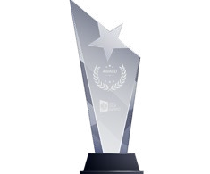
Academic and Research Excellence
This award honors those who have excelled in their academic and research endeavors and have made significant contributions to the development of knowledge in their profession. The award is frequently bestowed
upon persons who have made major contributions to the academic community via their research and teaching, and it is typically seen as a mark of acknowledgment and respect within the academic community. It is a distinguished award that recognizes the devotion and hard work of people who have committed their careers to expanding knowledge and understanding.

Award of Research Excellence
Individuals who have made substantial contributions to their area via study are recognized with the Award of Research Excellence. This award celebrates research excellence and the hard work and devotion
of researchers who have committed their lives to the advancement of knowledge and understanding. It is a prominent accolade bestowed upon persons who have made major contributions to the academic community via their research, and it is regarded as a mark of acknowledgment and respect within the academic community.

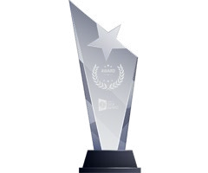
Best Research Paper Citation
The Best Research Paper Citation honors research publications that have been frequently cited by other scholars in their own work. This prize acknowledges research publications that have made substantial contributions to their
discipline and had an influence on the academic community. Papers that earn this honor are usually regarded as significant contributions to the area and are widely referenced as a source of information or as a point of reference in other research.


Young Faculty Award
The Young Faculty Award is a renowned accolade bestowed on young faculty members who demonstrate remarkable promise in research and teaching. The award is often presented to early career faculty members who
have already made major contributions to their discipline and have the potential to make even larger achievements in the future. Award winners get a stipend to help their research and professional growth, as well as acknowledgment and exposure within the academic community. The prize is competitive, and it is frequently seen as a stepping stone to even greater achievement in academics. It is an excellent chance for young faculty members to enhance their careers and have a good effect on their profession.

Outstanding Research Award
The Outstanding Scientific Award is a distinguished award awarded to persons who have made substantial research contributions to their profession. This award celebrates research excellence and the hard work and
devotion of researchers who have committed their lives to the advancement of knowledge and understanding. It is a prominent accolade bestowed upon persons who have made major contributions to the academic community via their research, and it is regarded as a mark of acknowledgment and respect within the academic community.

Open Research Award
The Open Research Award recognizes people or organizations that have made major contributions to the open research movement. Open research is the practise of making research results, including data, techniques, and
materials, available to the public in order to improve research openness and reproducibility. Individuals or organizations who have exhibited a dedication to open research principles and practices and have made substantial contributions to the open research community are recognized with the Open Research Award.


Best Speaker Award
The Best Speaker Award is a prestigious honor bestowed upon individuals who demonstrate exceptional speaking prowess. It recognizes their ability to command a stage, captivate audiences, and deliver impactful presentations. These
outstanding speakers possess impeccable communication skills, articulate their ideas with clarity, and engage listeners with their passion and charisma. Their ability to connect emotionally, inspire, and influence others sets them apart as extraordinary communicators. The Best Speaker Award acknowledges their remarkable talent and contribution to the art of public speaking, elevating them as shining examples in their field.

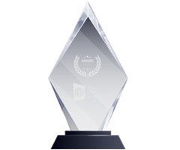
Best Keynote Speaker Award
The Best Keynote Speaker Award is a coveted accolade honoring individuals who excel in delivering impactful and influential keynote speeches. Recognizing their ability to engage, inspire, and motivate audiences, this award
celebrates their exceptional storytelling, persuasive communication, and profound insights. These outstanding speakers captivate listeners with their unique blend of charisma, knowledge, and stage presence, leaving a lasting impact on attendees. The Best Keynote Speaker Award serves as a testament to their ability to set the tone, inspire change, and deliver memorable experiences that resonate long after the event.

Best Track Wise Speaker Award
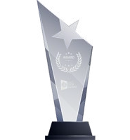
Introducing the prestigious Best Track Wise Speaker Award, celebrating exceptional speakers who captivate audiences with their eloquence and knowledge. This coveted accolade recognizes individuals who possess
remarkable communication skills and a deep understanding of their subject matter. From engaging keynotes to thought- provoking presentations, these trailblazers inspire and inform with every word. The Best Track Wise Speaker Award honors those who have mastered the art of effective communication, leaving a lasting impact on their listeners.



UPCOMING GLOBAL TECH SUMMITS 2023


Global Tech Summit - Saudi Arabia
July 17-18, 2023 | Riyadh, Saudi Arabia
Global Tech Summit - Republic of Korea
Aug 21-22, 2023 | Seoul, Republic of Korea


Global Tech Summit - USA
July 24-25, 2023 | New York, USA
Global Tech Summit - China
Aug 28-29, 2023 | Beijing, China


Global Tech Summit - Japan
July 24-25, 2023 | New York, USA
Global Tech Summit - France
Aug 31 - Sep 01, 2023 | Rome, Italy

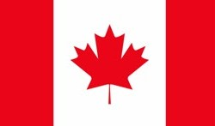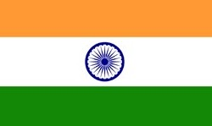
Global Tech Summit - Canada
Aug 07-08, 2023 | Toronto, Canada
Global Tech Summit - India
Sep 01-02, 2023 | Vizag, India


Global Tech Summit - Australia
Aug 17-18, 2023 | Melbourn, Australia
Global Tech Summit - United Kingdom
Sep 04-05, 2023 | London, United Kingdom

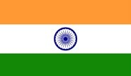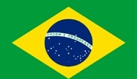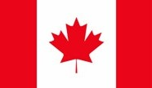
UPCOMING GLOBAL - PHARMA AND HEALTH SUMMITS 2023
Oct 02-03, 2023 | Frankfurt, Germany
Nov 13-14, 2023 | Paris, France
Oct 09-10, 2023 | Tokyo, Japan
Nov 20-21, 2023 | Melbourne, Australia
Oct 09-10, 2023 | Buenos Aires, Argentina
Nov 20-21, 2023 | Vizag, India
Oct 16-17, 2023 | Mexico City, Mexico
Nov 27-28, 2023 | Sao Paulo, Brazil
Oct 16-17, 2023 | Toronto, Canada
Nov 27-28, 2023 | Bali, Indonesia
Oct 23-24, 2023 | Beijing, China
Dec 04-05, 2023 | Moscow, Russia
Oct 23-24, 2023 | New York, USA
Dec 04-05, 2023 | Seoul, Republic of Korea

Dec 11-12, 2023 | Istanbul, Turkey
Oct 30-31, 2023 | Vienna, Austria
Dec 11-12, 2023 | Cape Town, South Africa Dec 18-19, 2023 | Riyadh, Saudi Arabia
Oct 30-31, 2023 | London, United Kingdom
Nov 06-07, 2023 | Rome, Italy

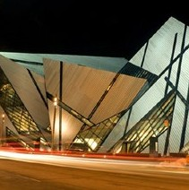
24th World Congress on Pediatrics
VANCOUVER, CANADA (AUGUST 10-11, 2023 )

4th Annual Summit on Cardiology and Heart Diseases
TORONTO, CANADA (AUGUST 24-25, 2023)

PRE-MEETINGS

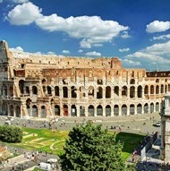
33rd Annual European Pharma Congress
FRANKFURT, GERMANY (MARCH 13-14, 2023)
21st International Conference and Exhibition on Materials Science and Chemistry

FRANKFURT, GERMANY (MARCH 13-14, 2023)
38th International Conference on Advanced Pediatrics and Neonatology

ROME, ITALY (MARCH 20-21, 2023)


8th International Conference & Expo on Euro Optometry and Vision Science

ROME, ITALY (MARCH 20-21, 2023)
29th Global Dentists and Pediat- ric Dentistry Meeting
ROME, ITALY (MARCH 20-21, 2023)
17th International Conference on European Immunology
ROME, ITALY (APRIL 17-18, 2023)

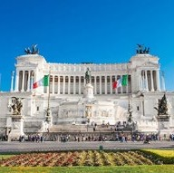
12th World Glycobiology Congress
ROME, ITALY (APRIL 17-18, 2023)
18th Euro-Global Gastroenterol- ogy Conference
ROME, ITLAY (APRIL 17-18, 2023)
35th Nano Congress for Future Advancements
PARIS, FRANCE (APRIL 17-18, 2023)

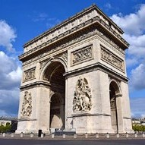
9th World Congress on Health Economics, Health Policy and Healthcare Management

PARIS, FRANCE (APRIL 17-18, 2023)
13th International Conference on Geriatrics, Gerontology & Elderly Care

PARIS, FRANCE (APRIL 17-18, 2023)
16th European Biosimilars Congress
BARCELONA, SPAIN (APRIL 03-04, 2023)

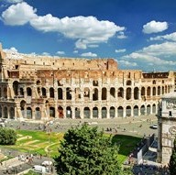
14th World Congress on Chemistry
BARCELONA, SPAIN (APRIL 03-04, 2023)
9th International Conference on Neurological Disorders and Stroke

ROME, ITLAY (APRIL 19-20, 2023)
7th International Conference on Infectious Diseases: Control and Prevention

LONDON, UK (MAY 26-27, 2023)

UPCOMING CONFERENCES

17th World Congress on Gastroenterology -Therapeutics & Hepatology

ZURICH, SWITZERLAND (JULY 17-18, 2023)
11th International Conference on Mental Health and Human Resilience

VANCOUVER, CANADA (JULY 31-AUGUST 01, 2023)

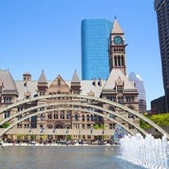
8th International Conference on Primary Healthcare & Management

ZURICH, SWITZERLAND (JULY 17-18, 2023)
10th World Summit on
Mental Health, Psychiatry and Wellbeing

TORONTO, CANADA (AUGUST 07-08, 2023 )

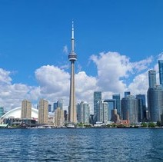
24th Global Summit on Analytical and Bioanalytical Techniques

PARIS, FRANCE (JULY 19-20, 2023 )
11th World Congress and Expo on Green Energy
TORONTO, CANADA (AUGUST 07-08, 2023)
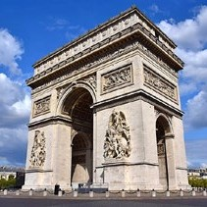
37th European Ophthalmology Congress
VANCOUVER, CANADA (JULY 31-AUGUST 01, 2023)
36th World Pediatrics Conference
PARIS, FRANCE (AUGUST 07-08, 2023)


19th World Congress on Infection Prevention and Control

BARCELONA, SPAIN (AUGUST 21-22, 2023)


26th International Conference and Exhibition on Pharmaceutical Formulations

BARCELONA, SPAIN (AUGUST 21-22, 2023)

