Obesity 2026


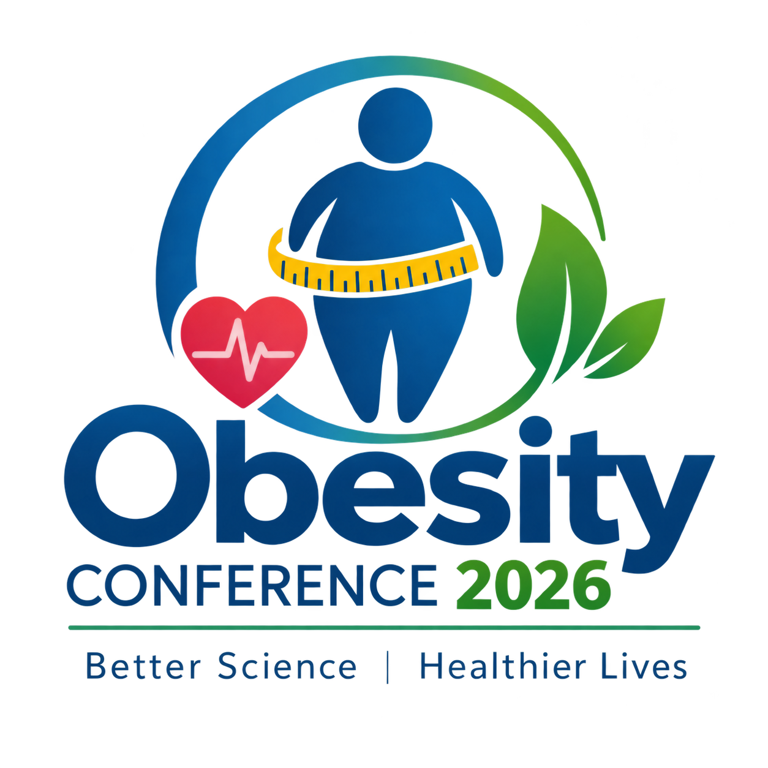
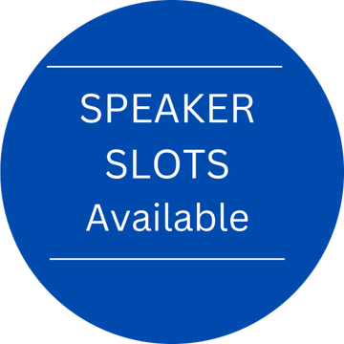

24th International Conference on

Obesity, Diet Management & Nutrition
November 26-27, 2026 | London, UK

THEME
"Innovating Nutrition, Inspiring Health, Transforming Lives”

Conference Series LLC Ltd
Phone: +44 1865 521861
Email: euroobesitycongress@speakersagenda.com

https://obesity.conferenceseries.com/

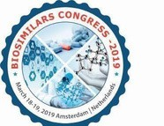


- Interactive Sessions
- Keynote/Plenary Lectures
- Workshops/Symposiums
- YRF/Best Poster Awards
- Exhibitors
- B2B Meetings

Registration Inaugural Session

Program Outline

08:00-09:00
09:00-09:15

Keynote/ Plenary talk: 1 (Academia) Keynote/ Plenary talk: 2 (Industry)
Keynote/ Plenary
talks
Keynote/ Plenary talk: 3 (Exhibitor/Sponsor slot)
Coffee break/ Networking
Oral Presentations and Panel Discussions Lunch break/ Networking
Sponsor/ Exhibitors presentations
Oral Presentations and Panel Discussions Coffee break/ Networking
Workshops/ YRF/ Posters/ Video Presentations Sponsor/ Exhibitors presentations
Certificate Distribution & Day 1 conclusion Remarks
09:15-09:45

09:45-10:15

10:15-10:45
10:45-11:00
11:00-13:00
13:00-14:00
14:00-14:30
14:30-16:00
16:00-16:15
16:15-17:00
17:00-17:30

17:30-18:00
Program Outline
Registration
Inaugural Session
08:00-09:00
09:00-09:15
Keynote/ Plenary talk: 1 (Academia/Industry)
09:15-09:45
Keynote/ Plenary talk: 3 (Exhibitor/Sponsor slot)
09:45-10:15
Workshops/ Symposium
Coffee break/ Networking
Oral Presentations and Panel Discussions Lunch break/ Networking
Sponsor/ Exhibitors presentations
Oral Presentations and Panel Discussions Coffee break/ Networking
YRF/ Posters/ Video Presentations
Certificate Distribution & Day 2 conclusion Remarks
10:15-10:45
10:45-11:00
11:00-13:00
13:00-14:00
14:00-14:30
14:30-16:00
16:00-16:15
16:15-17:00
17:00-17:15
Keynote/
Plenary talks




November 26-27, 2026
Toronto, Canada
Obesity 2026
- Interactive Sessions
- Workshops/Symposiums
- Exhibitors
- Keynote/Plenary Lectures
- YRF/Best Poster Awards
- B2B Meetings
https://obesity.conferenceseries.com/

Day-2




November 26-27, 2026
London, UK
Obesity 2026

Best Poster Award

  - You will be given about 5-7 minutes to present your poster including questions and answers. Judges may pose questions during the evaluation of the poster
- Judges will even evaluate the student’s enthusiasm towards their study, interest and knowledge in the area of their research
- The winners will be announced at the closing ceremony of the conference. The decision of the

Young Researchers Forum
- Present your research through oral presentations
- Learn about career development and the latest research Tools and technologies in your field
- This forum will give pertinent and timely information to those who conduct research and those who use and benefit from research
- Develop a foundation for collaboration among young researchers

winner will be withdrawn if the winner/winners is/are • The forum will provide an opportunity for

not present at the time of announcement

  - Apart from the judging time you may also be present at the poster to share your research with interested delegates
Collegial interaction with other investigators and established young senior investigators across the globe
- Interact and share ideas with both peers and mentors
For any Queries:
euroobesitycongress@speakersagenda.com

https://obesity.conferenceseries.com/
- Interactive Sessions
- Workshops/Symposiums
- Exhibitors
- Keynote/Plenary Lectures
- YRF/Best Poster Awards
- B2B Meetings


London, UK
Contact:
Program Director | Obesity 2026
Conference Series LLC Ltd.
Email: euroobesitycongress@speakersagenda.com
WhatsApp: +44 1865 521861

