Title: Mutation spectrum in 265 Chinese patients with hemophagocytic lymphohistiocytosis: Molecular analyses of PRF1, UNC13D, STX11, STXBP2, SH2D1A, and XIAP
Daijing Nie , Hebei Yanda Lu Daopei Hospital, China
Abstract (300 word limit)
Hemophagocytic lymphohistiocytosis (HLH) is a rare life-threatening hyperinflammatory disease. This study aimed to investigate the frequencies and distributions of inherited mutations in PRF1, UNC13D, STX11, STXBP2, SH2D1A, and XIAP genes in Chinese patients with HLH. A total of 265 patients diagnosed with HLH from January 2010 to December 2016 were recruited and analyzed for the six genes. Mutations were observed in 89 (33.58%) patients. 36 (13.58%) exhibited mutations in UNC13D, 18 (6.79%) exhibited PRF1 mutations, 11 (4.15%) exhibited mutations in STXBP2, 10 (3.77%) had mutations in XIAP, 6 (2.26%) carried mutations in SH2D1A, 1 (0.38%) had STX11 mutation, and 7 (2.64%) exhibited synergistic mutations of two distinct genes. Monoallelic mutations were the most common, which accounted for 50.56% of all cases with mutations. All mutations were confirmed to be germline derived. The present study describes a distinct mutation spectrum in Chinese patients with HLH, whereby UNC13D is the most frequently mutated gene with missense mutations that are the most common molecular defects. The mutation profile of Chinese HLH patients is quite different from that of Western cohorts but similar to that of Korean patients, yet showing its own uniqueness. This racial difference shows the role of genetic background in the occurrence of HLH.

Image
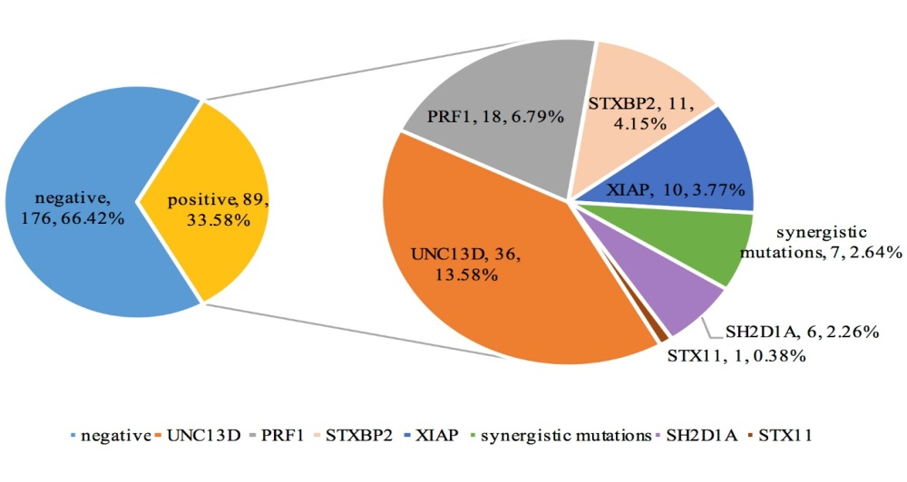

Recent Publications
- Hongxing Liu, Fang Wang, Daijing Nie. Comprehensive genomic analysis and clinical application in hematological disease [J]. Journal of Leukemia & Lymphomia. 2018,27(2):69-71.
- Xue Chen, Yang Zhang, Fang Wang, et al. Germline cytotoxic lymphocytes defective mutations in Chinese patients with lymphoma. Oncology Letters,2017,14:5249-56.
- Yang Zhang, Xue Chen, Tong Wang, et al. Relapsed/refractory childhood acute myeloid leukemia with congenital susceptible factors and complex gene mutation：report of one case and review of literature [J]. Journal of Leukemia & Lymphoma,2016,25(12):743-5.
- Hongxing Liu, Xue Chen, Fang Wang. Advances in research and application of immune repertoire analysis in hematological malignancies[J]. Journal of Leukemia & Lymphomia. 2017,26(2):68-70.


Biography ( 150 word limit )
Daijing Nie is a 3rd year PhD student at the Lu Daopei Hospital working in structural biology and complement related diseases. Part of his work was published in the following journal: http://www.pnas.org/content/115/4/768.long.
Email:XXXXXXX@xxxmail.com
- Full Name:
- Personal Email:
- Mobile Number:
- Linked In:
- Facebook:
- Session Name/ number:
- Category: ( Poster / Oral presentation )
- Date of Birth:
- Postal Address:
Notes or Comments:

