Compliance to self-glucose monitoring advice and maternal consequences in diabetes-complicated pregnancies

Andrea Morris, Phd, Stanford University, USA

Abstract
Self-glucose maintenance is crucial for the management of diabetes mellitus during pregnant; however, reliable data of screening compliance as well as related postnatal effects are scarce. We attempted to address the following questions using cloud-based, self-glucose monitoring technology: (1) Are there changes in testing adherence rates based on the type of diabetes mellitus in pregnancy? (2) Is adherence to glucose monitoring guidelines connected with perinatal outcomes in diabetes-complicated pregnant women? We expected that adherence to glucose testing recommendations differs by type of diabetes mellitus and that increasing adherence to testing guidelines is related with better perinatal outcomes. Women with type 2 diabetes mellitus and gestational diabetes mellitus who were recruited in a perinatal diabetes programme at 29 weeks gestation between December 2015 and June 2018 were included in this single-center, prospective cohort research. All women got a mitochondrial blood glucose meter that uploaded glucose results in real time to a cloud-based, Health Insurance Portability and Accountability Act–compliant platform, ensuring correct glucose transfer. Adherence to self-glucose monitoring advice was the key result. Four glucose tests each day were recommended, and the percentage of adherence was assessed. Preeclampsia, caesarean birth, large-for-gestational-age neonates, and neonatal hypoglycemia were secondary outcomes. The study was powered to detect a 10% difference in the primary outcome of adherence to advised self-glucose monitoring by diabetes mellitus type. Adjusted risk ratios and 95% confidence intervals were generated with the use of logistic regression. This research comprised 103 women who were eligible. The baseline features of the groups differed, with women with type 2 diabetes mellitus having greater beginning HgbA1c and body mass index than women with gestational diabetes mellitus. There were no variations in age or parity. Adherence was measured over 206 weeks in women with type 2 diabetes mellitus and 94 weeks in women with gestational diabetes mellitus. Females having type 2 diabetes mellitus had considerably worse compliance to glucose monitoring than those with gestational diabetes mellitus. Our diabetes programme recently implemented the use of a cellular-enabled glucometer forum for the management of all diabetes-complicated pregnancies, which eliminates under-, over-, and discordant self-reporting. Furthermore, values are associated with meal times and do not require any human entering of glucometer results. The primary result was average adherence to suggestions for self-glucose monitoring. Average daily adherence was calculated at two points: during the first week of suggested pregnancy testing and during the whole term of pregnancy monitoring. Preeclampsia, caesarean birth, newborn hypoglycemia, and big for gestational age were also evaluated as secondary outcomes. According to hospital protocol, hypoglycemia was defined as a newborn with any blood glucose level less than 52 mg/dL. Birthweight greater than the 84th percentile for expected gestational age was used to determine large for gestational age. 10 Preeclampsia was defined as two blood pressure levels greater than 100 mm Hg systolic and/or 90 mm Hg diastolic, as well as an urinary protein greater than 300 mg, a urine protein to creatinine ratio greater than 0.3, or evidence of end organ damage. We assumed a 54 percent adherence in T2DM with a standard deviation of 24 percent based on adherence during the duration of pregnancy for 56 pregnant women with T2DM who were enrolled in our program me but ineligible for this trial. Our early study revealed an 8:7:5 ratio of women with T2DM, GDM class A2, and GDM class A1 participated in our programme. Using this information, our power analysis revealed that a sample of 93 patients would be required to detect a 10% difference in total adherence across groups, with a type I error rate of 5% and power of 80%.

Importance of research
The goal of this study was to use this unique technology to investigate two important issues about the management of women with diabetes mellitus: (1) Does adherence to glucose testing guidelines differ depending on the type of diabetes mellitus? Is adherence to self-glucose monitoring advice related to perinatal outcomes? We expected that adherence to glucose testing recommendations differed by type of diabetes mellitus, and that lower rates of adherence to glucose testing were related with worse perinatal outcomes. The level of adherence to glucose monitoring recommendations varies according to the type of diabetes. Women with gestational diabetes mellitus follow monitoring suggestions more closely than women with type 2 diabetes mellitus. Increased self-glucose monitoring adherence lowers the risk of poor perinatal outcomes. Previously, validated studies of evaluating adherence to self-glucose monitoring were restricted by the inaccuracy of patient-reported glucose logs, surrogate indicators, and short evaluation durations.This study reveals complete adherence to glucose testing throughout pregnancy, thanks to the use of innovative technologies. Clinical practise that fosters testing suggestion adherence correlates to better clinical outcomes.

Image
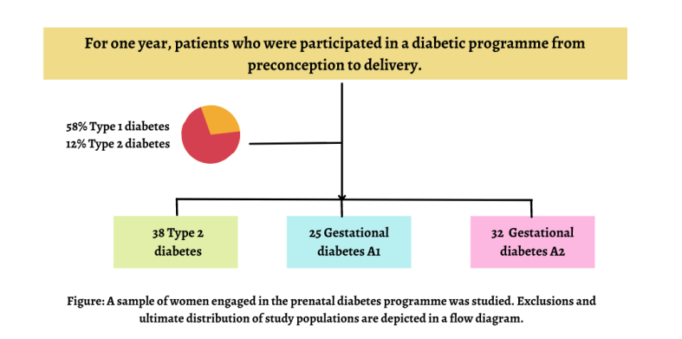
Recent Publications
- American Diabetes Association, 14 Diabetes Management in Pregnancy: Medical Care Standards in Diabetes. Diabetes Cure S172-112
- Hailing M, Emily KE (2006) Consistency of self-monitored blood sugar report in women who are pregnant. 329-334. Neonatal gynecology 329-334.
- Qua, Manchowng p, OlivengMer, oudhryMA (2008) In type 2 diabetes, comparing patient-generated blood glucose diary records with metre memory. Clinical Diabetes 29:377.
- Oliver R, Robert jian (2014) Diabatic parental care. Bookmark
365: 519-530.
- Nair Mith EV, David rob NM (2017) Maternal visit usage and results in type II and gestational diabetes pregnant ladies. Neonatal studies 418:20-12.
- John milIn W (2016) In women, low reliability and adherence to self-monitoring of blood glucose levels are prevalent. Diabetes Care 111-2018
- Malesic Kapoong (2017) Adherence to prenatal care and admission to the neonatal intensive care unit. Wordrings 23:456-23
- Jhonas e, Nowah Ne (2019) A new and improved society National standard for birth weight based on gestational age has been developed. Pediatrics 234:782
- Alisa Joseph (2017) Preeclampsia and gestational hypertension gynecology and obesity 333
- Joshuva ME. A detailed analysis of patient-generated blood glucose diary records vs metre recall in diabetic. Med Diabetic 678:3446
- William Edward (2015) Food insecurity in the home is linked to self-reported prenatal weight status, gestational weight increase, and pregnancy problems. Epidemiology health 692-701
- Quo nill, Alina Qim, Diabetes-related distress, self-care, and clinical outcomes in low-income diabetic patients. Diabetic Health Care 1279-1291
- Kendrick Quill (2007), Pregestational diabetes mellitus. Gestational diabetic care e228-e248
- Anne M, Chronic proteinuria complicating pregnancy: evolutionary biology Diabetes and pregnancy complications S79-S83
- Leveno S.L., Diabetes and preeclampsia are associated with early proteinuria. Clinical Diabetes 802-807


Biograph

Andrea Morris has completed her Phd from Stanford university and faculty member of the Diabetes Research Institute.. Her evaluative expertise and commitmenfor bettering people's health and well-being. Her research interest includes Chronic diseases, diabetes, Parental care, neonatal care, Diabetes Mellitus, Endocrinology Diabetes. She was a clinician, teacher, researcher and administrator and was devoted to her profession, with keen and discerning intellect and organisational skills. She had a passionate commitment to decrease the suffering of people with diabetes She developed this approach based on her years of expertise in research, assessment, teaching, and administration among both medical and educational settings. She provides competent and engaged treatment to patients suffering from type 1 and type 2 diabetes, as well as those suffering from lipid diseases. In the Stanford University region, she was in charge of turning current scientific research into clinical applications and training for health professionals and patients. She is an active and well-respected instructor of medical students and postgraduate physicians, and she helps to
organise the Division's Fellowship training programme
University Information

Stanford Institution, often known as Leland Stanford Junior University, is a private research university located in Stanford, California. The complex covers an area of 8,180 acres. It is one of the largest in the United States. Stanford University is regarded as one of the best in the world. Stanford was created in 1885 by Leland and Jane Stanford in memory of their only child, Leland Stanford Jr., who died the previous year of typhoid disease at the age of 15. Leland Stanford was a former California governor and U.S. senator who built his money as a railroad magnate. On October 1, 1891, the school welcomed its first pupils as a coeducational and non-denominational institution. Stanford University struggled financially following the death of Leland Stanford in 1893, and again after the 1906 San Francisco earthquake wrecked most of the campus. Following WWII, provost Frederick Terman encouraged teachers and alumni to pursue entrepreneurial endeavours in order to create self-sufficient local industries in what would eventually be known as Silicon Valley

