
conferenceseries._{com}

3rd World Congress on
Environmental Toxicology

December 03-04, 2019
London, UK

TENTATIVE PROGRAM
C I E N T I F I C P R O G R A M

SCIENTIFIC PROGRAM
DAY 1

Tuesday, 3rd December

09:00-09:30 | Registrations
09:30-10:00 | Introduction
10:00- 10:20 | COFFEE BREAK
10:20-11:05  Meeting Hall 01 | KEYNOTE LECTURES
 | MEETING HALL 01 | MEETING HALL 02
11:05-12:40 | Talks On: | Talks On:
 | Pollution | Economic Toxicology
 | Types of Pollution | Agricultural Toxicology
 | Environmental Toxicology | Climate Change
 | Regulatory Toxicology | Environmental Toxicology and Chemistry
12:40-13:00 | GROUP PHOTO
13:00-14:00 | LUNCH BREAK
 | MEETING HALL 01 | MEETING HALL 02
14:00-16:00 | Talks On: | Talks On:
 | Environmental Health and Safety | Acute Toxicity
 | Environmental Toxicology and Food Chain | Environmental Degradation
 | Global Warming | Ecotoxicology
 | Green Chemistry | Food Toxicology
16:00-16:15 | COFFEE BREAK
 | MEETING HALL 01 (16:15-17:00)
 | Young Researchers in Pediatrics Conference



SCIENTIFIC PROGRAM
DAY 2

Wednesday, 4th December

09:00-10:30  Meeting Hall 01 | KEYNOTE LECTURES
10:30-10:45 | COFFEE BREAK
 | MEETING HALL 01 | MEETING HALL 02
10:45-12:45 | Talks On:
 | Waste Recycling and Management | Environmental Compliance
 | Bioaccumulation and Ecology Impacts | Epidemiology and Biostatistics
 | Carcinogenesis | Mutagenesis
 | Health Economics and Public Policies | Acid Precipitation
12:45 – 13:30 | LUNCH BREAK
 | MEETING HALL 01 | MEETING HALL 02
13:30 – 15:30 | Talks On:
 | Ozone Depletion | Biomedical Waste Management
 | Environmental Pharmacology | Environmental Agent
 | Environmental Chemistry | Medical Toxicology
 | Geoscience | Bioaccumulation
15:30-15:45
 | MEETING HALL 01 (15:45-16:20) | MEETING HALL 01(16:20-17:00)
 | Poster Presentations | Workshops

PAST AFFILIATES

PAST AFFILIATES

PAST AFFILIATES
Arup Kumar Sarma
Indian Institute of Technology, India

Mukhtar Yusubovich Bekkiev
High-Mountain Geophysical Institute, Russia

Stanley D Brunn
University of Kentucky, USA

Hans J Mueller
Karlsruhe Institute of Technology, Germany

Wendy Lynne Lee  Bloomsburg University of Pennsylvania, USA | Adriana Zaleska-Medynska  University of Gdansk, Poland
Suree Chooprateep  Chiang Mai University, Thailand | Oanh Pham  Osaka Prefecture University, Japan
Jae Gang Kim  ANYTECH Co. Ltd., South Korea | Sangjo Jeong  Korea Military Academy, South Korea
Rozita Farzam  University of Tehran, Iran | Anirudra Parajuli  University of Helsinki, Finland
Shashi Bala Singh  Dayanand Girls P.G. College, India | Ai-Lin Shen  China Steel Corporation, Taiwan
Jean Sciare  The Cyprus Institute, Cyprus | Lavtizar Vesna  Kobe University, Japan
Ji Whan Ahn  Korea Institute of Geosciences and Mineral Resources, South Korea | Lisa B Bosman  College of Menominee Nation, USA
Sergey Piontkovski  Sultan Qaboos University, Oman | V Preethi  Hindustan University, India
Kikuro Tomine  National Defense Academy, Japan | Jun He  The University of Nottingham Ningbo, China
Mohammad R M Abu Zahra  Masdar Institute, UAE | Marie Stybnarova  Agrovyzkum Rapotin Ltd., Czech Republic

PAST AFFILIATES

PAST AFFILIATES
Adriana Zaleska-Medynska
University of Gdansk, Poland

Mehul Patel
CIPET, India

Abdeen Omer
Energy Research Institute (ERI), UK

Nader Parvin
Payame Noor University, Iran

Chalak Farzin Nejad  A.S. Sama University, Iran | Mohammad Anamul Haque Nayan  Jahangirnagar University, Bangladesh
Karim Hassanzeraat  A.S. Tabriz University, Iran | Abebe, Birhanu Ayalew  Ethiopian Biotechnology Institute, Ethiopia
Brigitte Wabuyabo-Okonga M  KCA University, Kenya | Sagun Thapa  Nepal Red Cross Society, Nepal
Anahita Rabii  Ryerson University, Canada | Deepak Aryal  Tribhuvan University, Nepal
Ikenna Eric Onuegbu  Green World Trade, Namibia | Solomon Fessehaye Woldeyohannes  Addis Ababa, Ethiopia
Mei Liu  Tohoku University, Japan | Yolanda González-García  Universidad de Guadalajara, Mexico
Saida Tayibi  Mohammed VI Polytechnic University, Morocco | Meron Mengistu Zewdie  Addis Ababa University, Ethiopia
P V V Prasada Rao  Andhra University, India | Wintana Kassahun Engeda  Ethiopia Biotechnology Institute, Ethiopia
Mohammad Hadi Dehghani  Tehran University of Medical Sciences, Iran | John Attridge  Chelsea Technologies Group Ltd, UK
Prakash Gyawali  Surybinayak Municipality, Nepal | Adel A Ismai  Kuwait Institute for Scientific Research, Kuwait

PAST AFFILIATES

PAST AFFILIATES
Yumiko Nitta
Hiroshima Shudo University, Japan

Mourad Terniche
CHU Mustapha, Algeria

Vincent Tan
Monash University, Australia

Hironori Hamasaki,
Nagasaki University, Japan

Tao Zeng  Nagoya University, Japan | Fahed Ayed N Aloufi  University of Bristol, UK
Samroot Samreen Wani,  TERI SAS, India | Mohamed Abouleish  American University of Sharjah, UAE
Farhana Abd Lahin  University Malaysia Sabah, Malaysia | Viveca M Vélez Negrón  University of Puerto Rico, Puerto Rico
Xian Ruan  South China University of Technology, China | Shyam Manohar  Kenyatta University, Nairobi, Kenya
Anna Poberezhna  Smart4tech, UK | Joy Manglani  Indian Institute of Technology, India
Monika Poppy  Sustainability is Cool, UK | Yon Rojanasakul  West Virginia University USA
Constantinos Sioutas,  University of Southern California, USA | Aizman Roman  Siberian center for Eurasian projects, Russia
Ahmed Talaat Tawfik  Dhafarah Region Municipality, UAE | Abbas Amini  Western Sydney University, Australia
Abel Girma  Donghua University, China | Ewa Cukrowska  University of the Witwatersrand, South Africa
Layla Salih Al Omran  University of Basrah, Iraq | Sergey Suchkov  First Moscow State Medical University, Russia




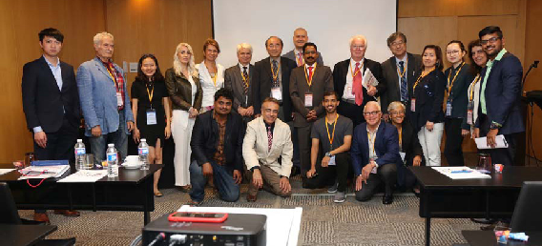
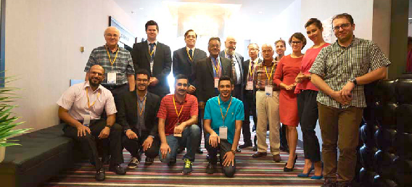

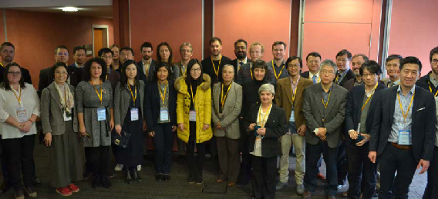
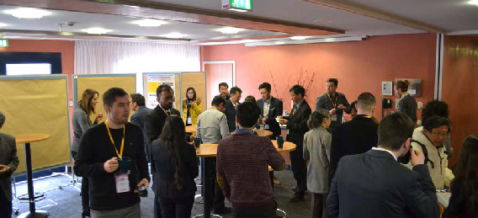
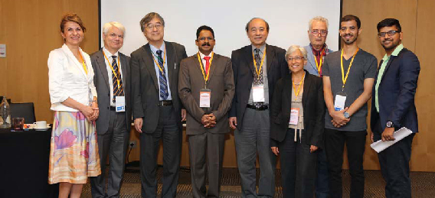
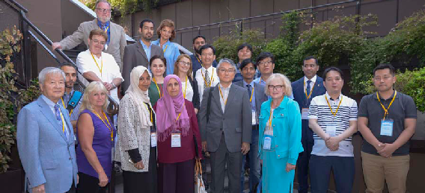
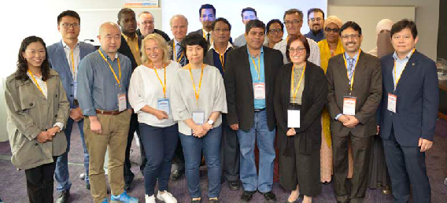
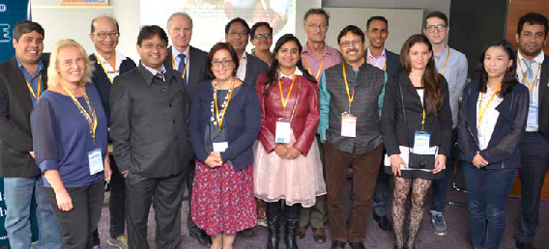
Gl Glimpses of
Environment Toxicology Conferences

Tourist Attractions of Valencia
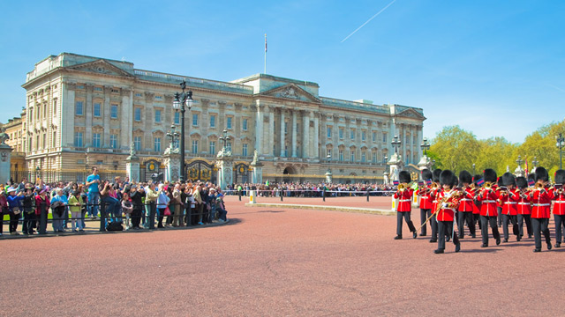
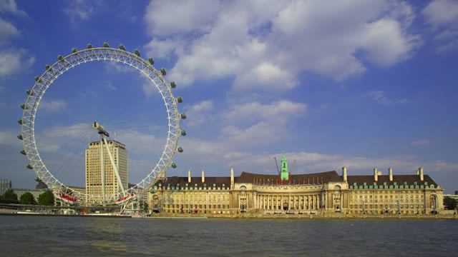



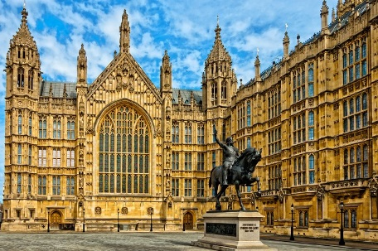
Buckingham Palace
Big Ben & Parliament
The London Eye
Trafalgar Square
The British Museum
Covent Garden

