Pre Conference Dinner Attendees

Maria A Miteva
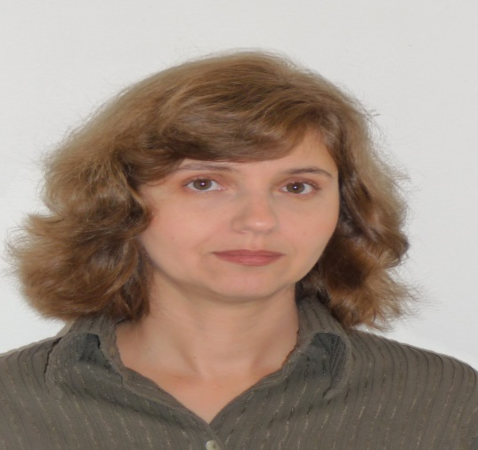
University Paris Diderot, France
--------------------------------------------------------------------
Arik Dahan
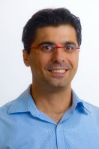
Ben-Gurion University of the Negev, Israel
--------------------------------------------------------------

