
conferenceseries.com

27th International Conference on
Advanced Clinical Research and Clinical Trials

November 29-30,2021 | Webinar

S C I E N T I F I C P R O G R A M

08:30-09:00
Registrations

09:00-09:30
Introduction

09:30-09:50 COFFEE BREAK

09:50-11:50

KEYNOTE LECTURES
Meeting Hall 01

11:50-13:10
MEETING HALL 01 | MEETING HALL 02
Talks On: Innovations in Clinical Trials | Talks On: Oncology Clinical Research
Clinical Trials on Different Diseases | Site Management Innovation
Design of Clinical Studies and Trials | Bioethics and Regulatory Compliance
Biomedical Devices Clinical Research | Patient Recruiting & Retention
Future of Clinical Trials
Future of Clinical Trials | Microbiology Clinical Research

13:10-13:15 GROUP PHOTO

13:15-14:00 LUNCH BREAK

14:00-16:00
MEETING HALL 01 | MEETING HALL 02
Talks On: Innovations in Pre-clinical Research | Talks On: Pharmacovigilance and Drug Safety
Imaging Research & Clinical Research | Stem Cell and Genetic Clinical Research
Nursing
Latest technologies in Biomedical Research | Causality Assessment
Advancements in Psychology Research | Drug Safety
Methods
Clinical and Medical Case Reports | Clinical Research and Statistics

16:00-16:20 COFFEE BREAK
Young Researchers in Pharmacovigilance Significance and Scope
MEETING HALL 01 (16:20-17:00)

09:00-10:30

KEYNOTE LECTURES
Meeting Hall 01

10:30-10:50 COFFEE BREAK

10:50-12:50
Talks On: Global Clinical Trials Talks On: Clinical Trails
Pharmacovigilance and Drug Safety Clinical Trials on different Diseases and
Disorders
Good Pharmacovigilance Practices Patient-Centric Clinical Trials Pharmacovigilance risk management plans Outsourcing in Clinical Trials Pharmacovigilance and Drug Safety Patient-Centric Clinical Trials
MEETING HALL 02
MEETING HALL 01
12:50-13:35 LUNCH BREAK

13:35-15:55
MEETING HALL 01 | MEETING HALL 02
Talks On: Pharmacovigilance | Talks On: Clinical Data Management
Clinical development of medicines | CRF Design and Development
Adverse drug reactions | Data Entry
Monitoring the safety of medicines | SAE Reconsilation
Pharmacovigilance in practice
Pharmacovigilance in clinical practice

15:55-16:15 COFFEE BREAK

Poster Presentations
Workshop
Awards & Closing Ceremony
MEETING HALL 01 (17:00-18:00)
MEETING HALL 01 (16:15-17:00)

Sanjay Gandhi,
Southmead Hospital, UK

Vikas Leelavati Balasaheb Jadhav,
Dr.D.Y.Patil University, India

Abdulrahman A. S. Alsayyari,
Qassim University, Saudi Arabia

Masoud Hashemi,
Shahid Beheshti University of Medical Sciences, Iran

Hissa Mohammed,
National center for Cancer Care and Research, Qatar

Chih-Jen Hung,
Taichung Veterans General Hospital, Taiwan

M. A. Alnafea
King Saud University, Saudi Arabia

Monica Kansal,
Jaypee Hospital, India

David Sipos,
University of Pecs Faculty of Health Sciences, Hungary

Amjed Eljaili,
Ysbyty Gwynedd, UK

Shahriari Mozhgan,
Tehran University, Iran

Daniel L. Farkas,
University of Southern California, USA

Claudia Paola Rivera-Uribe,
Nuevo León Autonomous University, Mexico

Ala khasawneh,
University of Pécs, Hungary

Syed Muhammad Anwar,
University of Engineering and Technology, Pakistan

Kunwarpal singh,
Sri Guru Ram Das Institute of Medical Sciences and Research, India

Shajeem Shahudeen,
Vivid Diagnostic Centre, India

Dongyeon Lee,
Yonsei University, South Korea

M. A. Alnafea,
King Saud University, Saudi Arabia

David Sipos,
University of Pecs Faculty of Health Sciences, Hungary

Ala khasawneh
University of Pécs, Hungary

Mustafa Sabil,
United Kingdom

PAST AFFILIATES

Zang-Hee Cho,
Seoul National University, South Korea

Bin Zheng,
University of Oklahoma, USA

Michael L Goris,
Stanford University School of Medicine, USA

Bital Savir-Baruch,
Loyola University Medical Center, USA

Ilona Kowalik-Urbaniak,
Client Outlook Inc., Canada

Monika Beresova,
University of Debrecen, Hungary

Hang Joon Jo,
Mayo Clinic, USA

Elaine Iuanow,
Cleveland Clinic Foundation, USA

Barath Narayanan Narayanan,
University of Dayton, USA

Jamal Zweit,
Virginia Commonwealth University, USA

David A Gutman,

Manohar Roda,
University of Mississippi, USA

Daniel Pastore,
Sao Paulo University School of Medicine, Brazil

Mafalda Gomes,
University of Porto, Portugal

Nilda Espinola-Zavaleta,
National Institute of Cardiology Ignacio Chavez, Mexico

Svjetlana Jefic,
University Clinical Centre of Repablic of Srpska, Bosnia and Herzegovina

Aminur Rahman,
National Institute of Neurosciences and Hospital, Bangladesh

Emory University School of Medicine, USA

Limin Yang,
PAST AFFILIATES
University of Iowa, USA

Tamara Feygin,
University of Pennsylvania, USA

Hesham El Sheikh,
Benha University, Egypt

Shivaram Poigai Arunachalam,
Mayo Clinic, USA

Ken Miles
University College London, UK

Tanya Moseley
University of Texas MD Anderson Cancer Centre, USA


Glimpses of
Clinical Research Conferences
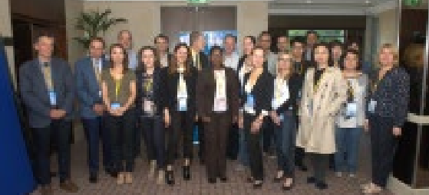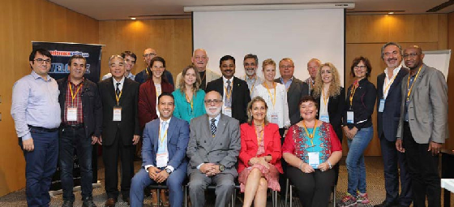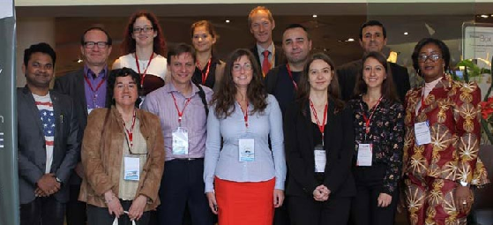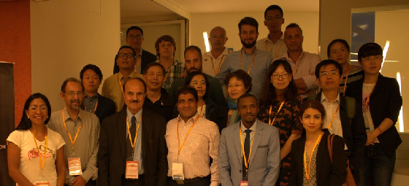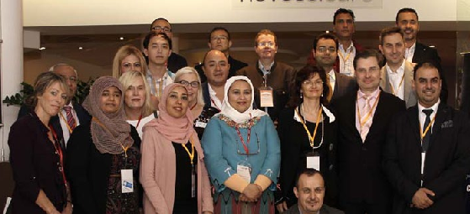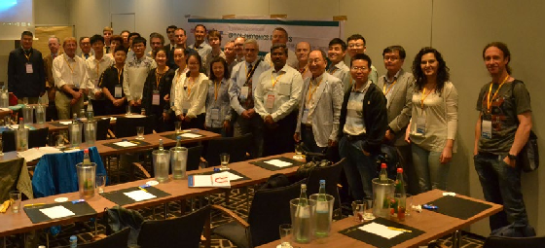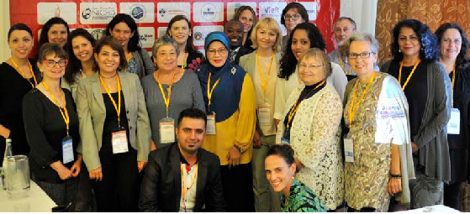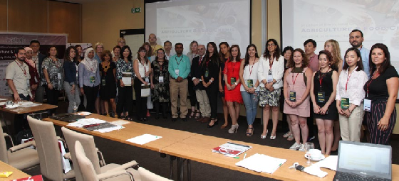

https://clinicalresearch.pharmaceuticalconferences.com/

