


2 ^{nd} World Congress on
Cardiac Surgery and
Medical Devices

October 29-30, 2021 Vancouver, Canada

https://cardiacsurgery.annualcongress.com

Invitation...
Dear Colleagues,
Past Presenters
James L RatcliffRowpar
Pharmaceuticals, Inc., USA

Alex A Giannini
Georgetown University School of Dentistry, USA

Emil Svoboda
University of Toronto, Canada

Sonya Dunbar
RDH, MHA Geriatric ToothFairy, USA

Hafsa Affendi
Rutgers School of Dental Medicine, USA

Umesh Pratap Verma
King Georges Medical University, India

Pradeep Acharya
B P Koirala Institute of Health Sciences, Nepal

Nourah Abdul Kader
Dr MGR Medical University, India

Amr Abouzeid
Faculty of Dentistry Tanta Univiersity, Egypt
many more .....
We are delighted to announce our “2 ^{nd} World Congress on, Cardiac Surgery and Medical Devices” & which is going to be held during October 29-30, 2021 Vancouver, Canada.
The main goal of organizing this event is to bring out the hidden talents, ideas and dreams of the people, who want to become an expert in dentistry. This conference will provide an international platform to present all their skills, to meet the inspiring personalities, open-up new perspectives, design tomorrow’s research agendas etc.
Cardiac Surgery invites people all over the world invariable of age to discuss the wonders happening in the ever growing field of nursing care. Conference aims to bring together high profiled researchers, scholars, eminent personalities and students from both academic and industrial fields throughout the world under single roof.
Then what are you waiting for, come let us meet there and learn and share more.


Cardiac Surgery 2021...

GOAL
The purpose of this year’s conference is to exemplify outstanding nursing and healthcare management networking that will bring together over start-up enthusiasts, corporates and connect
them globally. Our goal is to encourage a dialog on ideation, collaboration and resource sharing.
NETWORKING
The attending experts, industry partners and motivational speakers will provide a fantastic networking experience.
This conference provides B2B and B2C at a single international platform, which will definitely add value to your ideas in terms strategic development and management.

PREVIOUS EDITION
Cardiac Surgery 2019 brought together some 40+ presentations and 100+ delegates from leading institutes and organizations with wide subject expertise. More than 20 countries gathered to share and discuss on the latest Business Strategies in this field.

WHO CAN ATTEND?
- Doctors
- Professors
- Delegates
- Students and Scientist
- Research Scholars and Academicians.

Conference Schedule...
MORNING | CONFERENCE DAY 01  Registration
MORNING | Welcome Ceremony
MORNING | Keynote Presentation
MORNING | Round Table Panel Discussion
MORNING | Keynote Presentation
AFTERNOON | Lunch
AFTERNOON | Speaker Presentations
AFTERNOON | Round Table Panel Discussion
AFTERNOON | Speaker Presentations
AFTERNOON | B2B Session

 | CONFERENCE DAY 02
MORNING | Keynote Presentation
MORNING | Round Table Panel Discussion
MORNING | Speaker Presentations
MORNING | Speaker Presentations
 | Round Table Panel Discussion
 | Lunch
AFTERNOON | Speaker Presentations
AFTERNOON | Exhibiting Hours
AFTERNOON | Networking Session
AFTERNOON | Round Table B2B

Note: Program Schedule is subject to change with final allotment of the speaker slots
E-mail: https://cardiacsurgery.annualcongress.com

Venue & Accommodation...
Vancouver, Canada
Hotel details will be updated soon…

Registration Details...

ACADEMIC
Only Registration | 599 USD
Package A (Registration + 2 nights’ Accommodation) | 899 USD
Package B (Registration + 3 nights’ Accommodation) | 999 USD
DELEGATE
Only Registration | 699 USD
Package A (Registration + 2 nights’ Accommodation) | 999 USD
Package B (Registration + 3 nights’ Accommodation) | 1099 USD
STUDENT
Student Poster | 499 USD
Student Delegate | 399 USD
Young Research Forum | 299 USD
OTHER REGISTRATION
Video Presentation | 199 USD
Webinar | 199 USD
Only abstract publication | 99 USD
FOR EXHIBITOR
Conference Exhibitor | 2000 USD
-Registration Link-
https://cardiacsurgery.annualcongress.com/registration.php

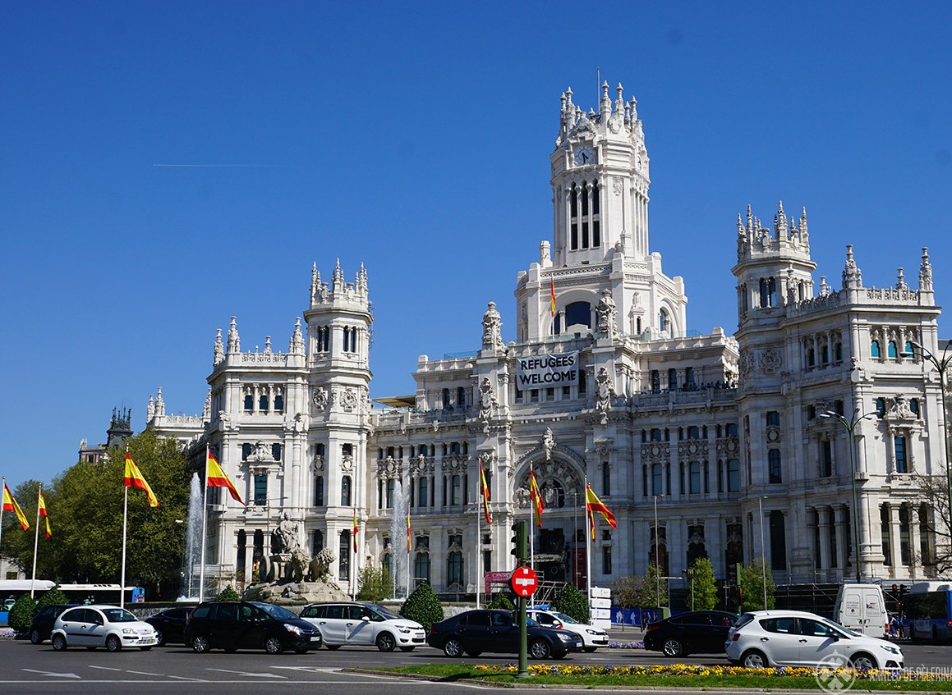


https://cardiacsurgery.annualcongress.com/

Mail us to know more!
For Abstract Submission Guidelines | For Reserving your slot
| Proposals | Registration | Posters | Accommodations
No doubt you have lots of queries...

For Queries
Contact: Business Event Manager
E:cardiacsurgery@annualamericacongress.com

For Exhibition & Sponsorship Contact: Manager
E: cardiacsurgery@annualamericacongress.com

Conference Series LLC Ltd
Vancouver, Canada W3 6AY.

Why not get in touch..!
Drop us your query with details and we will call you right away

