29th International Congress on Cardiology and Medical Interventions
October 11-12, 2021 Vancouver, Canada

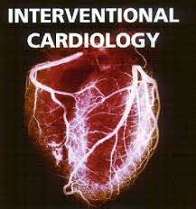

https://cardiac.conferenceseries.com/

Invitation

Dear Attendees,

CARDIAC CONFERENCE 2021

CARDIAC CONFERENCE 2021

We are glad to announce the 29th International Congress on Cardiology and Medical Interventions to be held in Canada from October 11-12, 2021

Webinar
Nov 5-6,
2021

Conference Series LLC Ltd in collaboration with generous support and cooperation from enthusiastic
academicians and editorial Board Members.
This conference is a unique international platform that’s a confluence of all stake holders of the ecosystem – Industry, Academia, Researchers, Innovators, Regulators – coming together to present and discuss current topics in Cardiology and main theme of this conference is Defining the Future Vision of Heart
As the premier event, we have developed a program with your interests in mind. We have not only increased the number of opportunities for you to network with colleagues from across the world but also introduced more focused sessions that will feature cutting edge presentations, special panel discussions, and livelier interaction with industry leaders and experts.
Life is full of give and take. Make it count in your professional life. Attend the Conference to network with your peers, exchange expertise and experiences, and arm yourself with the latest information to take your department to the next level.
Life is full of give and take. Make it count in your professional life. Attend the Conference to network with your peers, exchange expertise and experiences, and arm yourself with the latest information to take your department to the next level.
We look forward to personally welcoming you to Canada
Sincerely,

CARDIAC CONFERENCE 2021 Organizing Committee

About Conference

Webinar
Nov 5-6,
2021

CARDIAC CONFERENCE 2021 Conference website is attracting 25000+ Cardiology, Clinical Cardiology online visitors ranging from Researchers, Academicians and Business professionals, who are working in this field. This unique opportunity that we extend to our speakers and attendees is not being offered by any other conference organizers. Through this the abstracts and research profiles of our speakers and organizing committee members getting global visibility which is an additional feature that you would be receiving in addition to networking opportunities before, during and after the conference.
CARDIAC CONFERENCE 2021

How Conference Series Conferences differs from others?
- 3000+ Conferences across the globe in 70+ countries Annually
- Over 25 Million+ Visitors and 20000+ Unique Visitors per conference
- Participation by Stalwarts from various international societies
- Internationally renowned speakers and scientists representation
- Career guidance for early career researchers and students
- Interesting scientific deliberations and discussions
- Perfect platform for Global Networking

CARDIAC CONFERENCE 2021 salient features
- Meet Academia and Industry visionaries to get inspired
- Expand your knowledge and find solutions to problems
- Knowledge, Benchmarking and Networking offered at one place
- Forge connections and for global networking
- Highly Organized and Structured Scientific programs
- Poster presentations and world class exhibitions
- Meet with new vendors and suppliers

About Conference

Webinar
Nov 5-6,
2021

Purpose
CARDIAC CONFERENCE 2021
Experimental Cardiology Research is an arena for interdisciplinary exchange
Among professionals in the fields of CARDIAC CONFERENCE 2021.

Goals
The conference program emphasizes evidence-based practice, educational innovation, practical application, and peer to peer networking and collaboration. The goals of the conference is to provide a transformative professional development experience through

Bringing together the world’s scientific experts to catalyze and advance scientific knowledge about Clinical Cardiology present the most recent research findings, and promote and enhance scientific collaborations around the world.
Bringing together community leaders, scientists, and policy leaders to promote and enhance programmatic collaborations to more effectively address regional, national and local responses to Elderly Population around the world and overcome barriers that limit access to care and services.

Objectives
After participating in this meeting, attendees should be able to discuss emerging issues in Cardiology and Health Care
Discuss and apply recent research findings related to Cardiology and Cardiac Diseases Reflect on the place of critical distance in Cardiology

About Conference

Who should attend
CARDIAC CONFERENCE 2021
29th International Congress on Cardiology and Medical Interventions is exclusively
Designed for Cardiology Hygienists, Cardiology Physicians, Medical Directors, Cardiology Nurses,
Cardiology care Organizations and others engaged in endeavors related to Cardiology research and
business.

About hosting organization
Conference Series is the world’s leading specialist in organizing Academic, Scientific and Business conferences, meetings, symposiums and exhibitions in different verticals and horizontals like Medical, Pharma, Engineering, Science, Technology and Business to promote scientific research. Every year we host more than 3000+ global events inclusive of 1000+ Conferences 1000+ Symposiums 1000+ Workshops in USA, Europe, Middle East and Asia with the generous support and cooperation from our 30000+ Editorial Board Members, 1000+ Scientific Societies. All the conference proceedings are published in the special issues of our 700+ Open Access International Journals with the DOI provided by

Major Sessions

                - Pediatric Cardiology
                - Clinical Cardiology
                - Cardiovascular Diseases
                - Clinical and Experimental
                - Heart Diagnosis & Heart Devices
                - Cardiac Pharmacology
                - Heart Rhythm
                - Atherosclerosis

About Conference

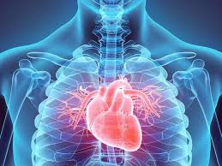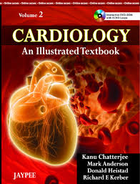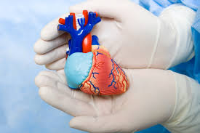


Media partners/Sponsors

October 11-12, 2021 Vancouver, Canada





Contact tfs

Contact us
George Sand
Cardiac Conference 2021

October 11-12, 2021 Vancouver, Canada

Program Director Cardiac Conference 2021
W: https://cardiac.conferenceseries.com/
E: cardiology@annualamericacongress.com


About Registration

Academic
Clinical Cardiology 2021
Only Registration: USD 199
E-poster: USD 99

Important Dates
Abstract submission opens: November 01, 2017

Registration opens: February 01, 2021
Early bird registration: March 30, 2021
On spot registration: Sep 6-7, 2021

To register online, please visit:
https://clinicalcardiology.cardiologymeeting.com/registration.php

