conferenceseries.com
BIOSIM2ILA0RS -220233

INTERNATIONAL CONFERENCE ON
BIOSIMILARS AND PHARMACEUTICALS
https://biomarkers.healthconferences.org/
Whatsapp : +44 748-287-3756

June 23-24,
2023

Paris, France



BIOSIMILARS-2023

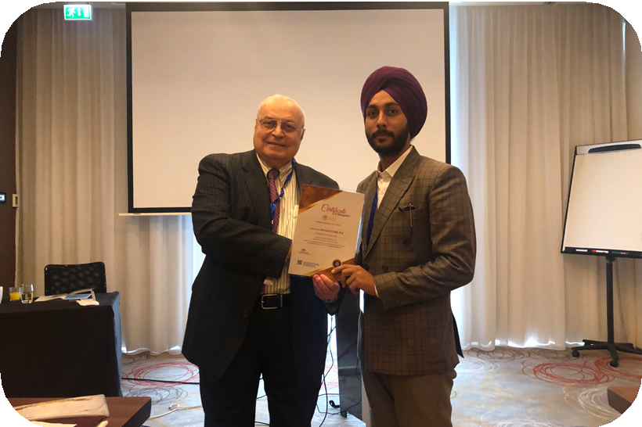Welcome to Biosimilars -2023
BIOSIMILARS 2023
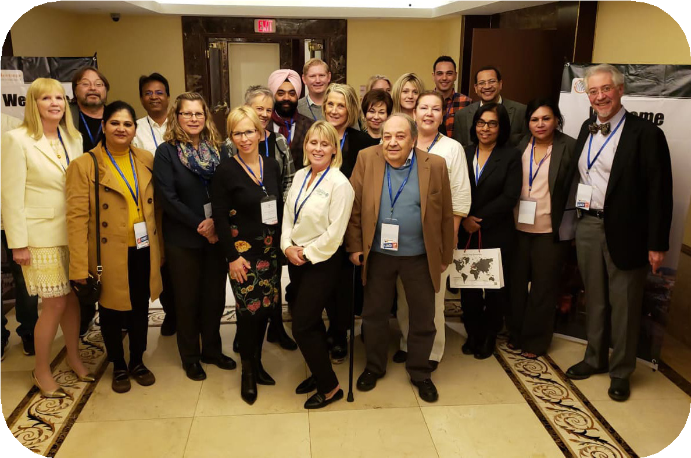We look forward to see researchers from all around the International Conference On Bi- osimilars And Pharmaceuticals during June 23-24, 2023 at the delightful venue of Par- is, France. Biosimilars-2023 is the premier international forum to present and discuss progress, research, development and appli- cation of the major topics related to Biosim- ilars And Pharmaceuticals.
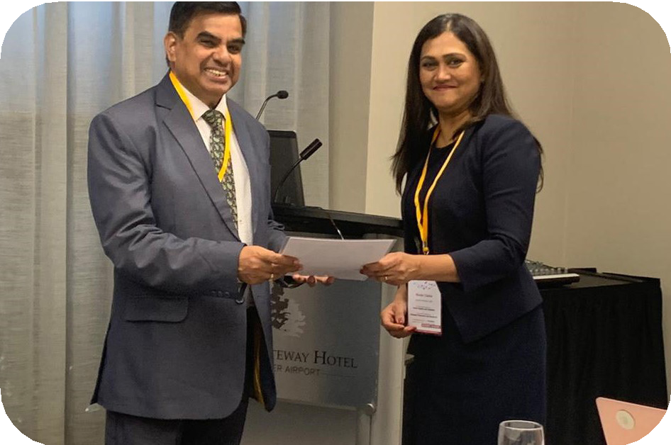The 2023 edition of the summit will offer high quality and relevant research session, poster session, workshop, exhibition, panel discussion etc. for the better understanding of the subject. The conference agenda has been prepared by the scientific committee to enable the exchange of ideas and to ex- pand network with leading experts and re- searchers during the summit.
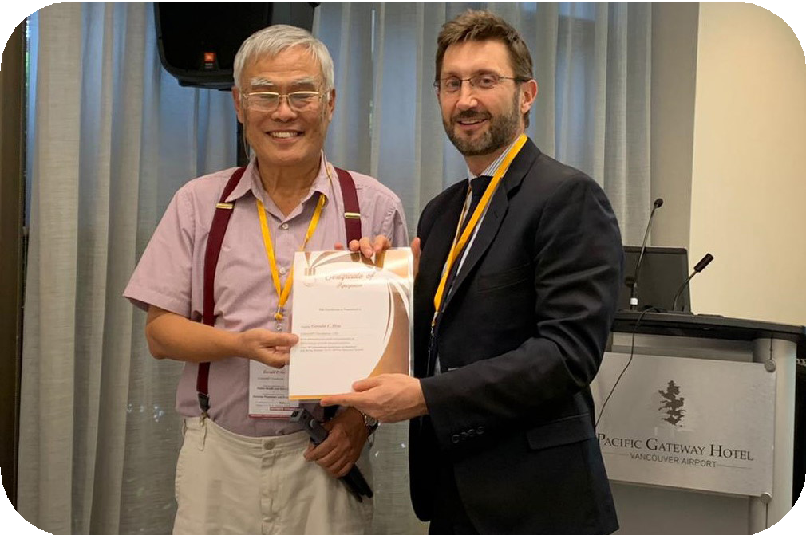Biosimilars 2023 will be a great meeting point for sharing the latest research papers of academic as well as to experience the matchless environment of Berlin, Germany- which has been known for its artistic, cul- tural as well as scientific developments.
We look forward to your participation for Biosimilars 2023 summit at Paris, France.

https://biomarkers.healthconferences.org/ Whatsapp : +44 748-287-3756

BIOSIMILARS-2023

Major Sessions:

- 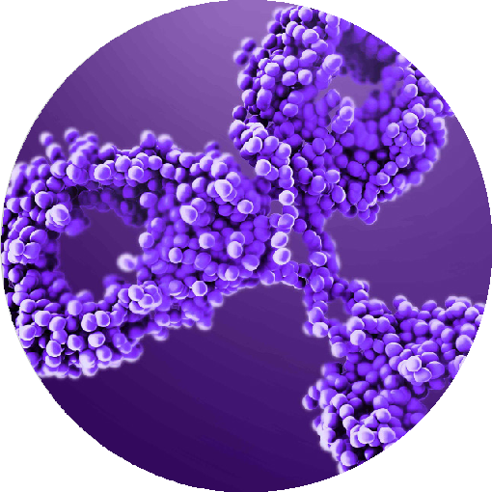Biosimilars And Biologics
- Biosimilars
- Biologics
- Biomarkers
- Emerging Biosimilars in Therapeutics
- Clinical Development Of Biosimilars
- Pharmacovigilance Challenges In Biosimilars
- Globilization Of Biosimilars

Why to join the summit
- Meet Experts & Influencers
- Networking Opportunities
- Learning In a global Space
- Added Research Value
- Investment in Knowledge for future

https://biomarkers.healthconferences.org/ Whatsapp : +44 748-287-3756

Paris Attractions
BIOSIMILARS-2023
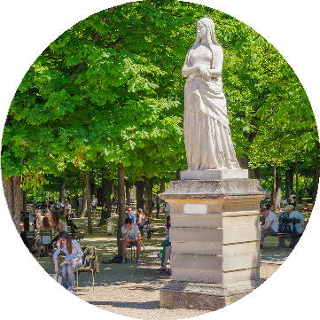
About Paris
Paris (French pronunciation: [pair] (listen)) is the capital and most populous city of France, with an estimated population of 2,165,423 residents in 2019 in an area of more than 105 km. (41 sq mi) making it the 34th most densely populated city in the world in 2020. Since the 17th century, Paris has been one of the world’s major centerers of finance, diplomacy, commerce, fashion, gastronomy, and sci- ence. For its leading role in the arts and sciences, as well as its very early system of street lighting, in the 19th century it became known as “the City of Light”. Like London, prior to the Second World War, it was also sometimes called the capital of the world.
The City of Paris is the centre of the region and province of Leapt-de-France, or Paris Region, with an estimated population of 12,262,544 in 2019, or about 19% of
the population of France.

https://biomarkers.healthconferences.org/ Whatsapp : +44 748-287-3756

Important Dates
BIOSIMILARS-2023
Registration Open: October 10,2022
Early Bird : December 10, 2022
Normal Registration : March 15, 2023
Final Registration : June 23-24, 2023

Registration Prices
Speaker Registration 359 euros Delegate Registration 249 euros Young Research Forum 260 euros Exhibitor 1350 euros

Useful Links

Registration:
https://biomarkers.healthconferences.org/registration.php

Abstract submission:
https://biomarkers.healthconferences.org/abstract-submission.php


Home Page
https://biomarkers.healthconferences.org/
Email
biosimilars@globalconference.net

https://biomarkers.healthconferences.org/ Whatsapp : +44 748-287-3756

Previous Conferences Links
BIOSIMILARS-2023

Biosimilars Congress 2019
https://biosimilars.annualcongress.com/2019

European Biosimilars Congress 2019
https://biosimilars-biologics.pharmaceuticalconferences.com/europe/2019

Asian Biosimilars 2019
https://biosimilars-biologics.pharmaceuticalconferences.com/asiapacific/2019

Pharma Biosimilars 2019
https://biosimilars.pharmaceuticalconferences.com/2019

Pervious Webinar Links

Pharma Biosimilars 2020
https://biosimilars.pharmaceuticalconferences.com/2020

Euro Biosimilars 2020
https://biosimilars-biologics.pharmaceuticalconferences.com/europe/2020

Biologicsmeet 2020
https://biologicsmeet.pharmaceuticalconferences.com/2020

Email
biosimilars851@gmail.com

CONTACT US
Email: biosimilars851@gmail.com
Call us at: +44-203-9664-287 Whatsapp : +44 748-287-3756

UK: Conference Series llc LTD
47 Churchfield Road,
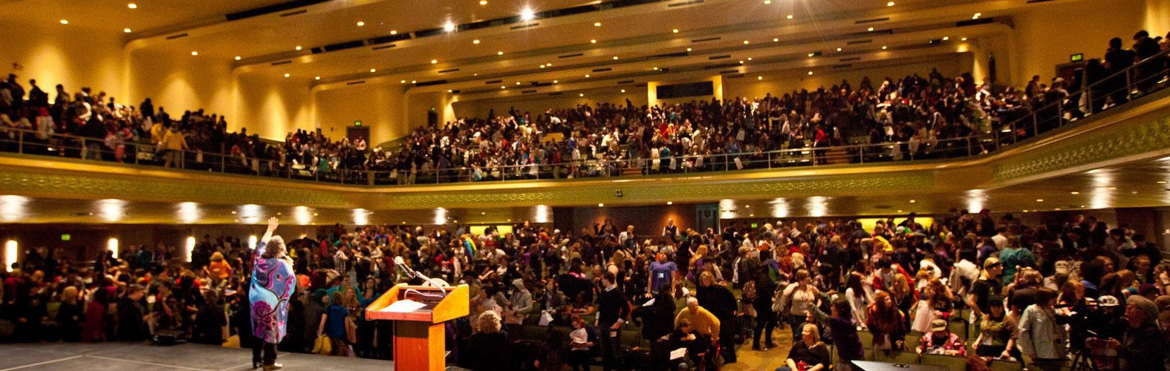
London, W3 6AY https://www.conferenceseries.com

https://biomarkers.healthconferences.org/ Whatsapp : +44 748-287-3756

