


5th International conference on
Microbes and
Beneficial Microbes

July 21-22, 2021
Canada

https://beneficialmicrobes.conferenceseries.com/

Invitation...
Dear Colleagues,
Past Presenters
Yasuhiro Koga
Professor, Tokai University School of Medicine, Japan

Dr. Hanna Evelina Sidjabat
University of Queensland

Judith Perez Peralta
St. Luke’s Medical Center, Philippines

Andrea Roncolini
Polytechnic University of Marche, Italy

Riccardo Sabbatini,
Marche Polytechnic University

Jose Luis Martinez
Université Laval, Canada

Dr. Behnam Khatabi
University of Maryland Eastern Shore, USA

Dr. Hiroshi Ohno
RIKEN Center for Integrative Medical Sciences, Japan

Ms. Mozhgan Sepehri
Shiraz University, Iran

many more .....
We are delighted to announce our 5th International conference on Microbes and Beneficial Microbes” scheduled from July 21-22, 2021 in Canada.
The main goal of organising this event is to bring out the hidden talents, ideas and dreams of the people, who want to become an expert in Beneficial Microbes. This conference will provide an international platform to present all their skills, to meet the inspiring personalities, open-up new perspectives, design tomorrow’s research agendas etc.
Beneficial Microbes 2021 invites people all over the world invariable of age to discuss the wonders happening in the ever growing field of Beneficial Microbes. Conference aims to bring together high profiled researchers, scholars, eminent personalities and students from both academic and industrial fields throughout the world under single roof.
Then what are you waiting for, come let us meet there and learn and share more.



Beneficial Microbes 2021...

GOAL
PREVIOUS EDITION
Beneficial Microbes 2019 brought together some 40+ presentations and 100+ delegates from leading institutes and organizations with wide subject expertise. More than 20 countries gathered to share and discuss on the latest Business Strategies in this field.
The purpose of this year’s conference is to exemplify outstanding Beneficial Microbes networking that will bring together over start-up enthusiasts, corporates and connect them globally. Our goal is to encourage a dialog on ideation, collaboration and resource sharing.
NETWORKING
The attending experts, industry partners and motivational speakers will provide a fantastic networking experience.
This conference provides B2B and B2C at a single international platform, which will definitely add value to your ideas in terms strategic development and management.

WHO CAN ATTEND?
- Doctors
- Professors
- Delegates
- Students and Scientist
- Research Scholars and Academicians.

Conference Schedule...
MORNING | CONFERENCE DAY 01  Registration
MORNING | Welcome Ceremony
MORNING | Keynote Presentation
MORNING | Round Table Panel Discussion
MORNING | Keynote Presentation
AFTERNOON | Lunch
AFTERNOON | Speaker Presentations
AFTERNOON | Round Table Panel Discussion
AFTERNOON | Speaker Presentations
AFTERNOON | B2B Session

 | CONFERENCE DAY 02
MORNING | Keynote Presentation
MORNING | Round Table Panel Discussion
MORNING | Speaker Presentations
MORNING | Speaker Presentations
 | Round Table Panel Discussion
 | Lunch
AFTERNOON | Speaker Presentations
AFTERNOON | Exhibiting Hours
AFTERNOON | Networking Session
AFTERNOON | Round Table B2B

Note: Program Schedule is subject to change with final allotment of the speaker slots
E-mail: beneficialmicrobes@annualamericacongress.com

Venue & Accommodation...

Canada
Hotel details will be updated soon…

Registration Details...

ACADEMIC
Only Registration | 599 USD
Package A (Registration + 2 nights’ Accommodation) | 899 USD
Package B (Registration + 3 nights’ Accommodation) | 999USD
DELEGATE
Only Registration | 699 USD
Package A (Registration + 2 nights’ Accommodation) | 999 USD
Package B (Registration + 3 nights’ Accommodation) | 1099 USD
STUDENT
Student Poster | 499 USD
Student Delegate | 399 USD
Young Research Forum | 299 USD
OTHER REGISTRATION
Video Presentation | 199 USD
Webinar | 99 USD
Only abstract publication | 99 USD
FOR EXHIBITOR
Conference Exhibitor | 2000 USD
-Registration Link-
https://beneficialmicrobes.conferenceseries.com/registration.php

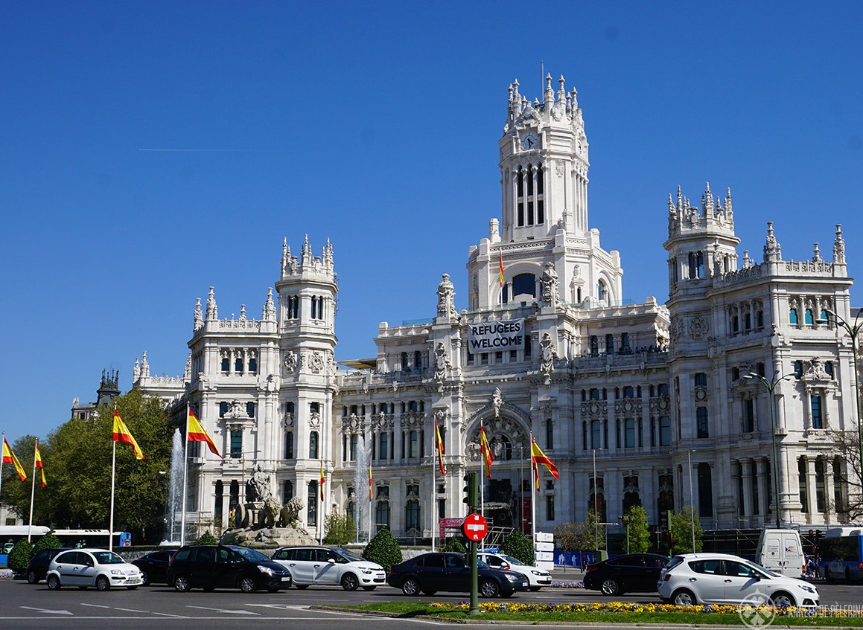


https://beneficialmicrobes.conferenceseries.com

Mail us to know more!
For Abstract Submission Guidelines | For Reserving your slot
| Proposals | Registration | Posters | Accommodations
No doubt you have lots of queries...

For Queries
Contact: Business Event Manager
E: beneficialmicrobes@annualamericacongress.com

For Exhibition & Sponsorship Contact: Manager
E: beneficialmicrobes@annualamericacongress.com

Conference Series LLC Ltd
7Churchfield Road, London, W3 6AY, UK
P: 44-800-098-8455
Why not get in touch..!
Drop us your query with details and we will call you right away

