
31st Annual
American Dentistry Congress

July 24-25, 2020 Vancouver, Canada

https://americandentistry.dentalcongress.com

Invitation...
Dear Colleagues,
We are delighted to announce our 31st American Dentistry Congress scheduled from July 24-25, 2020 in Vancouver, Canada.
“Innovative Ideas for Excellence Future in Dental and Oral Health Care” is the driving theme of the American Dentistry 2020, which will most definitely be reflected in the conference program, where we expect a remarkable turnout of world-renowned speakers.
American Dentistry 2020 will have more than 100 International renowned speakers to share their latest research results to participants; the planned program will cover a variety of subjects in the field of Dentistry. The conference will also provide an opportunity for interaction and interchange ideas through posters, open discussion and program project. We strongly believe that the exchange of knowledge and experience will result in a strong global collaboration between you and us
Attendees at American Dentistry 2020 will have unique opportunity to meet with leaders of the Dental and Oral Health profession from around the globe to discuss all of the scientific and technical breakthroughs that are changing the landscape of dentistry and fulfill their continuing education and professional development.

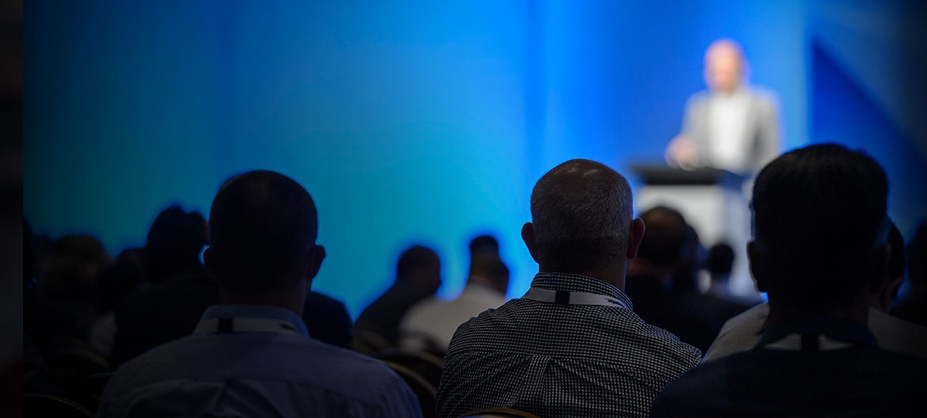
American Dentistry 2020

GOAL
The purpose of this year’s conference is to discuss the wonders happening in the ever growing field of Dentistry. This conference is an acting stage for business professionals, Dentists Directors, academicians, technicians and mainly students to showcase their innovations and new ideas.

NETWORKING

The attending experts, industry partners and motivational speakers will provide a fantastic networking experience.

This conference provides B2B and B2C at a single international platform, which will definitely add value to your ideas in terms strategic development and management.

WHO CAN ATTEND?
- Dentists and Dental nurses
- Dental and Oral Health Scientists.
- Directors and CEO’S
- Dental and Oral Health Faculty members, Researchers and Students.
- Dental Business/Practice Managers
- Procurement and Management teams from Corporate Dental Organizations
- Dental Wholesalers, Dealers and Distributors
- Manufacturing Medical Devices Companies

Conference Schedule...
MORNING | CONFERENCE DAY 01  Registration
MORNING | Welcome Ceremony
MORNING | Keynote Presentation
MORNING | Round Table Panel Discussion
MORNING | Keynote Presentation
AFTERNOON | Lunch
AFTERNOON | Speaker Presentations
AFTERNOON | Round Table Panel Discussion
AFTERNOON | Speaker Presentations
AFTERNOON | B2B Session

CONFERENCE DAY 02
MORNING | Keynote Presentation
MORNING | Round Table Panel Discussion
MORNING | Speaker Presentations
MORNING | Speaker Presentations
 | Round Table Panel Discussion
 | Lunch
AFTERNOON | Speaker Presentations
AFTERNOON | Exhibiting Hours
AFTERNOON | Networking Session
AFTERNOON | Round Table B2B

Note: Program Schedule is subject to change with final allotment of the speaker slots E-mail: americandentistry@eventsupporting.org

Venue & Accommodation...

Vancouver, Canada

Hotel details will be updated soon…

Registration Details...

ACADEMIC
Only Registration | 499 USD
Package A (Registration + 2 nights’ Accommodation) | 799 USD
Package B (Registration + 3 nights’ Accommodation) | 899 USD
DELEGATE
Only Registration | 399 USD
Package A (Registration + 2 nights’ Accommodation) | 799 USD
Package B (Registration + 3 nights’ Accommodation) | 949 USD
STUDENT
Student Poster | 399 USD
Student Delegate | 249 USD
Young Research Forum | 299 USD
OTHER REGISTRATION
Video Presentation | 199 USD
Webinar | 199 USD
Only abstract publication | 99 USD
FOR EXHIBITOR
Conference Exhibitor | 1499 USD
-Registration Link-
https://americandentistry.dentalcongress.com/registration.php

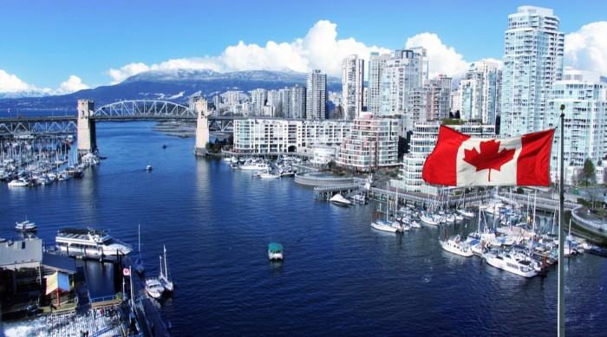


Mail us to know more!
For Abstract Submission Guidelines | For Reserving your slot
| Proposals | Registration | Posters | Accommodations
No doubt you have lots of queries...

For Queries
Contact: Business Event Manager
E: americandentistry@eventsupporting.org

For Exhibition & Sponsorship Contact: Manager
E: americandentistry@eventsupporting.org

Conference Series LLC Ltd
7 Churchfield Road, London, W3 6AY, UK
P: 44-800-098-8455
Why not get in touch..!
Drop us your query with details and we will call you right away

https://americandentistry.dentalcongress.com/

