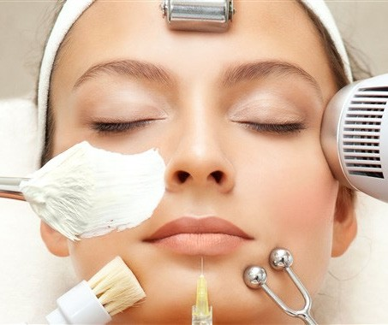
conferenceseries._{com}

32ndAmerican Dentistry Congress
July 26-27, 2021 | Webinar

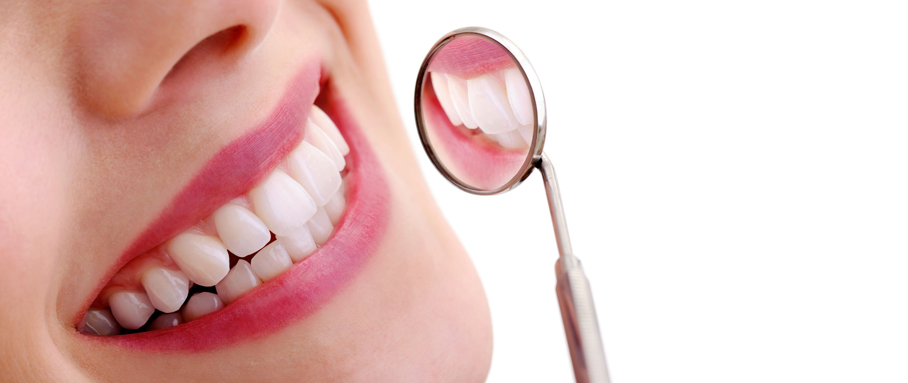

09:00-09:30 | Introduction
09:30-09:50 | COFFEE BREAK
09:50-11:50 | KEYNOTE LECTURES
11:50-13:10 | Talks On: American Dentistry
 | Dental Public Health and Oral Diseases
 | Dental Hygiene and Oral Health
 | Oral and Maxillofacial Surgery
13:10-13:15 | Case Reports
13:15-14:00 | LUNCH BREAK
14:00-16:00 | Talks On: American Dentistry
 | Periodontics and Preventive Dentistry
 | Orthodontics and Dentofacial Orthopaedics
 | Pediatric Dentistry, Oral Care and Therapeutics
16:00-16:20 | COFFEE BREAK
 | Young Researchers Presentations | Workshop

09:00-10:30 | KEYNOTE LECTURES
10:30-10:50 | COFFEE BREAK
10:50-12:50 | Talks On: American Dentistry
 | Geriatric Dentistry, Aging and Palliative Care
 | Restorative Dentistry and Endodontics
 | Dental Research and Practice Management
 | Dental Anesthesiology and Pain Management
12:50-13:35 | LUNCH BREAK
 | MEETING HALL
13:35-15:55 | Talks On: American Dentistry  Oral Cancer, Oral Oncology and its complications
 | Digital Dentistry, 3D Imaging and Dental Technology
 | Nanodentistry, Nanomaterials and Nanotechnology
 | Dental Sleep Medicine and Obstructive Sleep Apnea
15:55-16:15 | COFFEE BREAK
 | Poster Presentations | Workshop

Matthias Kern,
Christian-Albrechts University, Germany

Mohamed Mehanny,
Minia University, Egypt

Michael J Pontack,
Smile Right Dental Laboratories, Inc, USA

Pisi Paolo,
University of Bologna, Italy

Amr Abouzeid,
BDS Faculty of Dentistry, Tanta University, Egypt

Richard J Miron,
University of Bern, Switzerland

Michael J Pontack,
Smile Right Dental Laboratories, USA

Rimah Tariq Rajhi,
Jazan University, Saudi Arabia

Bin Hassan Saeed A,
King Khalid Univercity, Dentistry College, SA

Eynar Berdeli and Kubra Aral,
Izmir Katip Celebi University, TurkeyThe Turkish
Ministry of Health, Turkey

Ahmed Moustafa Mobarak,
Alexandria University, Egypt

Greta Kersyte,
Lithuanian University of Health Sciences, Lithuania

Fakhrul Hasan Kaleemi,
H.K.E’s S.N Institute of Dental Sciences & Research, India

Amr Abouzeid,
Tanta Univiersity, Egypt

Sameer Atrash,
Tufts Dental School, USA

Andre Galembeck,
Universidade Federal de Pernambuco, Brazil

Syed Muhammad Anwar,
University of Engineering and Technology, Pakistan

Miguel Monteiro,
University of Rio de Janeiro State, France

Gouri Sankara Krishna Gattupalli,
Shree Narayana Datte Dental Clinic, India

Abdulkhaliq Alshadidi,
King Khalid University, KSA

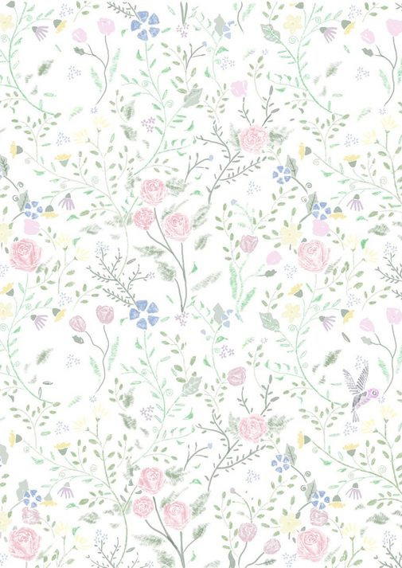
Glimpses of American Dentistry
Congress

