Sponsorship Catalog

7th International Conference on Aerodynamics, Fluid Dynamics and Aerospace Engineering
November 12-13, 2018
Melbourne, Australia
https://aerodynamics.enggconferences.com/
Aerodynamics 2018 Sponsorship Opportunities:
Aerodynamics 2018 Conference is organizing an outstanding Scientific/ Business product oriented Exhibition Program and anticipates the world’s leading specialists involved in Aerospace and Fluid dynamics from all across the globe. Conference organizing committee anticipates over 200 participants to attend this premier event in Melbourne, Australia during November 12-13, 2018. Your organization will benefit with excellent exposure and networking with the various top decision makers of the respective organizations.
Aerodynamics 2018 is an exciting opportunity to showcase the new technology, new products of your company, and/or the service your industry to a broad international audience. Lots of thoughts were put together to make this conference a premier event. Sponsoring at Aerodynamics 2018 will attain you with an exceptional format in showcasing your product and services and to gain the potential clients for the future business prospects.

We provide you one location to reach your top customers.

7 Best Perks Offering @ Aerodynamics 2018

- Broadcast your presentation Live over the web! Join us with your Colleagues
- Global Exposure to your Research
- Networking with Experts in the Field
- Best Poster Competition and Young Researcher Competition
- Publish your research in International Journal
- The Career Guidance Workshops to the Graduates, Doctorates and Post-Doctoral Fellows
- Website visibility to more than 35K visitors in less than 6 months

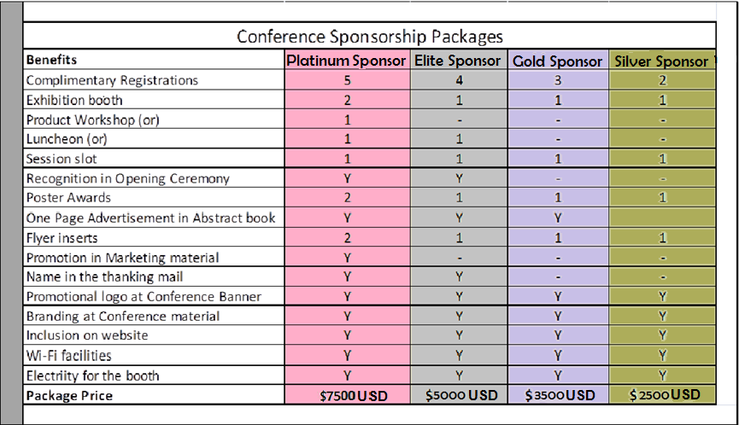

Exhibitor Benefits

- An exhibition booth
- Two complimentary Speaker/ Delegate Registration
- Electricity and Wi-Fi facility
- Lunch and coffee break passes
- Conference material/ Delegate bag
- Your company logo share at our website visible to 35K plus visitor during the conference proceedings
- Logo Recognition on conference material (Abstract book and Program)
- Half page advertisement in our conference book
- 30% registration discount to your members for participation

- Exhibition Partnering or Vendor stall installation charges: $1750 USD (including taxes)

Other Sponsorships & Partnering

- Keynote Sponsorship - $2000 USD
- Session Sponsors - $1500 USD
- Delegate Bag Sponsors – $999 USD
- Lunch Sponsors - $2000 USD
- Poster Award Sponsor - $1000 USD
- Committee Dinner Sponsor - $1500 USD
- Breakfast Sponsors - $1000 USD
- Advertisement - $500 USD/ ID Card Sponsors - $500 USD

Contact details:

William Klaasen
Aerodynamics 2018 - OC Assistant
Business Partnering and Sponsorships
Aerospace Conferences
https://aerodynamics.enggconferences.com/
Email id: aerodynamics2018@gmail.com
Phone: 6508894686 (EXT: 6094).

