Fast and label-free single cell analysis in regenerative medicine
Karin Schütze, CellTool GmbH Bernried, Germany
Heidi Kremling, CellTool GmbH Bernried, Germany

Abstract (300 word limit)

In the last years, the field of regenerative medicine have opened unforeseen therapeutic opportunities. In order to ensure functionality and safety of cell based therapies used for patient care, methods allowing reliable quality control during all steps of product development are essential. Raman Spectroscopy (RS) is a highly sensitive technology increasingly used for biomedical applications like cell identification and characterization, as well as quality control of cell based products as it reveals detailed information on the metabolic state of living single cells in a label-free and non-invasive way. Here, we demonstrate that RS is a valuable tool also in regenerative medicine. It helps to understand basic cellular processes, to ensure quality of cell based products and to improve current gold standard methods. We provide latest data from Raman analyses of single cells as well as of 3D cell culture and tissues, including investigations on retina tissue, insights on the influence of stem cell freezing and quality control of chondrocytes and blood products, showing that this non-invasive approach provides new insights on the whole metabolome of cells which help to improve and secure analysis in regenerative medicine.
This project received funding from EU 7th Health Program grant agreement No 279288 and the German Federal Ministry of Education and Research “KMU-innovative: Medizintechnik: HämatoRam” 13GW0112A.

Image
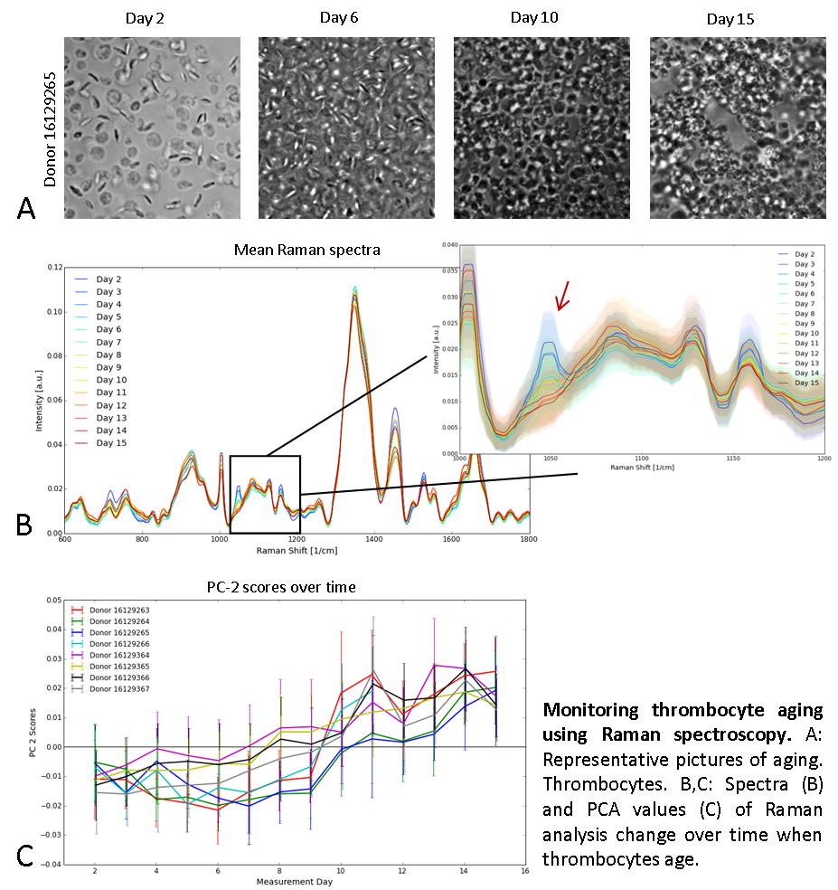
Recent Publications (minimum 5)
- "Zellanalyse neu definiert", Heidi Kremling, Florian Zunhammer, Karin Schütze,Waldemar Lernhardt; BIOPHOTONIK 2/16, S. 34-38, (2016)
- Florian Zunhammer, Dr Heidi Kremling, Dr Tanja Buchacher, Dr Torsten Tonn, Dr Roland Werk, Dr Karin Schütze, Lab&More, (2015) 4.15:30-31
- Potential and limitations of microscopy and Raman spectroscopy for live-cell analysis of 3D cell cultures. Charwat V, Schütze K, Holnthoner W, Lavrentieva A, Gangnus R, Hofbauer P, Hoffmann C, Angres B, Kasper C; Journal of Biotechnology 205 (2015) 70–81
- An engineered 3D human airway mucosa model based on an SIS scaffold Steinke M, Gross R, Walles H, Gangnus R, Schütze K, Walles T; Biomaterials. 2014 Aug;35(26):7355-62. doi:0.1016/j.biomaterials.2014.05.031. (2014)
- Photons on duty for health: Raman spectroscopy for biologists and clinicians. Gangnus R, Grigaravicius P, Becker KF, Schütze K
Labore&More (2014) 2.14:22-27

Biography (150 word limit)


Dr. Schuetze is a biologist and expert in non-contact cell handling and label-free cell analysis using innovative photonic technologies. She did her PhD work at the Institute for Applied Physical Chemistry in Heidelberg and her postdoc research at the University of California in Berkeley where she assembled her first Optical Trap. In 1993 she and her husband founded the PALM company, which was successfully sold to Zeiss. In 2008, they both founded their second company, the CellTool GmbH, where they develop Raman microscope systems for biomedical applications, providing physicians and biologists with a label- free and non-invasive tool for cell analysis.

Email: k.schuetze@celltool.de

Notes/Comments:

