Impact of furfural biotransformation on the transcriptional level of acetate metabolism and oxidative phosphorylation genes
Eduardo Arteaga* and Juan Carlos Sigala
The Universidad Autónoma Metropolitana (UAM), Mexico
Abstract
Statement of the problem: Pretreatment of lignocellulosic biomass produces inhibitors substances such as furfural which is toxic to fermentative microorganisms. Acinetobacter baylyi ADP1 cannot use furfural as a carbon source, instead it bio-transforms furfural into difurfuryl ether using the NADH-dependent alcohol dehydrogenases AreB and FrmA during aerobic Acetate Catabolism (AC) in detriment of growth. The NADH competition between furfural biotransformation and the production of energy by Oxidative Phosphorylation (OP) might compromise the growth of A. baylyi ADP1. Depending on the growth phase, exponential or stationary phases, several AC and OP genes may change their expression so key central metabolic pathways can be affected. The purpose of this study is to determine the effect of the furfural bio-transformation on the expression of genes for the growth of A. baylyi ADP1 on acetate.
Methodology and theoretical orientation: Transcriptional analysis was done at exponential and stationary growth phase. Samples were collected before and after the addition of two pulses of furfural to 0.5 g furfural/L. RT-qPCR was used according to MIQE guidelines and the double delta Cq method was used to calculate the relative gene expression.
Findings: Changes in transcriptional levels of several genes showed the influence of furfural on AC and OP. At exponential growth phase, reactions involved in the formation of NADPH (icd) and NADH (sfcA) are preferred. In contrast, at stationary growth phase glyoxylate shunt is preferred.
Conclusion: At exponential growth phase a higher NADH/NADPH production might support furfural biotransformation and NADH generation favored mainly the biotransformation of furfural. Characterization of this physiological behavior can clarify the impact of furfural biotransformation in Acinetobacter species.
A
B
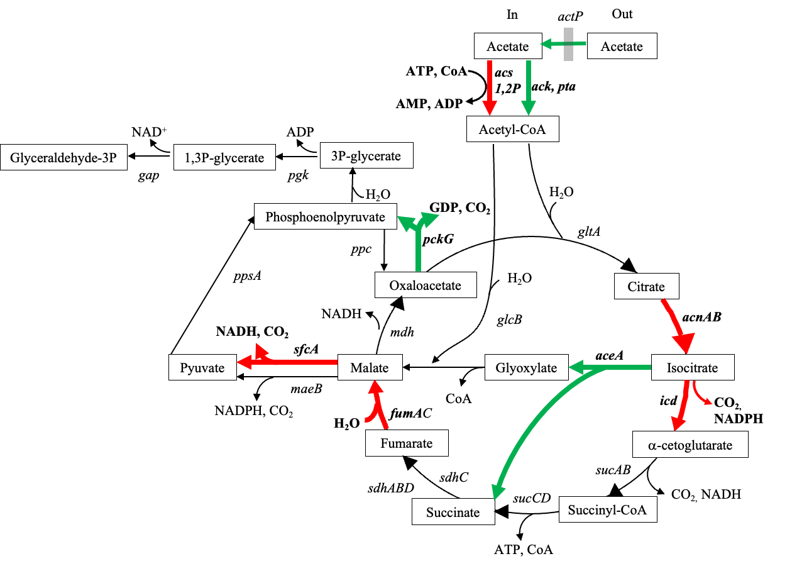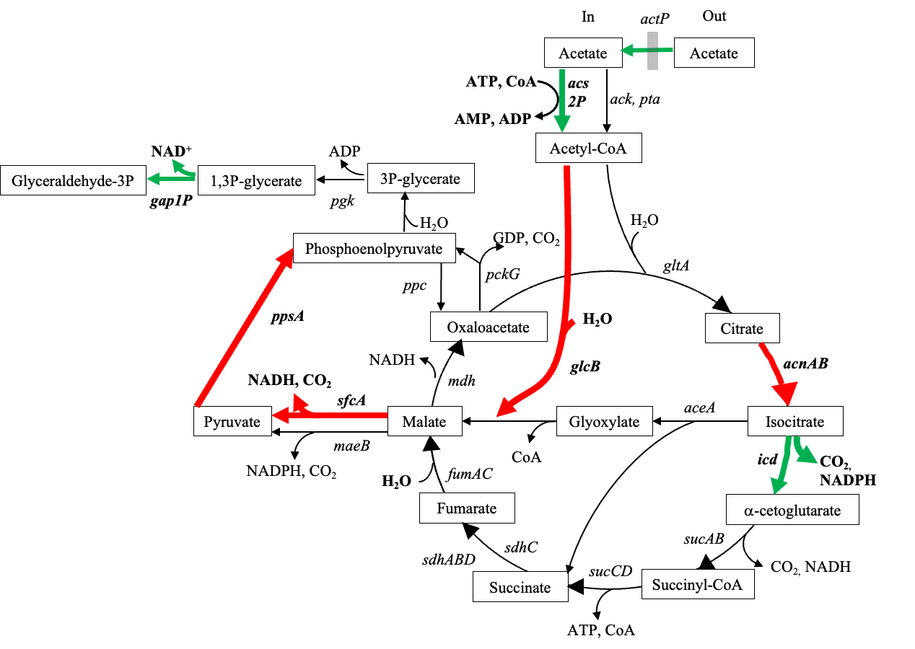
Figure 1. Acetate catabolism in exponential (A) and stationary phase (B) with 1 g of furfural/L. Key pathways, metabolites and genes are highlighted. Green and red arrows represent under expression or overexpression of the involved genes, respectively.
Biography
Eduardo Arteaga holds a BSc in Bio-pharmaceutical Chemistry and a MSc in Natural Sciences and Engineering. He has experience in Microbiology, Microbial Biotechnology, Molecular Biology, Microbial Physiology, Biocatalysis, and Genetic Engineering. He has interests in Bioinformatics, Synthetic Biology, and Biopolymers. Currently, he is a PhD student at Universidad Autónoma Metropolitana, Mexico. He is a member of a team that works with bacterial strains with the potential capacity to detoxify lignocellulosic biomass hydrolysates.

