Single polymer UHMWPE thermoplastic composite through different techniques for various high-performance applications

Ashraf Nawaz Khan*, R. Alagirusamy, Apurba Das and Puneet Mahajan

Indian Institute of Technology, India

Abstract

The present work offers a suitable manufacturing technique for the development of very lightweight UHMWPE fiber-based fully thermoplastic composite materials. The weak interface formation with the highly viscous thermoplastic matrices is the major limitation. This major limitation is resolved through the powder-coated towpreg which is the primary substrate for the composite materials. The flexible powder-coated UHMWPE/LDPE towpreg results in homogenous matrix distribution throughout the composite on consolidation after hot-pressing. The produced ‘matrix impregnated’ flexible towpreg can be easily woven to any complex weave structure which is hard to achieve with other techniques such as melt impregnation, solution impregnation, etc. Furthermore, the current work made it possible to deposit charged LDPE powder onto the non-conductive UHMWPE fibers’ surface through the electrostatic powder spray technique uniquely and neatly. The improved technique extends the application of electrostatic-based powder coating to all fibers material (i.e., conductive or non-conductive) with a chemical-free methodology (environment friendly).

Moreover, the fiber reinforced composite produced through the powder-coated towpreg has been compared with the composite prepared through other conventional techniques such as the Film stack technique, etc. The different material characterization such as DSC, TGA, XRD, DMA, etc., and mechanical characterization such as tensile, compression, shear test, drop weight impact test, abrasion wear, etc. has been done to examine the utility of the single polymer UHMWPE composites. The end composite product finds its applicability in various fields such as Impact panels, biomedical implants, and other lightweight high-strength Structural applications. The composite produced through powder-coated preform is found to be the superior in comparison to other laminates prepared through the Film stack technique in terms of mechanical performance as mentioned above. Furthermore, the fractography analysis has been carried out with the help of SEM, micro-CT, and other tools to extract the comprehensive information from the damaged samples.
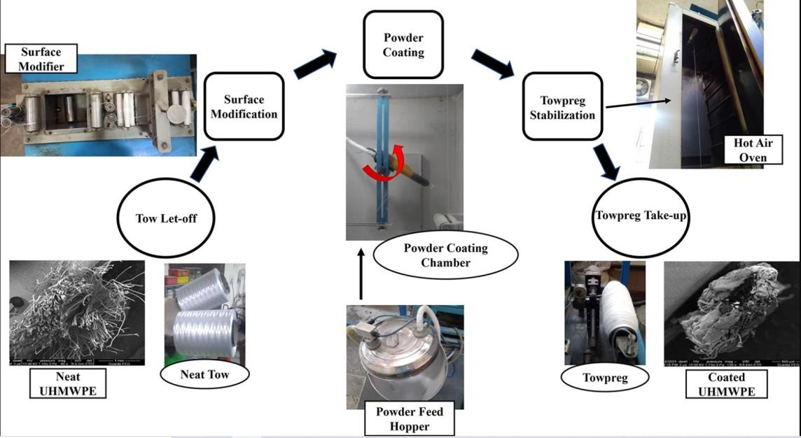

Figure 1.

Biography
Mr. Ashraf Nawaz Khan is pursuing a PhD at Indian Institute of Technology (IIT), Delhi. He completed graduation in Mechanical Engineering (B. Tech.) in 2015. He obtained M. Tech. Degree in Textile Engineering (2017). His area of research includes Thermoset and Thermoplastic based fiber reinforced composite materials, Preparation of different Hybrid yarn towpreg, Natural fiber based composite materials, Different weaving architecture preforms, Modelling and Simulation for Mechanical performance prediction, Developments of towpreg machines, etc. As of now, he published four research papers in reputed journals and several others are under communications. He attended various international conferences in past. Recently, he filed a patent for the development of the system for powder coating. He is awarded Research Travel Excellency Award (2022) from IIT Delhi for outstanding research and best paper presentation at the conference (ICETT, 2019) also the merit scholarship during the entire graduation year (2011-2015).

