Innovations and applications of 3D printing in food sector: A review
Akriti Taneja^{1*}, Ruchi Sharma¹, Krishna Ayush¹, Anshu Sharma², Amin Mousavi Khaneghah³, Joe M Regenstein⁴, Francisco J. Barba⁵, Yuthana Phimolsiripol⁶ and Somesh Sharma¹
¹Shoolini University, India
²Dr.Y.S.Parmar University of Horticulture and Forestry, India
³State University of Campinas Faculty of Food Engineering, Brazil
⁴Cornell University, USA
⁵Universitat de València, Spain
⁶Chiang Mai University, Thailand

Abstract
Background: 3-D printing is a neoteric technology that can make existing food value chains client-desirable and sustainable by providing on-demand food production, enabling automated food personalization, and minimizing food wastage. However, its applicability is currently limited, and many researchers are investigating the technique' utility.
Scope and Research: This review paper provides a holistic outlook of the technology beginning with the various techniques utilized for 3-D printing and printers commercially available in the market. Substantial raw ingredients used for printing and the components which could be used soon are discussed. The pros and cons of this technology along with its potential applications and future perspectives of 3-D food printing are also evaluated. The aim of the review is to draw more attention to 3-D printing among researchers in order to improve the printing process and to provide some valuable knowledge for future research.
Conclusion: Food printing has a huge impact on food processing methods, allowing designers/users to change forms and materials with remarkable capability. It can address hunger issues in countries where affordable and fresh ingredients are inaccessible by integrating nutrient-rich substrates, probiotics, bioactive compounds, and functional ingredients into complex fabricated foods. More research is needed to identify alternative materials that could be manufactured using this process. Furthermore, dissemination of information and knowledge about the rise of 3-D printing in food should be well organized and corroborated by relevant and logical scientific findings that will improve consumers or users understanding and acceptance of the technology.

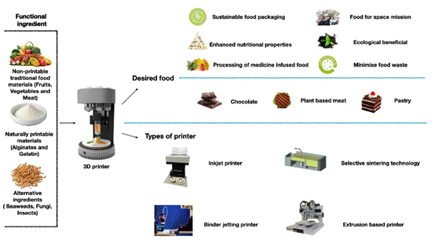
Figure 1:

References
- Varvara R, Szabo K, Vodnar D. 3D food printing: Principles of obtaining digitally-designed nourishment. Nutrients. 2021;13(10):3617.
- Escalante‐Aburto A, Trujillo‐de Santiago G, Álvarez M, et al. Advances and prospective applications of 3D food printing for health improvement and personalized nutrition. Compr Rev Food Sci Food Saf COMPR REV FOOD SCI F. 2021;20(6):5722-41.
- Carvajal-Mena N, Tabilo-Munizaga G, Pérez-Won M, et al. Valorization of salmon industry by-products: Evaluation of salmon skin gelatin as a biomaterial suitable for 3D food printing. LWT. 2022;155:112931.
- Watkins P, Logan A, Bhandari B. Three-dimensional (3D) food printing: An overview. Food Engineering Innovations Across The Food Supply Chain. 2022;261-76.
Biography
Akriti Taneja is a 3rd year Btech food technology student at Shoolini University, Solan, H.P, India. She is a highly pragmatic, methodological and hard working person who aims to bring revolution in food Industry through innovation and creativity. She is the executive member of Student outreach program under NSS (National Social Service)-Bapu Dham colony, Sec-26 Chandigarh, has an experience of organizing many cultural programs and food drive for the residents, as this colony is espoused by her school. She is the Class Representative of her batch and a volunteer at YOUWECAN, which is a non-profit organization established by Indian cricketer and cancer survivor Yuvraj Singh and its mission, is to empower people to fight cancer through awareness, prevention, early detection, patient support and survivor empowerment.

