Raman spectroscopy: In vivo application for bone evaluation in oral surgery. Possible alternative to histhology
Gatin Eduard
University of Bucharest, Romania
Abstract
Our days, there is a large number of surgical techniques involving the implantation of various types of bone graft and /or bone substitutes in order to achieve periodontal regeneration. Despite positive observations in animal models and successful outcomes reported for many of the available regenerative techniques and materials in patients, including histologic evidence, robust information on the degree to which reported clinical improvements reflect true periodontal regeneration remains just limited. It is requested a method adapted for a quick evaluation of the bone and precise in the meantime.
For the bone tissue, at micro level Octa Calcium Phosphate (OCP) (Ca₈(HPO₄)2(PO₄)4•5H₂O) is considered very important because it is regarded as an in vivo precursor of HA. Trying to find traces for phase transition of OCP to HA, the presence of HA nano rods and plate-like HA particles can be utilized as signs of bone good quality evidenced by histology investigation (Figure 1). The normalized peak intensity values are related to each compounds concentration.
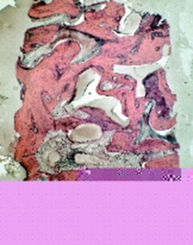
Figure 1. Histological results.
A group of five patients was involved to our study. Investigation was performed by RAMAN technique, first in vivo and then in vitro for the harvested bone samples.
There were evaluated/compared the following peaks, for in vivo and then in vitro for the harvested bone samples [Figure 2 (a),(b)]:
- 430–450 cm⁻¹ (ν2, PO₄³⁻)
- 955–960 cm⁻¹ (HPO₄²⁻, immature bone)
- 960–965 cm⁻¹ (mineral bone, mature bone)
- 1023 cm⁻¹ (P₂O₇⁴⁻; PPi, inorganic pyrophosphate)
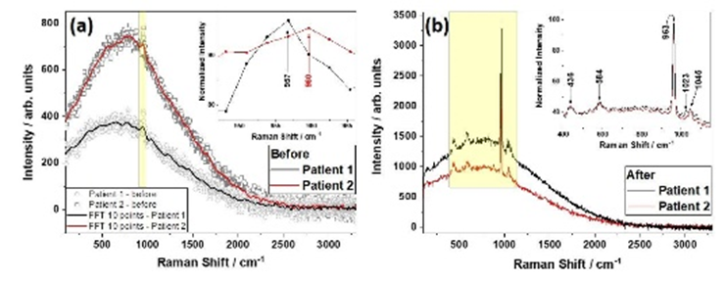
Figure 2. Raman spectra for bone samples (a) before treatment, (b) after treatment.
Raman method adapted for “in vivo” bone quality evaluation, is much less invasive then the well-known CT (Computer Tomography) or CBCT (Con Beam Computer Tomography) already used and more accurate. For this purpose, the Raman probe was modified with a “special cap” in order to assure regular sterilization for in vivo use.
Biography
Eduard Gatin, Physicist Education, research in polymer and materials science, dental materials University of Bucharest, Faculty of Physics (1994–present, Assistant/Lecturer) PhD Biology & Physiology. From 2010–present, he is a Lecturer–Biophysics Department University of Medicine “Carol Davila”, Faculty of Medicine. His Area of interest: polymer membranes for blood filtration. He continued with research in material science-polymers, advanced nano materials, ceramics, metal alloys, corrosion, dental materials and tissue regeneration. His Laboratory Research activity: Materials structure, physical/chemical properties, dental enamel, bacteria activity, polymer resin composites, dental ceramics, metal alloys and corrosion studies. His Techniques skills: RAMAN spectroscopy (improved by SERS), SEM, EDX. In 2013 he succeeded to propose a method for quality evaluation of dental enamel by Raman method, to be applied “in vivo”. In 2015, patent registration certificate was issued. It was started the study of Introducing RAMAN technique to Periodontology” (in vivo application).

