Overview of medium voltage DC shipboard microgrids
Luona Xu
Aalborg University, Denmark
Abstract
Integrated Power Systems (IPSs) in electric ships are popular in the maritime industry. Medium Voltage DC (MVDC) Shipboard Micro Grids (SMGs) have many advantages compared with AC ones in terms of system efficiency, operation flexibility, and component size. However, the study and application of MVDC SMGs are still in exploration stage, and many challenges need to be solved before commercial applications. In this presentation, an overview of MVDC SMGs including the hardware composition and control system, as well as future research trends are introduced. By reviewing and summarizing existing scientific research literatures, industrial reports, standards, and commercial products, existing and potential system configurations, and power components, including power sources, energy storage devices, shipboard loads, and power converters (rectifiers, inverters, and DC/DC converters), and their comparisons in MVDC SMGs are discussed. Based on the comparisons, design recommendations for different types of ships from the aspects of system architecture and power components are presented. Besides, from the aspects of control system, general control configurations and special issues in DC electric ship application, such as the integration of energy storage system, the stability issue related to pulsed power loads, and the protection system in DC SMGs are discussed as well. This review gives insight into the design and control of DC system for modern electric ships (Figure 1).
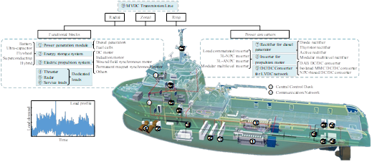
Figure 1. Overview of a typical DC-SMG.
Biography
Luona Xu received the B.S. degree in Electrical Engineering and Automation from China Agricultural University, Beijing, China, in 2014, and M.S. degree in Electrical Engineering from University of Chinese Academy of Sciences, Beijing, China, in 2017. From 2017 to 2019, she was an electrical engineer in East China Electric Power Design Institute Co., Ltd., Shanghai, China. She is currently working toward the PhD degree at AAU Energy, Aalborg University, Denmark. Her research interests include coordinated control for shipboard microgirds and pulsed load power supply in maritime application.

