Thermoacoustic engine for thermoacoustic cooler with different heating and cooling temperature
Irna Farikhah
Universitas PGRI Semarang, Indonesia
Abstract
Handling thermal pollution due to the industrial waste heat is required to minimize the impact of the emitted thermal heat on the environment. There are some technologies that can be used to recovery the waste heat, one of which is thermoacoustic technology. In recent years, converting low-grade energy into valuable energy such as acoustic for driving cooler has become an applicable method to regain wasted thermal energy. The thermoacoustic engine can convert thermal into acoustic energy then the acoustic energy could be transferred for refrigeration. Thermoacoustic technology can be divided into two parts: one is thermoacoustic engine and cooler. To design the cooler system having high efficiency and lower onset heating temperature, the varied cooling temperature is numerically investigated from -15 to 15℃. The heating temperature generating acoustic power can be decreased from 256 to 205℃. Moreover, 6% of Thermodynamic upper limit value of the whole system is achieve and the efficiency of the engine, cooler and tube are 66%, 41% and 23%, respectively when the cooling temperature is -15℃ and the heating temperature is 256℃.
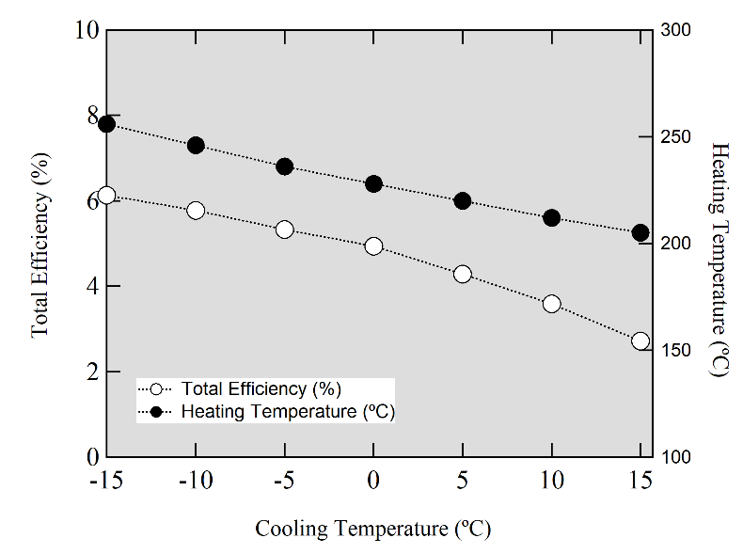
Figure 1.
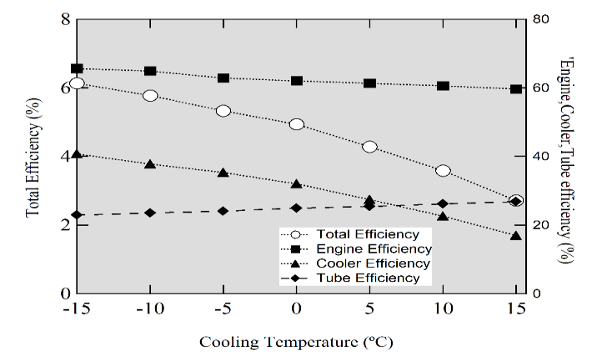
Figure 2.
Biography
Irna Farikhah, PhD is currently an Assistant Professor at Mechanical Engineering, Universitas PGRI Semarang, Indonesia. She holds a PhD degree from Tokyo University of Agriculture and Technology Japan majoring in System Engineering. Moreover, she published some articles in some International Journals and Proceedings from International Conferences in Singapore, Tokyo and London. In 2019, she got scholarship from Turkish government as a research fellowship in Department of Mechanical Engineering, Celal Bayar University, Turkey. In 2020, she has appointed as a visiting research fellow at the Universitas Malaysia Perlis (UniMAP). She is also a member of World Society of Sustainable Energy Technologies (WSSET).

