A case report of severe ovarian hyper stimulation syndrome
Punhiru Udeshika
University of Colombo, Sri Lanka
Abstract
Ovarian Hyper Stimulation Syndrome (OHSS) is a gynaecological emergency which occurs when the ovaries are hyper stimulated and enlarged most commonly due to fertility treatments or sometimes rarely due to mutations in the Follicle Stimulating Hormone (FSH) receptor. Vasoactive substances released by the ovary thought to be responsible for increased vascular permeability associated with OHSS though exact pathology is not fully understood. 26-year-old lady who was primary sub fertile for 3 years and underwent In-Utero Insemination (IUI) one week prior to the onset of symptoms was admitted with severe abdominal pain and increasing difficulty in breathing for 05 days. On admission she had gross ascites and bilateral moderate pleural effusions with haematocrit of 45.9. Clinical suspicion of OHSS was made. There was neutrophil leucocytosis, mild hyponatremia, mild elevated liver enzymes, hypoalbuminemia, normal clotting and normal serum osmolality. She was managed with oral cabergoline 0.5 mg daily, daily dose of steroids, fluid management to maintain urine output of 0.5-1 mL/kg/hr, prophylactic anticoagulants and abdominal paracentesis for symptomatic relief, supplementary oxygen, coupled with intensive care monitoring. Later in the course she was found to have intra uterine pregnancy (IUP) and OHSS regressed with clinical improvement and normalization of laboratory parameters. She made a full recovery and discharged on day 11 of admission after antenatal clinic registration. This case demonstrated that early diagnosis and intensive supportive care which include steroids and oral inhibitors of vascular endothelial growth factor phosphorylation, effective fluid management and symptomatic abdominal paracentesis are important in successful management of severe OHSS (Figure 1).
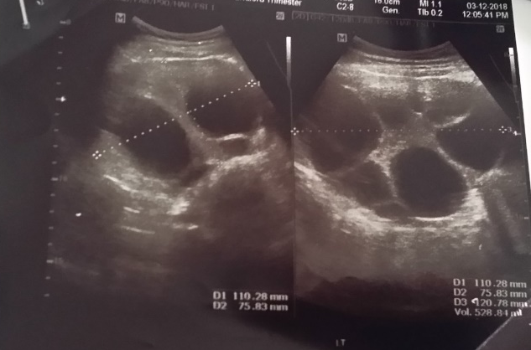

Figure 1: Enlarged right ovary (volume 500 ml) with multiple ovarian cysts on abdominal ultrasound scan
Biography
Dr. Punhiru Udeshika earned her primary medical degree MBBS from the University of Ruhuna, Sri Lanka and currently working as a registrar in Emergency Medicine in Accident Service Unit of National Hospital of Sri Lanka. She is completing her MD in Emergency Medicine in October 2020.

