The effect of different scanning protocols on the retention of digitally constructed complete denture bases
Rizk FN^{1*}, Eldahmy LS¹, Sabet ME² and Tarek HM²
¹British University in Egypt, Egypt
²Ain Shams University and British university, Egypt
Abstract
Aim: This cross-sectional clinical trial with ten completely edentulous patients compares the retention of two groups of complete denture bases. Group A denture bases fabricated by final impression digital scanning and group B denture bases fabricated by master cast digital scanning.
Methods: After taking primary impressions closed-mouth impression technique was done and scanned then the impressions were boxed, poured and the resulting master casts were scanned. From each group a denture base was fabricated by additive manufacturing technique and the retention of each denture base was evaluated intraorally by using digital force gauge.
Results: The readings were recorded, tabulated and student’s t-test (unpaired) was used to identify the difference between the two scanning groups’ retention values. The significance level was set at P ≤ 0.05. The data revealed that impression scanning group had slightly higher values of retention than cast scanning group even though there was no statistically significant difference between the retention of the two scanning protocols (Figure 1).
Conclusion: Within the limitations of this study it was concluded that both extraoral digital scanning protocols has no effect on the degree of complete denture base retention.
Keywords: Digital Denture; Digital Impression; CAD/CAM Dentures; Impression Scanning; Additive Manufacturing Technique.
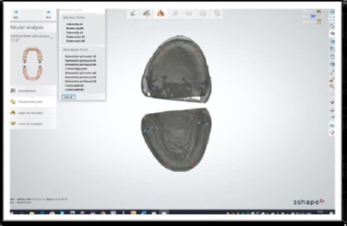
Figure 1: Final design of 3Shape dentures

Biography
Rizk FN is a Vice Dean for Teaching and Learning, Faculty of Dentistry, The British University in Egypt, 2019-present. Program Director and Head of Prosthodontics Department at Faculty of Dentistry, British University in Egypt, 2012-present. She is a professor of Prosthodontics at Faculty of Dentistry, British University in Egypt, 2017-present. A. Professor of Prosthodontics at Faculty of Dentistry, British University in Egypt, 2012-2017. PhD Prosthodontics, Faculty of Dentistry, Ain Shams University 2007. M.Sc. Prosthodontics, Crown and Bridge and Dental Materials, Faculty of Dentistry, Cairo University, 2000. B.D.S Oral and Dental Medicine, Faculty of Dentistry, Caro University 1994.

