Management of tooth hypersensitivity using diode laser and nano hydroxyapatite toothpaste
Mohamed Shamel* and Sara Elbanna
The British University in Egypt, Egypt
Abstract
Introduction: Dentin hypersensitivity is a very common problem that faces many patients and maintaining treatments with long term effectiveness remains a challenge. Based on hydrodynamic theory, the main approach of overcoming DH is tubular occlusion. At home Nano hydroxyapatite tooth pastes and in-office diode lasers are among the treatment options. Main aim of this study was to discover the efficacy of diode laser alone and in combination with desensitizing toothpaste containing Nano hydroxyapatite to evaluate dentinal tubular occlusion after acid challenge under scanning electron microscope.
Material and methods: Forty dentin discs were divided into 4 groups; Group I control, Group II dentin disc treated with nHap tooth paste for one week, Group III discs treated with diode laser in non-contact mode for 60 seconds, Group IV discs treated with nHap tooth paste for one week followed by laser application. SEM analysis was performed after acid challenge to the discs (Figure 1).
Results: Tubular occlusion was evident in all groups after acid challenge, however, Group IV, the laser and Nano hydroxyapatite combination, showed the most occluded tubules which was the most resistant to the acid challenge.
Conclusions: Combination of diode laser and tooth paste containing nHap has a greater effect on occluding dentinal tubules rather than each treatment alone.
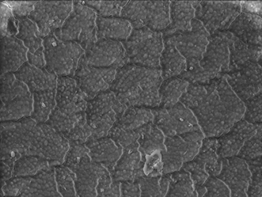
Figure 1: SEM image (2500×) of a dentin sample in group IV (Biorepair+ diode laser) the tubules of the irradiated dentin are not visible where some areas show deposition of some minerals from the toothpaste and multiple microcracks are seen.
Biography
Dr. Mohamed Shamel, associate professor of Oral Biology, has his expertise in studying different diseases affecting the oral cavity tissues. Correlating the research work with the clinical implications is a main focus in his studies. Research areas include stem cell and regenerative dentistry, preventive dentistry and salivary gland diseases.

