Evaluation of socket shield technique with immediate implant placement in the esthetic zone
Mohamed Elseasy¹*, Mohamed Elsholkamy², Khaled Tawfik³, Hesham Elhawary³ and Tamer Abd Elbari⁴
¹Egyptian Russian University, Egypt
²Suez Canal University, Egypt
³Cairo University, Egypt
⁴University of Science and Technology of Fujairah, UAE
Abstract
Extraction socket resorption is considered a challenging procedure when it involves the esthetic zone. The objective of the present study was to evaluate the efficacy of the socket shield technique for immediate implantation at the esthetic zone, through comparison to the traditional conventional immediate implant technique. The study was conducted on 20 immediate implant placement sites in the anterior maxillary region. In the study group, 10 implants were inserted using socket shield technique, while in the control group, 10 implants were inserted using conventional immediate placement technique. All patients received immediate and 6 month’s post-operative CBCT to assess horizontal bone loss, vertical bone loss, and measurement of bone density. Implant stability quotients (ISQs) were measured immediately, 1st, 3rd and 6 months post-operatively. The horizontal bone loss recorded a median percent decrease equal -13.04% in the study group, and -5.55% in the control group. The difference between groups was statistically significant (p=0.013). Vertical bone loss recorded insignificant increase (p= 0.267) in mean value from (13.44±1.52) immediately post-operatively; to (13.54±1.36) at 6 months in the study group. While the control group reported a statistically significant (p=0.005) decrease in mean vertical bone loss from (13.61±0.38) immediately post-operatively, to (13.08±0.54) at 6 months. Both groups reported a gradual statistically significant (p= 0.00) increases in mean implant stability (ISQ) With a higher mean value was recorded in the study group in comparison to the control group immediately, after one month, three months, and six months post-operatively. It has been concluded that the Socket shield technique, eliminates the negative consequences of bone resorption of the buccal plate of bone; leading to maintaining hard and soft tissue contours providing perfect esthetic result and good function (Figure 1).
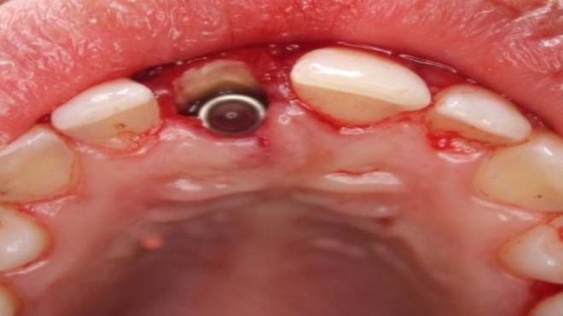
Figure 1: The implant housing was composed of the mesial, distal, and palatal bony walls while the buccal wall was occupied by the retained buccal aspect of the root composed of a thin layer of dentin followed by cementum, periodontal ligament, and bundle bone.

Biography
Mohamed Elseasy is an Assistant lecturer of Oral & Maxillofacial surgery at Faculty of Dentistry, Egyptian Russian University (ERU). He is an Experienced Specialist with a demonstrated history of working in the dental practice and skilled in Oral & Maxillofacial Surgery. He is a strong professional with a Bachelor's degree focused in Oral and Dental Medicine from Faculty of Oral and Dental Medicine Misr International University (MIU) and Master degree of Oral & Maxillofacial Surgery from Faculty of Dentistry Suez Canal University. He is a Member of German Society of Oral Implantology (DGOI).

