The GNLS solitons in fiber and planar optical waveguides
Vasily Yu Belashov¹*, Oleg A Kharshiladze² and Elena S Belashova³
¹Kazan Federal University, Russia
²Ivane Javakhishvili Tbilisi State University, Georgia
³Kazan National Research Technical University, Russia
Abstract
Study of the evolution and dynamics of the 2D and 3D envelop solitons in fiber and planar optical waveguides is very actual problem. The interaction of such solitons sufficiently changes their characteristics and background Electromagnetic (EM) field. Problem of the dynamics and stability becomes more complicated if it is necessary to take into account an influence of different dispersive and nonlinear in homogeneities and non-stationary parameters of optical medium on the soliton structure and evolution. In this case the problem reduces to the Generalized Nonlinear Schrodinger (GNLS) equation for the amplitude of the EM field with due account of the spatial and temporal in homogeneities in optical propagation medium. The analysis of stability of the multidimensional GNLS solitons was based on the Hamiltonian method developed by authors earlier for the Belashov-Karpman class of equations. As a result, we have found the conditions of existence of the multidimensional stable GNLS optical soliton solutions. Numerical simulation with use of the especially developed by authors numerical methods showed that inhomogeneity of medium changes the amplitudes and velocities of the EM solitary waves, their quantity that is caused by their non-elastic interaction in inhomogeneous medium. Non-stationary medium changes form of impulses and affects its spectral features, Changes of modulation of the optical medium parameters leads to variation of character of non-elastic interaction at solitons attraction-repulsion [Figure 1].
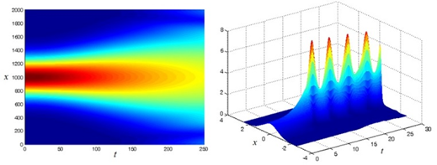
Figure 1. Scattering of a soliton-like envelope pulse at negative nonlinearity, when the stability condition is not satisfied (left), and the arizing of powerful stable pulsations of the breather type when the stability condition is satisfied.
Biography
Prof. Vasily Yu Belashov is a PhD (Radiophysics), DSci (Physics and Mathematics). He is Chief Scientist and Professor at the Kazan Federal University. He is author of more than 400 publications including 8 monographs.
Dr. Oleg A. Kharshiladze is Associated Professor at the Ivane Javakhishvili Tbilisi State University. He is involved in international scientific group, working on analysis of ionospheric and magnetospheric processes (turbulence, BBF and others).
Dr. Elena S Belashova, PhD (Physics of Atmosphere and Hydrosphere). She is Associate Professor at the Kazan National Research Technical University named after A. N. Tupolev – KAI. She is author of more than 90 publications.

