Peptic ulcer disease
Osei Frank Kofi
V.N Karazin Medical National University, Ukraine
Abstract
Peptic ulcer occurs when there is erosion in the lining of the digestive tract. Or we can say it occurs when there is a breech in the lining of the alimentary canal. The cause of peptic ulcer disease occurs as a result of the imbalance of the defensive and offensive mechanisms with regards to the gastro duodenal mucosa. Many say the cause is usually H.Pylori infection as concluded in 1994 and/or excess use of non-steroidal inflammatory anti-inflammatory agents. Symptoms usually depend on the location of occurrence of the ulcer. Generally, there is epigastric pain, heartburn, nausea, vomiting. Investigations done to confirm include upper G.I endoscopy, X-ray With barium, blood grouping. Complications include perforation, penetration, malignancy, outlet obstruction. Management will include lifestyle modification, pharmacological treatment and surgery.
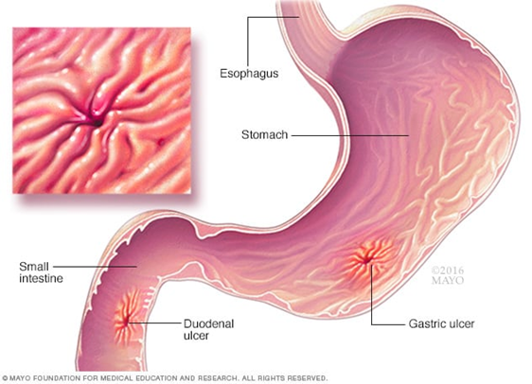
Figure 1.
Biography

