Trabecular micro bypass stent (istent) implantation in open angle glaucoma patients-Techniques and outcomes
Nadisha P Singh
Central Middlesex Hospital, UK
Abstract
Glaucoma is a leading cause of blindness in the world. Intra-ocular pressure (IOP) is a modifiable risk factor in glaucoma which helps to reduce the progression of the disease. Eye drops and glaucoma filtration surgeries have long known to be effective in lowering the IOP. However, they have their own set of serious complications associated with them.
One of the newer minimally invasive glaucoma devices includes istent. This technology can be used alongside cataract surgery in order to reduce the post-operative IOP and help reduce the number of medications that the patient is taking.
In this presentation, I will explain to you regarding the technique of implanting istent and discuss the outcomes of the istent technology [Figure 1].
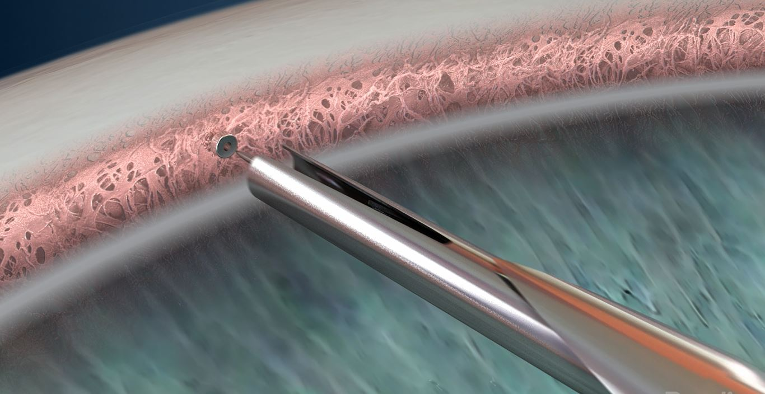
Figure 1. Diagrammatic presentation anatomy of the angle on gonioscopy showing Istent implantation in the Trabecular meshwork.
Biography
Nadisha Singh is a Consultant Ophthalmologist practicing in Central Middlesex hospital, London Northwest NHS trust. Her main areas of interests are Cataract Surgery, Glaucoma, Cornea and Medical retina. She has done four fellowships including at the prestigious Moorfields Eye Hospital. She has a keen interest in teaching and education and has been faculty at various regional, national & international conferences. She has been a tutor at the Undergraduate teaching at Kings College hospital.

