Unilateral lambda can be a sign of occipital structural lesion
Futoon AlOtaibi¹* and Danah Aljaafari²
¹Ministry of Health, Saudi Arabia
²Imam Abdulrahman Bin Faisal University, Saudi Arabia
Abstract
Introduction: Lambda waves are normal EEG pattern that are described as sharp transients occurring over the occipital region of waking subjects during visual exploration. They are surface positive, strictly bilateral and synchronous, although maybe asymmetric, rarely present in one side, less than 10%. When they are a symmetric or unilateral there may be confusion with interictal epileptiform discharges. our case demonstrate how unilateral Lambda waves was a sign of structural abnormality that was confirmed by neuroimaging.
Case: We present a 64-year-old female patient who is known to have diabetes, hypertension, dyslipidemia and anemia, she presented to epilepsy clinic with 2 years history of right focal unaware tonic seizure and focal to bilateral tonic clonic seizures. She had six events in two years. Clinical examination was remarkable for: mild dysarthria left upper motor facial weakness, hyper reflexia on left side, planter: up going on the right side.
EEG was requested and showed: posterior dominant alpha background activity 8-9 Hz which was bilateral symmetrical and reactive to eye opening and closure, no interictal epileptiform discharges were recorded and no ictal abnormalities, however, her routine EEG showed frequent runs of right occipital positive diphasic sharp discharges during scanning eye movements as shown in [Figure 1 (A and B)].
MRI of brain was done and showed multiple areas of hyper intensities in FLAIR sequence seen at bilateral middle frontal regions and left occipital region. As shown in [Figure 2 (A, B and C)].
Patient was started on carbamazepine 200 mg twice daily, in addition to antiplatelet ASA and lipid lowering agent with controlling her risk factors. Upon OPD follow up visits she showed improvement in term of seizure control.
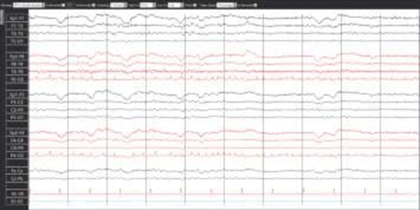
Figure 1. A) EEG longitudinal bipolar montage demonstrating right occipital Lambda waves recording parameters include sensitivity 7 uv and filters of 1-70 Hz.

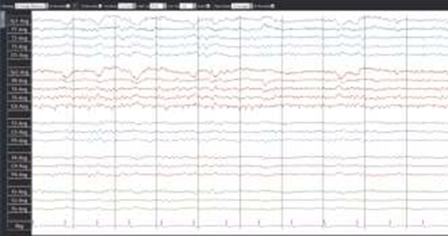
Figure 1. B) EEG Common average reference montage demonstrating runs of right occipital Lambda waves discharges which were absent at O1 electrode.
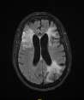
Figure 2. A) MRI brain Flair sequence showing hyper intense lesions at bilateral frontal areas and left occipital area.
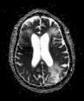
Figure 2. B) ADC map MRI sequences an apparent diffusion coefficient image showing diffusion areas at bilateral frontal areas and left occipital area.
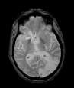
Figure 2. C) GRE gradient Echo MRI sequence showing high signal intensity at left occipital area.
Discussion: Lambda waves resemble the Greek letter λ with diphasic or triphasic waveforms with prominent surface positive waveforms, more common in young adults and not usually seen before one year of age. It is transient predominantly occipital potentials occurring singly or in irregular trains, the field may extend to parietal and posterior temporal regions. It is diphasic or triphasic with a predominantly positive sharp peak of 75-200 ms duration. It has variable amplitude that may exceed 50 uV, especially in children. The pathophysiology of Lambda waves is that it’s probably spontaneous visual evoked potentials elicited by shifts of the subject’s gaze during saccadic eye movements. Their incidence varies (up to about 50%) depending on laboratory environment. It disappears with blank card viewing, darkness, eye closure, drowsiness and sleep. It is crucial to know the features of Lambda waves because in the suspicion of an epileptic correlate, the disappearance of the waves replacing a geometric multicolor image with a blank surface clearly indicates the finding of non- pathologic Lambda waves. It is also important to characterize their features and distinguish them from the POSTS (Positive Occipital Sharp Transients of Sleep), While Lambda and POSTS are both normal EEG patterns and have many similarities in terms of morphology, polarity and location, Lambda waves occur in wakefulness and as an evoked response, whereas POSTS appear typically during physiologic sleep. The clinical significance of Lambda waves could be to demonstrate the physiological functioning of the saccadic visual exploration processes. In other words, as Lambda waves are probably related to an oculomotor visual integration mechanism, the failure to demonstrate Lambda waves could be indicative of a specific dysfunction involving particular areas of the visual cortex. In our case, the unilateral lambda waves was suggestive of a structural pathology, our patient had left PCA ischemic stroke, so Lambda was absent in the pathologic side, the left occipital region (at O1 electrode derivation).
Conclusion: Unilateral or asymmetric Lambda can be a normal finding in EEG recordings, but a structural pathology of occipital region should be ruled out. We recommend considering neuroimaging for any patients who have unilateral Lambda wave’s discharges on EEG before passing it as a normal or insignificant finding. This case shows us how EEG can be a useful tool to localize a pathology not only capturing epileptic activity.
Biography
Futoon AlOtaibi is currently working as Pediatric Resident at Ministry of National Guard Health Affairs, Saudi Arabia.

