Piperine, a possible therapeutic agent in management of COPD via attenuating oxidative stress in lungs
Poonam Arora
SGT University, India
Abstract
Statement of the problem: Chronic Obstructive Pulmonary Disease (COPD) is one of common respiratory disorders and third leading cause of deaths worldwide. Cigarette Smoke (CS) is considered as one of the major risk factor for exacerbations in COPD patients. Many secondary metabolites isolated from plants are elated to exhibit therapeutic potential in respiratory disorders including, asthma and COPD. Piperine, a major bioactive compound of black pepper (Piper nigrum Linn.), is widely used as spice in food products, but is also commonly used as a medicine in folk medicine. It is well established that inflammatory mechanisms induced by smoking are related to production of oxidative stress in COPD. Piperine has the ability to reverse inflammatory mechanisms in airways of experimental animals. Finding excellent anti-inflammatory effects of piperine in various cell types, we could propose the possible protective role of piperine in CS-induced COPD.
Methodology & theoretical orientation: COPD was induced in experimental mice, by exposure to smoke of 10 commercial cigarettes concurrently, twice daily for 10 weeks. Further, animals were treated with methyl prednisolone (3.25 mg/kg, b.w.) or piperine (10 mg/kg, b.w.) for 1 or 3 weeks, respectively. Levels of inflammatory cells and oxidative stress biomarkers Malondialdehyde (MDA), Myeloperoxidase (MPO), nitric oxide were analysed in all animals [Figure 1].
Findings: CS-exposure increased the production of Bronchial (BAL) neutrophils count and MDA, MPO, nitric oxide in mice lungs as compared to normal control group (P<0.001). Oral treatment of CS-exposed animals with piperine (10 mg/kg, b.w.) or reference standard, methyl prednisolone (3.25 mg/kg, b.w.) for 1 week or 3 weeks, respectively, significantly (p<0.05,0.01,0.001) reversed CS-induced production of oxidative stress biomarkers as compared to CS-exposed control mice.
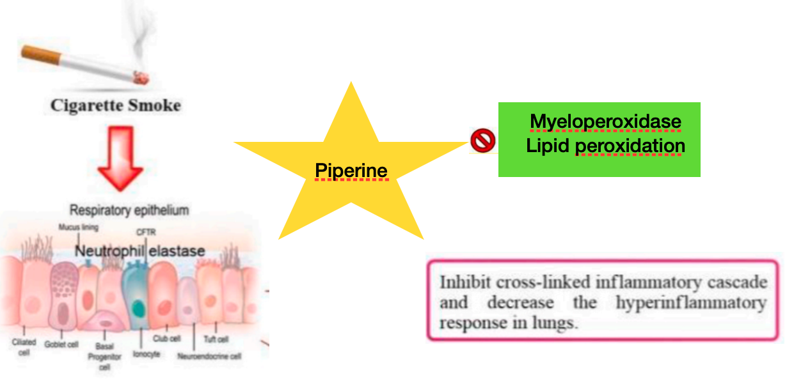
Figure 1. Effects of piperine on lungs of cigarette smoke-induced COPD.
Conclusion: Findings of our study suggest protective effect of piperine in experimental animals by repressing CS-induced exaggerated production of oxidative stress.
Biography
Poonam Arora is working as an Associate Professor in SGT College of Pharmacy with keen interest in studying pharmacology of novel or existing phytocompounds to understand how these interventions modulate immune response in chronic pulmonary diseases. She has more than 18 years of cumulative experience in teaching, research and industry with expertise in isolation of bioactive compounds from natural sources and studying their therapeutic potential in asthma and other lung disorders using various modern approaches at molecular and cellular levels. She has received P.D. Seth’s best research paper award and young researcher award from INSc. Her research career is credited by publication of more than 30 research/review papers in high impact factor peer reviewed/SCI indexed journals and has presented many research papers in national and international conferences held in India and abroad. In addition she is serving as board member of reviewer/editorial committees of various journals of national and international repute including, Royal Society of Chemistry, ISE, Elsevier, Taylor and Francis, Brazilian Journal of Natural Sciences and Indian Pharmaceutical Society.

