Synthesis of widely-soluble biocompatible ionic liquids aiming to enhance transdermal drug delivery system
Shihab Uddin* and Fahmida Habib Nabila
Kyushu University, Japan
ABSTRACT
Ionic Liquids (ILs) are a novel class of environmentally benign and tailor-made solvents. They have been increasingly exploited as solvents, co-solvents, and/or materials in the fields of pharmaceutical drug delivery and Active Pharmaceutical Ingredient (API) formulation because of their unique properties [1]. ILs ensures potent therapeutic action by solubilizing or stabilizing as well as enhancing skin penetration of drugs in Transdermal Drug Delivery Systems (TDDSs). We’ve developed three novel Lipid-Based Bio-Ils (LBILs), each including a long chain phosphonium cation, the phosphatidylcholine derivative named 1,2-dimyristoyl-sn-glycero-3-ethyl-phosphatidylcholine; EDMPC (similar to natural lipids on the skin) and a long-chain Fatty Acid (FA) [2]. In the synthesis of LBILs, EDMPC Chloride (EDMPC-Cl) was first synthesized by a series of reactions under specific conditions. Then, the combination of equimolar amounts of either linoleic, oleic, or stearic acid with the EDMPC-Cl synthesize three LBILs, [EDMPC][Lin], [EDMPC][Ole], and [EDMPC][Ste]. At room temperature, [EDMPC][Lin], [EDMPC][Ole] and [EDMPC][Ste] are viscous liquid, highly viscous liquid and semi-solid respectively [3]. The purity, thermal phase behavior, and identical properties of LBILs were optimized by proton nuclear magnetic resonance (¹H NMR), Fourier Transform Infrared (FTIR) spectroscopy, Differential Scanning Calorimetry (DSC), Elemental Analysis (EA), Mass Spectroscopy (MS), Dynamic Light Scattering (DLS) and UV visible spectroscopy. The three LBILs were found soluble at an equal ratio in both polar (ethanol, methanol, etc.) and non-polar solvents (hexane, heptane, etc.) solvents. DLS and UV analysis revealed that LBILs were molecularly soluble in nonpolar solvents and dispersible in polar solvents by forming microemulsions/ nanoparticles [4]. Using an artificial three-dimensional human epidermis model these compounds were tested for biocompatibility in a well-established skin irritation test (MTT-assay) only to exhibit excellent biocompatibility. The Ionic-liquid-in-oil-nanodispersions (IL/O-NDs) from three LBILs enhanced the transdermal permeation of the peptide to the skin layers by deforming its lipid and protein arrangements to enhance the transdermal permeation of the peptide compared to other Conventional Skin Permeation Enhancers (CPE) and Tween-80. Transdermal peptide delivery profiles of IL/O-NDs of these three peptide-LBIL complexes revealed that [EDMPC][Lin]/O-ND was the most preferable for a TDDS based on the pharmacokinetic parameters compared to others [5]. These results clearly state the assurance of enhanced TDDS by synthesis of these universal soluble biocompatible Ionic Liquids (Figure 1).
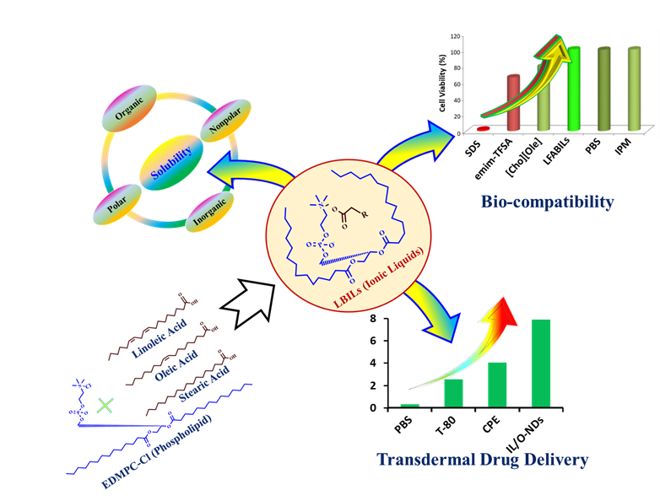
Figure 1.
References
- Uddin S, Chowdhury MR, Wakabayashi R, et al. Lipid based biocompatible ionic liquids: synthesis, characterization and biocompatibility evaluation. Chem Commun 2020;56(89):13756–9.
- Uddin S, Islam MR, Chowdhury MR, et al. Lipid-based ionic-liquid-mediated nanodispersions as biocompatible carriers for the enhanced transdermal delivery of a peptide drug. ACS Appl. Bio Mater. 2021,4,6256–67.
- Islam MR, Uddin S, Chowdhury MR, et al. Insulin transdermal delivery system for diabetes treatment using a biocompatible ionic liquid-based micro emulsion. ACS Appl Mater Interfaces. 2021.
- Uddin S, Islam MM, Hassan MM, et al. Amaranthus viridis modulates anti-hyperglycemic pathways in hemi-diaphragm and improves glycogenesis liver function in rats. J Pharmacogn Phyther. 2016;8(10):73–181.
- Hassan MM, Uddin S, Bhowmik A, et al. Phytochemical screening and antidiabetic effects of fruit rind of Momordica dioica on streptozocin induced type 2 diabetic rats. Heliyon. 2022;8:e08771.
Biography
Shihab Uddin has received his PhD in Engineering on Chemical System and Engineering (leading to Biomedical Engineering) from the Kyushu University, Fukuoka, Japan in 2021. Currently, he is working in the Kyushu University, Fukuoka, Japan as a postdoctoral research fellow in the Dept. of Applied Chemistry and very soon he will join in the University of the British Columbia, Vancouver, Canada as a postdoctoral research fellow at the faculty of the Pharmaceutical Sciences. He is a highly motivated and innovated research scientist with demonstrated academic and industrial experienced in synthetic/material chemistry, pharmaceutical-formulations, nano biotechnology, and lipid-based nano drug delivery. He is expert in synthetic biology, methods developments and validations, pharmacokinetics, pharmacodynamics, drug delivery, and targeted tumor immune therapy. He is serving as an editorial board member of “Pharmacotherapy and Pharma science Discovery” journal. He has several publications in well repeated journal of RSC, ACS, Springer, and Elsevier and many of them are noted as front cover pages. He is focusing his research on the developing and translating innovative drug delivery technologies to clinical use and educating the next generation of scientist in the drug delivery field.

