Brain thrombosis detection and removal system designed by delivery nano drug
Nazila soleymani fard
Tabriz University, Iran
Abstract
The incidence of strokes at an early age has increased, due to the use of drugs that make cerebral thrombosis in the field necessary to reduce the medical and reduce the side effects of this group of drugs. Targeted drug while identifying the prevention of thrombosis formation and blockage of the brain due to the use of drugs from amphetamines, thrombolytic drugs available in the market have a low efficiency in crisis recovery and nanomaterials produced in this field due to the use of polymers A time-consuming process for those that are economically viable in the same region, having long-lasting properties, intelligent materials for identification and biodegradability with a dose of toxicity. It seems necessary to eliminate cerebral thrombosis, so we decided to play a role in improving and preventing cerebral thrombosis by designing and producing a drug-delivery nano system. Cerebral thrombosis, if diagnosed early, prevents unwanted complications, which is designed to be used by the patient. Or does not have reasonable stability, but this drug designed because of the preparation of nanomaterials can be considered the lowest dose of toxicity and the most accurate method possible (Figure 1).
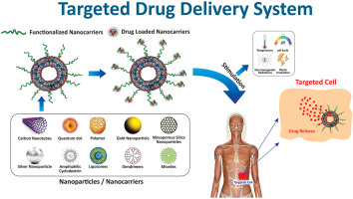
Figure 1. Targeted drug delivery system
Biography
Nazila Soleymani Fard is a student of Tabriz university of Iran. I started my research by examining the toxicity of silver nanoparticles on rat liver and then I studied the anti-cancer properties of silver nanoparticles on liver carcinoma and now I am going to eliminate brain thrombosis with smart nanoparticles, my idea in this The case is global and prerequisite research has been done.

