In silico and in vitro identification of pan-coronaviral main protease inhibitors from a large natural product library
Nasim Shahhamzehei*, Sara Abdelfatah and Thomas Efferth
Institute of Pharmaceutical and Biomedical Sciences, Germany
Abstract
The main protease (Mpro or 3CLpro) in coronaviruses represents a promising, specific drug target since it is essential for the cleavage of the virus polypeptide with a unique cleavage site that does not exist in human host proteases. In this study, we explored the potential natural pan-coronavirus drugs using in vitro and in silico approaches and three coronavirus main proteases as treatment targets. The PyRx program was first used to screen 39,442 natural product-like compounds from the ZINC database and 121 preselected phytochemicals with known antiviral activity against SARS-CoV-2 Mpro. After assessment with the Lipinski’s rule of 5, molecular docking was performed for the top 33 compounds of both libraries. Enzymatic assays were applied for the top candidates from both in silico approaches for testing their ability to inhibit the SARS-CoV-2 Mpro. Four compounds (hypericin, rosmarinic acid, isorhamnetin, luteolin) that most efficiently inhibited SARS-CoV-2 Mpro in vitro were then further tested for their efficacy to inhibit Mpro of SARS-CoV-1 and MERS-CoV as well. Microscale thermophoresis was performed to determine the dissociation constant (Kd) values to validate the binding of these active compounds to recombinant Mpro proteins of SARS-Cov-2, SARS-CoV-1, and MERS-CoV. The cytotoxicity of hypericin, rosmarinic acid, isorhamnetin, and luteolin was also assessed in human diploid MRC-5 lung fibroblasts using the resazurin cell viability assay to determine the therapeutic indices. Sequence alignment of Mpro of SARS-CoV-2 demonstrated 96.08%, 50.83%, 49.17%, 48.51%, 44.04%, and 41.06% similarity to Mpro of other human-pathogenic coronaviruses (SARS CoV-1, MERS-COV, HCoV-NL63, HCoV-OC43, HCoV-HKU1, and HCoV-229E, respectively). Molecular docking showed that 12 out of 121 compounds were bound to the SARS-CoV-2 Mpro with the same binding site at Mpro as the control inhibitor GC376. Enzyme inhibition assays revealed that hypericin, rosmarinic acid, isorhamnetin, and luteolin inhibited Mpro of SARS-CoV-2, while hypericin and isorhamnetin inhibited Mpro of SARS-CoV-1 and hypericin showed inhibitory effects towards Mpro of MERS-CoV. Microscale thermophoresis confirmed the binding of these compounds to Mpro with high affinity. Resazurin assays showed that rosmarinic acid and luteolin did not reveal significant cytotoxicity toward MRC-5 cells, whereas hypericin and isorhamnetin were slightly cytotoxic. We demonstrated that hypericin represents a potential novel pan-anti-coronaviral agent by binding to and inhibition of Mpro of several human-3pathogenic coronaviruses. Moreover, isorhamnetin showed inhibitory effects towards SARS-CoV-2 and SARS-CoV-1 Mpro indicating that this compound may also reveal at least some pan-coronaviral potential. Luteolin revealed inhibitory effects against SARS-CoV-2 Mpro.
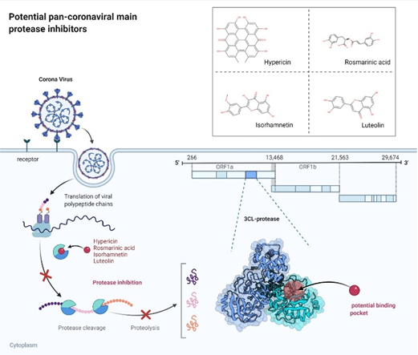
Figure 1.
Biography
Nasim Shahhamzehei have completed my Master in Clinical Biochemistry at Tarbiat Modares University in Iran and published 2 papers, and now I am doing a Ph.D. in Pharmaceutical Biology at, the Institute of Pharmaceutical and Biomedical Sciences, Johannes Gutenberg University, Mainz, Germany. I am interested in the molecular modes of action of small molecules, phytochemicals, and microbiological compounds with activity towards infectious diseases, cancer and Inflammation.

