Saliva as a source of antibodies for MMR vaccine screening in teenagers
Barbara Fialho Carvalho Sampaio* and Andrade Jr. HF
University of Sao Paulo, Brazil
Abstract
The use of safe and effective vaccines is a well-established public health intervention, with a major impact on the fall in the prevalence of infectious diseases. In the absence of environmental transmission, vaccines do not work for life, as originally detected. This has now generated the occurrence of vaccinated susceptible people, which allows the importation of diseases, since vaccination coverage does not equate to population immunity. The serological control of the vaccination status and the protection of a population is essential, and its execution is not friendly due to the blood collection necessary for the tests. In these assays, the specific IgG for the vaccine agent is quantified, it would be important to detect IgA as well. This is an immunoglobulin secreted for mucous membranes that neutralizes or directs the agent to non- permissive neutrophils, it is very important in vaccine protection, but difficult to detect and quantify. Saliva can be a friendly alternative material as a source of IgA and IgG for use in conventional tests and its obtainment is not invasive, facilitating the acceptance of these studies in protected groups. We standardized assays with detection of antibodies in solid phase, to prospect for effective vaccine coverage in adolescents using saliva as a biological fluid. Once established and standardized, these techniques will allow for eventual vaccine control without the need for aversive blood collection, adequate public health measures, such as revaccination, can be adequately planned.
According to the State of the World’s Vaccines and Immunization report, “Vaccination-even with the addition of new, more expensive vaccines-remains one of the most cost-effective health interventions”. The publication notes that more children are reached with the immunization of one hundred million children per year in the period 2005-2007, approximately. And the benefits of immunization are increasingly extended to adolescents and adults, providing protection against potentially fatal diseases, such as influenza, meningitis and cancers that occur in adulthood.
Some authors have demonstrated that there may be a lack of response to the vaccine, called Primary Vaccine Failure (FVP), in about 2% to 5% for measles, 3% to 7% for mumps and 2% to 5% for rubella. Among the main causes of PVF are the presence of maternal antibodies and the improper conditions of the vaccine (handling, administration, cold chain). It has also been shown that Secondary Vaccine Failure (FVS) can occur, which is the drop in antibody levels, which over time can reach levels so low or undetectable that they do not provide more protection. These studies have observed that the levels of antibodies after vaccination are lower than after natural infection.
For these reasons, even with an effective immunization program in a child population, birth and the vaccination period can generate susceptible after a few years; therefore, vaccination coverage may not be equivalent to population immunity. During the past few decades, the triple viral vaccine has been introduced into immunization policy in several countries. In order to have a good immunization, two doses are recommended, the first at 12-15 months of age and the second at 4-6 years of age, in order to cover possible vaccine failures.
The vaccination process is the most effective public health intervention in the control of infectious diseases. The detection of the presence of specific IgG antibodies in serum has numerous medical uses, whether in detecting contact with infectious agents, such as in human toxoplasmosis or in demonstrating vaccine efficiency for some diseases such as measles [Figure 1], mumps [Figure 2] and rubella [Figure 3].
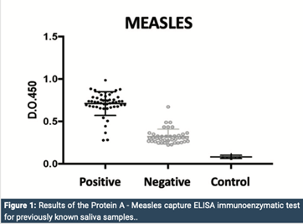
Figure 1. We note a clear discrimination between positive (50) and negative (40) saliva for measles antigen. The sensitivity of the assay was 98% (95% CI 89-99%) and the specificity was 91% (95% CI 79-96%) which was excellent, although some false positives (1) and false negatives (4) have occurred.
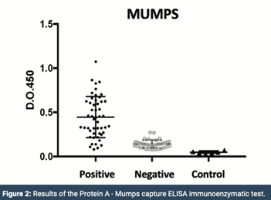
Figure 2. We can see, the reactivity of positives was less intense, although with clear discrimination between positives and negatives. Using the cut- off of two standard deviations, there was a greater number of false negatives (10), but without false positives, which resulted in 100% sensitivity (95% CI 91-100%) and 80% specificity (95 CI % 67-89%). This fact is related to a lower intensity of the reaction and perhaps to a less efficient response quantitatively to the vaccine, since the criterion of positivity was that of a young adult with complete childhood vaccination.
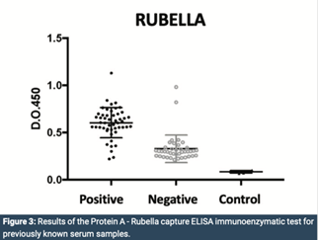
Figure 3. We note that the populations were again clearly distinguished by the assay, albeit with a greater background of positivity and interbreeding. The negative reactions of vaccinated adults may have been caused by the loss of antibodies produced by a less lasting immunization despite the previous vaccination. The test had a sensitivity of 95% (I.C. 95% 85-99%) and a specificity of 83% (I.C. 95% 69-91%). The finding of false positives in the fraction of negative pools could be explained by the cross reaction with other viral antigens occurring in this age group.
Biography
Dr. Barbara Fialho C Sampaio, is coordinator of clinical research and Posdoctoral Researcher in the Medical School of Sao Paulo University. Develop innovative diagnostic research using non-invasive techniques, which aims to create possibilities for expanding diagnosis of infectious diseases. She is focused today is on the detection of measles, rubella and mumps in human saliva, such as had developed a new diagnostic technique to detect the vaccination status of children using saliva as an alternative biological fluid to blood.

